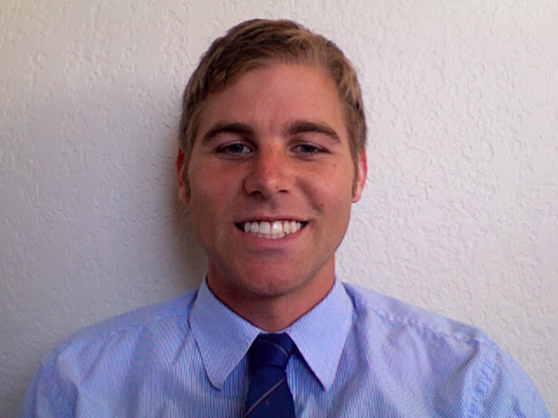

Brian Alexander
5455 west oasis road
Tucson, AZ 85742
(520) 744-8498
Email: brialexander25@gmail.com

Objective: My objective is to be an asset and leader to the educational organization that I am working for. I can call upon my knowledge of education and history in order to take command of the classroom. I believe I can be an integral part to any organization or department. I excelled in my student teaching program as well as my ESL teaching position in Korea. I am great when teaching either kids or young adults. With my attention to detail and organizational skills I am an excellent and versatile candidate for nearly any position.

Education History:

  - Graduated from Neuqua Valley High School Naperville, Illinois

  - Attended College of Dupage Glen Ellyn, Illinois
Political Science major

  - Graduated from University of Arizona Tucson, Arizona
College of Education: Secondary education (History) major, political science minor

Employment History:

Summers of 1999-2005 Ashbury Aquatic Center, Naperville Illinois- Besides being a head lifeguard and swim instructor for grade school age children, I managed this private pool on numerous occasions and helped to keep a clean, safe, and friendly environment.

Jan/2008 to May/2008 Teaching Practicum at Canyon Del Oro High School- In this Tucson area school I taught U.S. and World History to over a hundred upper level high school students. In my letter of recommendation from my mentor teacher he described my performance of over 5 months as “flawless.”

Oct/2008 to May/2009 Employed as an exhibit guide at the Phoenix Zoo- I worked in the Monkey Village, Wallaby, and Harmony Farm areas. My duties included greeting patrons at the beginning of the exhibits, establishing rules and boundaries from toddlers to adults, and fielding a variety of public questions about the animals.

May/2009 to Oct/2009 Employed at Primavera Online High School- As an Enrollment Advisor I was in charge of handling any questions incoming by students and parents pertaining to documents needed for enrollment.

Nov/2009 to July/2010 Real estate consultant with Realty Executives- I worked with both homebuyers and sellers who are looking to move up in life or just change their location. I had to respond to many different needs of my customers.

Oct/2010 to Mar/2012 English Immersion teacher at LCI Kids Club in South Korea- I had a wonderful teaching experience while being abroad. I taught all primary subjects (Social studies, Math, etc…) to students aged 5-14. I also gained valuable experience in teaching a second language to such young groups.

References:
Julian Lee +82 (033) 644-2905
Director yh8303@lycos.co.kr
LCI Kids Club, Gangneung, South Korea

William Bendt 011 (520) 909-2930
Canyon Del Oro High School Oro Valley, AZ wbendt@earthlink.net

Esther Lee +82 (033) 644-2905
Vice Director djsdir2000@naver.com
LCI Kids Club, Gangneung, South Korea

Eileen Pfaff 011 (630) 212-2711
(Former manager, Ashbury Aquatic Center)
Ungaretti & Harris Law Firm Chicago, IL

