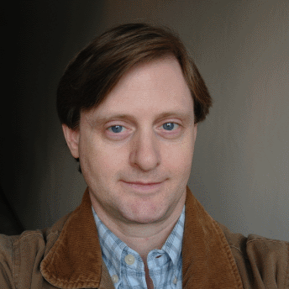
WILL HOOVER
Woojeonghansarang Apt. 512
447-39 Kaesin-dong, Heungdok-gu
Cheongju-si, Chungcheongbuk-do 361-805
phone: 010-8529-5967
will5967@gmail.com

SUMMARY OF QUALIFICATIONS
- Native English speaker (Natural born United States citizen)
- Bilingual speaker of American English and Mandarin Chinese (Learning Korean)
- Clean cut, articulate and responsible, with strong interpersonal communication skills
- TESOL/TEFL certified English teacher, skilled at working with adults and children of all ages
- Nine years combined experience teaching English as a Second Language in Taiwan, Mainland China and South Korea
- Currently based in Cheongju, South Korea

RELEVANT EXPERIENCE
- 9 years experience teaching students of all ages (kindergarten to adult)
- 12+ years experience as a private tutor and teacher of group classes of various sizes

EDUCATION AND TRAINING
- TESOL Certificate – International TEFL Corporation
Certified 100 hours of TESOL/TEFL training, July 2008

- Bachelor of Arts degree – Individual Studies (Emphasis in English, Art and History)
Columbia College, Columbia, Missouri, August 1993 – December 1995

- Associate of Applied Arts degree – Commercial Art
Hawkeye Community College, Waterloo, Iowa, September 1990 – May 1992

EMPLOYMENT HISTORY
- 01/2011 – 01/2012 English Teacher Wiz Island Institute – Cheongju, Korea
- 01/2009 – 12/2010 English Teacher Eton English School – Cheongju, Korea
- 06/2007 – 12/2007 English Teacher Melody Language Center – Shanghai, China
- 05/2000 – 06/2002 English Teacher Global Village Language Center – Taipei, Taiwan
- 09/1998 – 04/2000 English Teacher Mentor Language Institute – Kaohsiung, Taiwan
- 07/1997 – 08/1998 English Teacher Ker-May English School – Hsin-ying, Taiwan

