Andy H.T. Chung
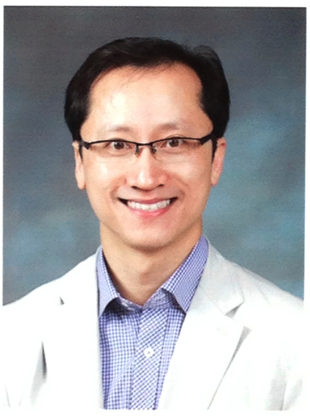
Daejeon City, South Korea
Mobile Phone: 010-7342-5593
Email Address: chung.andy71@gmail.com
Skype ID: andychung71

Education:
Master of Education: Technology Innovation and Education (currently enrolled)
December 2014 Kongju National University – South Korea

ITTT 120-Hour TEFL Certificate, Pass A
February 2013

The International TEFL Corporation 60-hour Teaching of Business English Certificate
February 2013 (currently enrolled)

Associates Degree: Computer Science and Network Administration
May 1999 Parks College – Aurora, Colorado, U.S.A.
Bachelor of Art: Department of Liberal Art: Fine Arts
December 1997 University of Colorado @ Denver, U.S.A.
Work Experiences:
Joongbu University
101 Daehak-ro, Chubu-myeon, Geumsan-gun, Chungnam, South Korea 312-702
Tel: 82-41-750-6523 Fax: 82-41-753-8748
March 2011 – Present
“Conversational English Instructor”
-Teaching speaking and writing of English language

Child-U English Institute, Daejeon City, South Korea 305-308
January 2010 – February 2011
“English Teacher”
-Teaching Kindergarten to Middle School students conversational English

Language International Kim Enterprises Foreign Language Academy – Ulsan City, South Korea 683-803
October 2008 – January 2010
“English Teacher”
- Teaching Kindergarten to Middle School students conversational English

Simple Home Lending Inc. – Highlands Ranch, CO, USA
July 2007 – October 2008
“Mortgage Broker – Owner”
-Loan originator and loan processor of “Conventional Home Loans”

Trans Home Loans, Inc. - Denver, CO, USA
April 2006 – December 2007
“Loan Officer”
– Processing “Conventional Home Loans” from start to finish

Heidi’s Brooklyn Deli – Greenwood Village, CO, USA
April 2006 – March 2007
“General Manager, Baker, and Inventory Specialist”
-Responsible for the entire operation of a delicatessen business

Echostar Inc. - Denver, CO, USA
January 2005 - April 2006
“Corporate Warehouse Manager”
ComPATH Inc. - Denver, CO, USA
May 1999 to April 2004
“Technical Supervisor / Quality Assurance Specialist / Trainer”

Interactive Knowledge: DBA Netlibrary.com - Boulder, CO, USA
Sept 1998 to April 1999
“Assistant Network Administrator and Editor of Online Book Publications”
United States Postal Service - Denver, CO, USA
July 1996 to October 1997
“Mark-up Clerk”

Skills / Certifications / Licensing:

- ITTT 120-hour TEFL Certificate
- Over 5 years of academic teaching experience in South Korea
- Health & Life Insurance Licensed 2008
- Mortgage Broker Licensed 2007
- Certified Forklift Operator by Echostar Inc. 2004
- Telephony Certified by AT&T, June 2002
- Experienced with Windows 95-98, 2000, NT, XP, Vista, Windows 7, Macintosh OsX
- Proficient with Microsoft Office

Languages:

Native English speaker, Advanced Vietnamese, Basic Chinese (Mandarin & Cantonese)

References:

Jarrod Taylor – English Department Supervisor
Joongbu University, South Korea
(+82) 01-4240-1976
Email: jarrod@joongbu.ac.kr

Yoo-Jin Song – Supervisor of Academic Affairs
Joongbu University, South Korea
(+82) 41-750-6531
(+82) 01-5154-7184
Email: tjsong@joongbu.ac.kr

Iris Shin - Owner
Child-U English Institute, South Korea
(+82) 01-4188-2010
Email: greeniris2002@hanmail.net

Mrs. Kim Byeong-Ae - Owner
Language International Kim Enterprises Academy, South Korea
(+82) 01-4566-1275

***Other references available upon request

