Isaac J. Colson
Mok-5-Dong Apt. 527-403
Yangcheon, Seoul, South Korea
Phone # 010-9855-9802
Email: isaac.colson@gmail.com
2009.07.21

To whom it may Concern,
Hello, my name is Isaac Colson and I would love the opportunity to continue teaching English in South Korea. There are many reasons I have chosen South Korea to start my teaching career. The first one is my love for the culture of Korea. I love the food, people, landscape, and language of Korea. I have visited the country twice and look forward to living there more long term. I also have many Korean friends who I meet while they were studying in Rhode Island, my home state. And the final reason is I like adventure and believe that experiencing another culture is a wonderful opportunity.
If I get the chance to work for your school, you will soon discover my strengths as a person and a teacher. My most important trait, besides being friendly and outgoing) is that I am a very hard worker. I know in Korea it is expected to work hard for the money you earn. I have had many jobs and learned from my father how to be a hard worker. I also learned from my experiences to be a patient person, especially when I am teaching others. I am patient with people because I understand that some people comprehend information at a slower speed than others. I am also a quick learner and am able to adapt to different situations easily. I do not get stressed out easily when I am asked to do many different things. And most importantly, I love to meet new people! I was a volunteer at my local University helping out with international students. I think understanding foreign cultures have been very beneficial to my personal growth.
I have loved teaching and helping others since I was ten years old, and I look forward to teaching others my whole life. I have had many great opportunities teaching adults and children and found myself very happy and content.
Thank you for taking the time to read this letter and considering me as an applicant.

Sincerely,

Isaac Colson

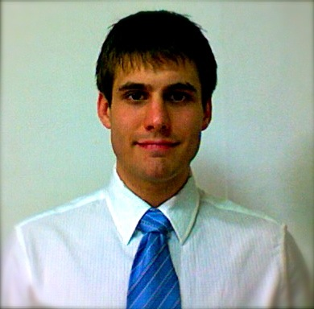
I. Personal Information:

Isaac J. Colson
Mok-5-Dong Apt. 527-403
Yangcheon, Seoul, South Korea
Phone # 010-9855-9802
Email: isaac.colson@gmail.com

II. Working Preference:
Starting Availability: August 1st 2009
Desired Wage: 2.3 million won/ month

III. Working Experience:
I have had many jobs with a lot of responsibilities. I worked at Dunkin Donuts as a Shift Supervisor for 2 years, I worked at a small pizza place as a manager for a year and a half, and I worked at an orthotic brace manufacture as a technician for three years.

IV. Cross Culture Experience:
I have been to Korea two times in the past two years. I came for a ten day visit November of 07 and a month long visit December 08-January 09. I have also been to Iceland, Romania, and Africa as part of volunteer service with my church.
VI: Education:
I graduated from Rhode Island College May 09 with a Bachelors degree in English. I earned a 3.2 GPA, which could have been better if I didn’t do so many extracurricular activities. However, I believe that all of my experiences have helped me develop more as a person, much more than simple school knowledge could have. I also have taken an ESL Certification Course online to prepare me for teaching in Korea.

References:
Chris(Moon) Cho: A friend and mentor of mine. She is from Korea, but is studying and working in America. She has helped me learn Korean, and has seen me teach.
Email Address: chrischo@mail.uri.edu
Phone Number: 401-450-2061

Seryun Kim: I met her at school when she was an exchange student in America. I helped her practice her English and have had the opportunity to continue our friendship when I visited Korea. She is now working at a Koreana Patent Firm in Kangnam-Ku.
Email Address: sr0525@empal.com
Phone Number: 82-2-554-7562~4

Barry McCoy: My boss at Custom Composite Manufacturing for nearly 3 years. He gave me an excellent opportunity to work for him while I was pursuing my degree at RIC. He saw what a hard worker I was.
Email Address: barry@cc-mfg.com
Phone Number: 401-275-2230

