Genevieve M. Tecson
Yongin City Suji Gu, Pongdeokchon 1 dong Tongbu Apartment 103-602
Tel: 010-4196-3294 E-mail: sky_bae@yahoo.com
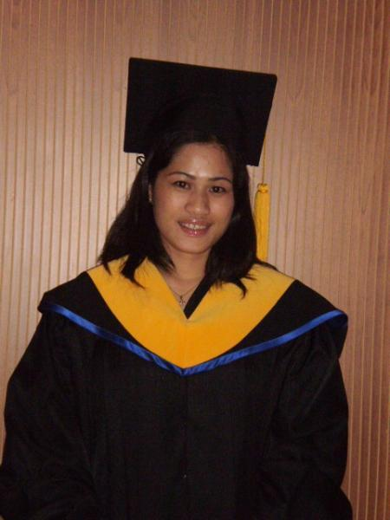
OBJECTIVE:
Students learn different learning style in my teaching on English as second language.
Students will be learn not only in the book of knowledge but also in the life knowledge.
KEY SKILLS
- Give students motivation of learning English.
- Fluent in English
- Respect the students.
- I can give to my students satisfaction on their English literacy skill.
EDUCATION
July 03, 2009 Winglish Tesol & Biz Education Center
Yoochang Bld 10th floor 1305-7, Seocho-dong, Seocho gu, Seoul, korea
TESOL Certificate

March 25, 2002 Information Technology Graduate
Acts College of Technology
Bansalan, Davao del Sur Philippines

EMPLOYMENT HISTORY

JUNE 15, 2002 – DECEMBER 2002 ASSISTANT SCHOOL TEACHER
AGAPE KINDERGARTEN SCHOOL
BANSALAN, DAVAO DEL SUR PHILIPPINES

AUGUST 2003 –AUGUST 2006 STORE SUPERVISOR – BOYET FAJARDO INITIALS ENTERPRISES
ROBISONS PLACE IMUS CAVITE PHILIPPINES

OCTOBER 2006 – OCTOBER 2007 JARMAN SHOES CORPORATION
SHOEMART BACOOR CAVITE PHILIPPINES

LANGUAGES
English , Tagalog and Korean.

PERSONALA DATA:

Provincial Address : Bansalan, Davao del Sur
City Address : Davao del Sur
Date of Birth : June 04, 1983
Age : 26 years old
Nationality : Filipino
Civil Status : Married
Religion : Roman Catholic

SPECIAL SKILL: Good in both written and oral communication, highly develop in personal relations.

