Jon Doucette
Bachelor of Arts Degree, English Major
jonathan.doucette@gmail.com
010-7137-1940

December 21, 2010

ESL Agent
Daehan Building 202
Dangsan-Dong, Yeongdeungpo-gu
Seoul, South Korea

Dear Mr. Kim,

I am writing to you today because I am seeking a position in Korea as an early years teacher. My teaching experience includes working at Gunpo Middle School through the GEPIC program. The GEPIC program provided me the opportunity to attend several seminars and training. These experiences have helped me become a better teacher and gave me training on effectively working with co-teachers, all of which would benefit me as well as my employer. I have learned a lot about Korean culture and also the educational system in Korea through my work experiences.

My plan, in the year to come, is to further my education and to complete my Bachelor’s of Education Degree online. I am very enthusiastic about teaching. In my past year, I have learned a great deal from the teachers at my school and look forward to learning even more next year. I am a hands-on learner, myself, and have had to improvise and adapt my teaching approach to many of the different intelligences. I have found that young children are very visual and kinesthetic learners. As the language barrier often presents complications, I have often found myself, “entertaining,” children in an effort to maintain their focus. I have thoroughly enjoyed my teaching successes in the past year, and have made it a point to learn from approaches that were not as successful as well.

Although I have not taught younger children before, I have had a invaluable experience with young children through my family. I have 2 nieces and a nephew back home in Canada who are now between 2 and 12. I spent a lot of time with them before I moved to Korea and I feel I have a natural report with young learners. As mentioned before I enjoy the humor you can cultivate with young children and have enjoyed making that part of my teaching method.

I have been living and teaching in South Korea for the past year and am looking to further my teaching career in this country. I have greatly enjoyed my time here and the many experiences I have had with the Korean culture and see myself in Korea for years to come.

My contract is finished at the end of December of this year. I am looking for a position for the first quarter of 2011. I will thank you kindly for any consideration you might afford me for any positions at your school that become available in the near future or in the following school year to come. I look forward to making connections with you.

Sincerely yours,

Jon Doucette

Jon Doucette
Gunpo, South Korea
C:010-7137-1940
jonathan.doucette@gmail.com
Native of New Brunswick, Canada
October 21, 1980

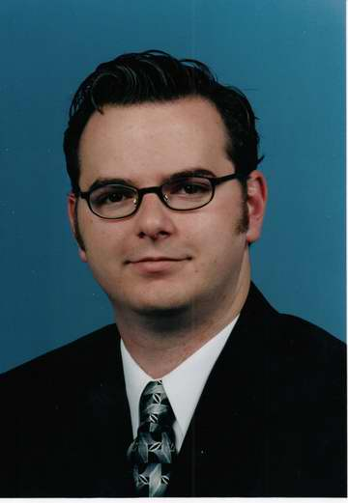

EDUCATION
Bachelor of Arts - Major in English Literature
Concordia University, Montreal, 2001-2003
Atlantic Baptist University, Moncton 1999-2001

Highly developed written and oral communication skills
Exceptional interpersonal skills
Proven team player who also works well independently
Computer skills including MS Word, Excel, Outlook and Power Point

RELATED EXPERIENCE
Gunpo Middle School, Gyeonggi-do, 2010
Foreign English Teacher
- Taught English to public middle school students with low English language proficiency in class sizes ranging from 25 – 40 students
- Formed weekly lesson plans for students in three separate grades
- Conducted a twice weekly conversation group for students interested in furthering their English conversation abilities

Coldwell Banker First Choice Realty, Moncton 2003-2006
Residential Real Estate Sales
- Conducted seminars for first time home buyers
- Educated clients on how achieve their financial goals through real estate planning
- Received several sales awards on company and regional levels for performance

Hillsborough Computer Access Center, Hillsborough, 1999 - 2002
Supervisor / Instructor
- Supervised and provided instruction to varying age groups while using computer systems
(Most common ages ranged from 8-15 and adults)
- Assisted in planning and execution of summer camps which provided instruction of how to use computer hardware and software
- Instructed and assisted the users of online/software based course material

TECHNICAL SKILLS
OS / Software: Windows 2000, XP, Vista / Microsoft Office (Word, Excel, PowerPoint, Outlook)
Typing: 40 wpm

