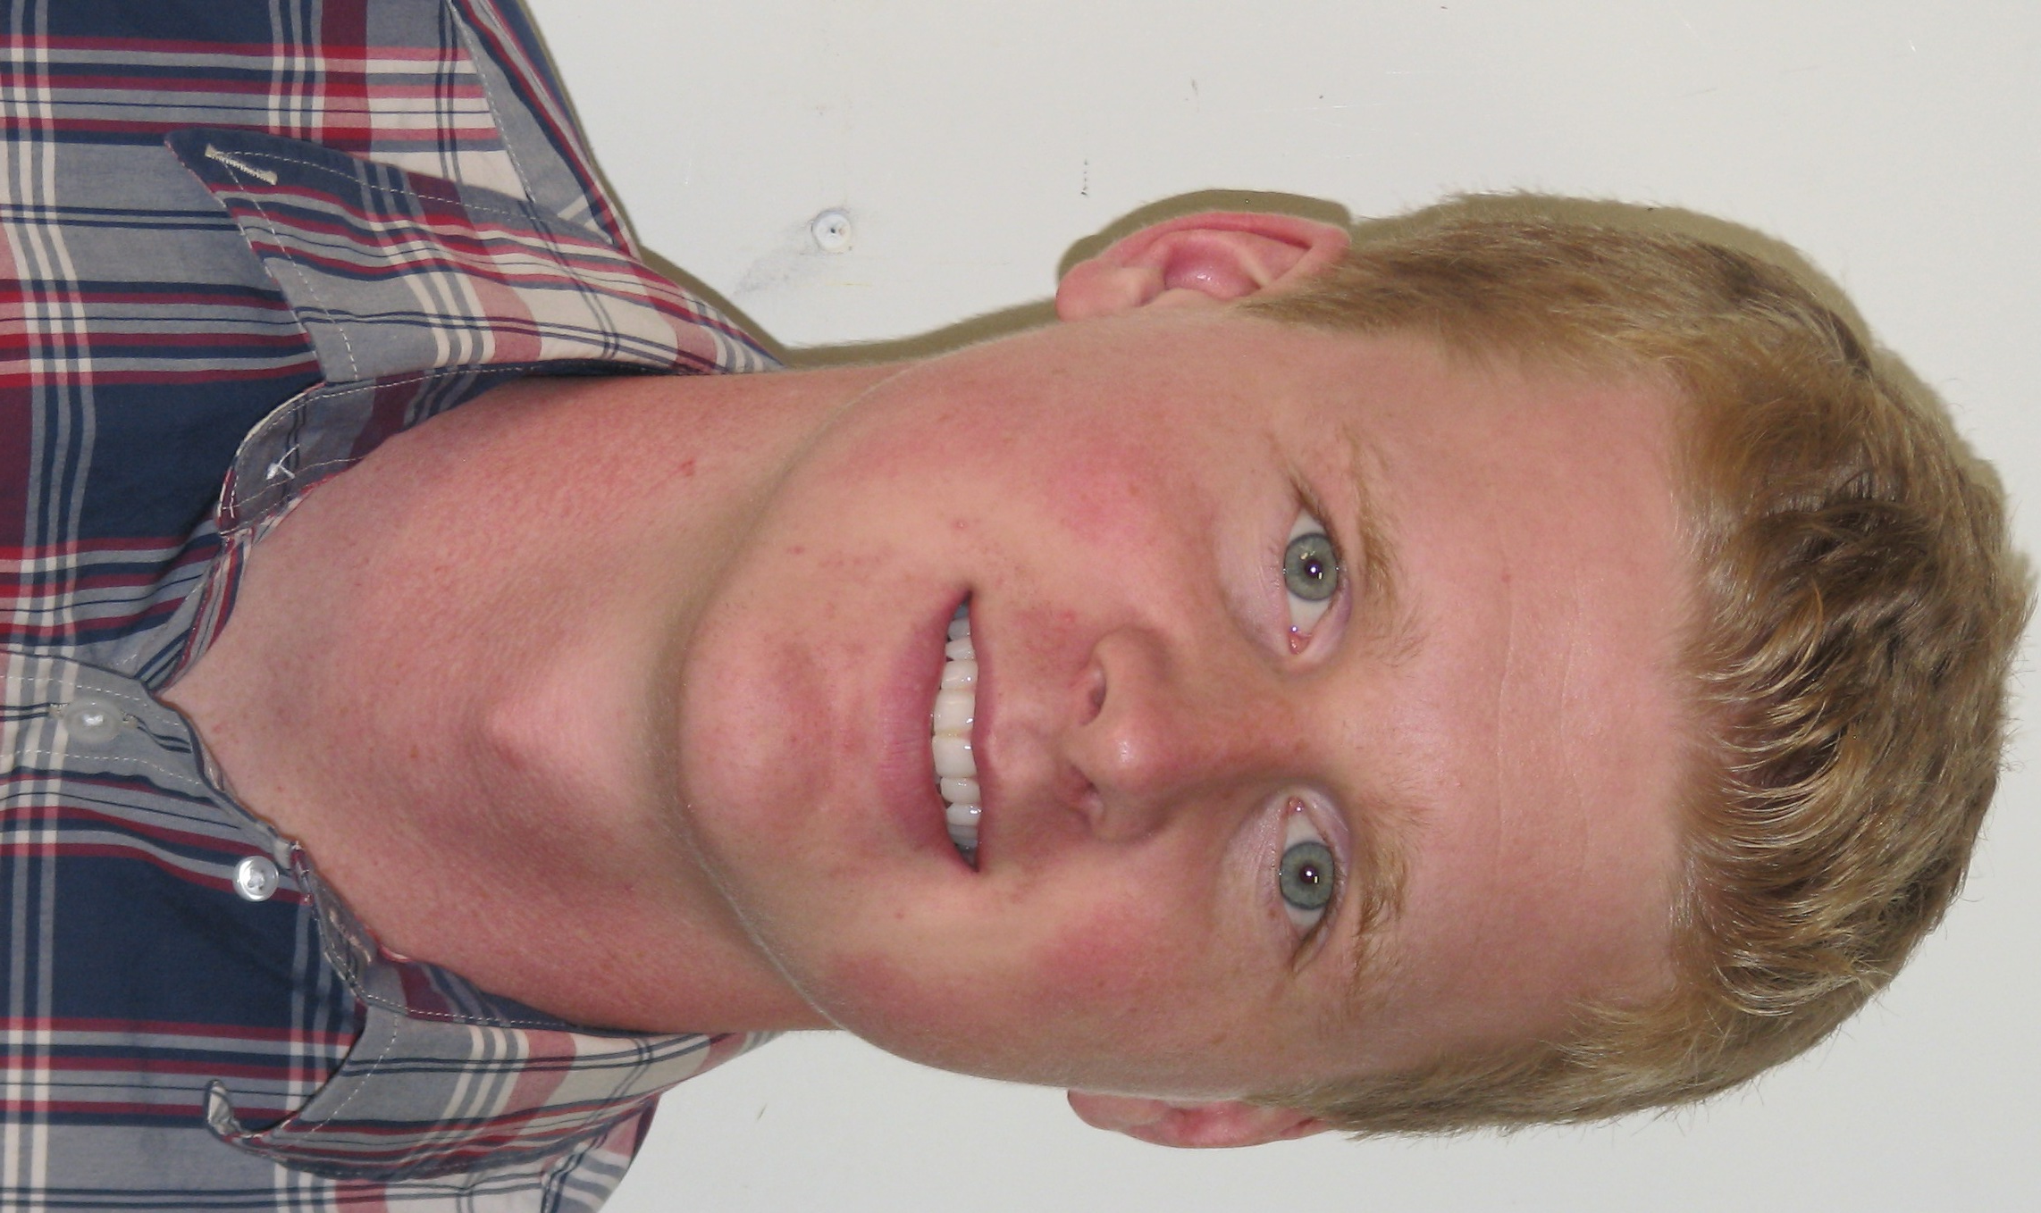
Riley Horgan

Objective To obtain a teaching position in South Korea

Education
University of St. Thomas, St. Paul, MN
Bachelor of Science in Health Promotion, May 2013
Major GPA: 3.43

Related experience
120 hour TEFL Certification (Will be completed on October 1st)

Grandview Middle School, Volunteer teacher, 5th - 7th grade Mound, MN September 2013
- observed teaching methods of several instructors
- assisted with implementation of lesson plan
- worked with students individually and in small groups

MAP South Hockey, Intern Instructor Mendota Heights, MN March - June 2012
Whitehawk Hockey STP, Lead Assistant Mound, MN May - August 2010 - 2013
- Instructed on-ice in proper skating technique, stick handling, and strategies
- Led dry-land training to improve fitness
- Worked with all age groups from peewees through high school (age 8 – 18)

Work Experience
Lord Fletcher’s Old Lake Lodge, Security/Docker Spring Park, MN May - September 2011 - 2013
- Mediated arguments or disturbances throughout the wharf
- Stopped alcohol from entering or exiting the restaurant
- Assisted all bartenders, servers, and bar back personnel when necessary
- Guided boats in docking and leaving the restaurant

General Sports, Sales Associate Edina, MN October 2010 - January 2011
Varsity Sports, Assistant Manager Mound, MN April 2006 - August 2009
- Assisted customers in finding and fitting sports equipment; sharpened skates
- Managed inventory and keeping it organized
- Maintained store to display products in the best possible light for optimum sales
- Displayed excellent customer service skills by responding to customer inquiries and complaints
- Demonstrated sound judgment through management of inventory and restocking of floor merchandise

Extracurriculars
University of St. Thomas: St. Paul, MN
Men’s Ice Hockey, Team Member September 2009 – March 2013
- Honored All Conference (2010-11, 2011-12), Rookie of the Year (2009-10), MIAC All Rookie Team (2009-10)
Health and Human Performance Club, Member September 2011 – May 2013
Mound Westonka: Mound, MN
Varsity Men’s Ice Hockey, Captain (2007-08, 2008-09) 2005 - 2009
- Awarded Team MVP (2006-07, 2007-08, 2008-09), Great 8 Team Minnesota (2008-09), All State Honorable Mention (2008-09), All Conference (2006-07, 2008-09), All Conference Honorable Mention (2005-06, 2007-08), Rookie of the Year (2005-06)

