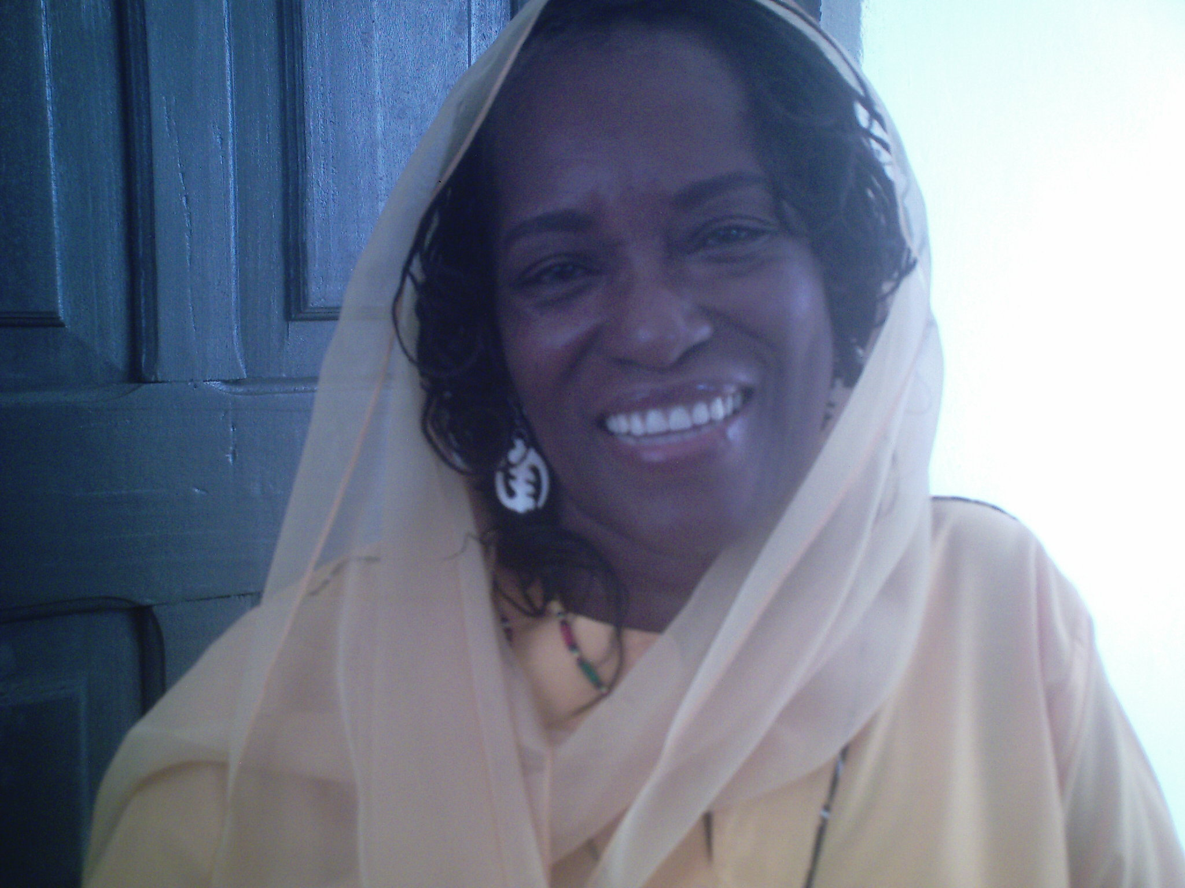
Rita Muhammad
5633 South 5th Drive
Phoenix, Arizona 85041
(323) 947-9918
ritamuh@gmail.com

Qualifications
I am a qualified educator, administrator, case manager, program/project director, contract/grant, and policy/procedure writer. I have more than 15 years of progressive administrative and management experience. I am a curriculum developer, having created numerous curricula, implemented and directed educational programs for students from primary to tertiary level. Additionally, I have coordinated programs in life skills, self-esteem, health education, and teachers’ continuing education seminars. I have written numerous grant proposals and have monitored, coordinated and reconciled numerous grant budgets. I am computer literate, with good written and verbal communication skills and excellent organizational skills.

Education
2000 - 2001 Certificate in Early Childhood Education - Compton Community College
1994 - 1996 Baccalaureate of Arts – Communication - Regis University

Experience
9/2006 – Present – International Foundation of Education & Self-Help – Teachers for Africa Program – Scottsdale, Arizona
Currently living and teaching at Berekum Teacher Training College in Berekum, Ghana, West Africa. Teach 2nd year students how to teach English, Mathematics, Science, and online GPS program.. Manage a Teacher Resource Center where continuing education seminars and workshops are convened for teachers within the Berekum Educational District. Pre-Teachers, mentors, and in-service teachers participate in various workshops that include, classroom management, student program/project management, peer-review observation and supervision, discipline subjects, time management, interactive learning basic ICT, Provide program and project oversight and management of the following programs: Women’s Entrepreneurial Project: Project which assists women who live in poverty to become self-sufficient by making, marketing and selling soap; Youth Association and Conference: Project which bring together youth in Berekum, Ghana with youth in America who are introduced to international business and leadership concepts. The youth corresponds with one another, and the America students visit Ghana and research entrepreneurial opportunities together for the future; Clothing Project: Create and liaison between tailor and seamstress in Berekum with distributors in America to create and purchase clothing for men and women.

Muhammad, Rita
Resume
Page Two

Internet Café: Create, manage and train students to maintain a professional campus internet café for themselves and campus staff and teachers. Prepare students to manage daily operation, maintenance of equipment, and coordination of fees, staffing, etc; HIV/AIDS Peer Group: Assist students to organize themselves in peer education circle for research and peer discussion on HIV/AIDS and STDs.

11/2005 – 9/2006 – State of Arizona - Child Support Enforcement Officer
Dept. of Economic Security – Phoenix, Arizona
Assist custodial and non-custodial parents with issues relating to child support as required through superior court and other official reporting agencies. Additionally, research customer service inquiries regarding government Title IV-D and non-IV-D programs. Use ATLAS and AZTECS computer systems.

11/2002 – 10/2005 - School Director - Circle of Life Development Corporation
Prepare curriculum and lesson plans.. Train all teachers and teacher assistants. Supervise all personnel. Staff Development. Coordinate continuing education seminars for teachers. Conduct research, initiate, write and coordinate the requests for proposals for funding applications and grants. Coordinate fundraising activities and events for child care center and food distribution center. Manage the accounts payable and receivables and manage payroll for non-profit organization.

11//2000 - 8/2002 - Eligibility Interviewer – Los Angeles City Housing Authority
Conduct interviews with tenants assessing the eligibility for low-income, subsidized
housing. Interview property owners/managers to qualify them to provide low-income housing to families. Maintain case management of more than 400 designated clientele. Obtain data on income, family composition, health and social issues. Calculate and negotiation contracts. Assist owners in the proper tenant regulations. Coordinate
landlord/tenant disputes. Update client, both tenant and owner, enter information in computer system and print contract. Evaluate and resolve tenant complaints as they arise. Coordinate and perform voucher issuances informational seminars. This is a large call-center.

12/1995 - 10/2000 - School Director/Teacher - Maryam’s Academy
Owner and operator of a private school for girls, in a very drug-infested, crime-ridden and challenging community of Compton, California. Responsibilities include staff, recruit and train new teachers and other personnel. Coordinate and manage the interview process for enrollment of children. Perform needs assessment and testing for proper placement. Teach Language Arts, Life Skills, Reading, Math, etc. Coordinate various programs: Dance, music, computer, community outreach, equestrian, summer camp program, tutorial, self-esteem workshop, “Just Say Yes” program. Design and
develop curriculum and lesson plans. Maintain payroll, obtain permits, generate city and state regulatory compliance reports, submitting contract and grant applications for funding, maintain state required attendance records, writing policy and procedures manuals and preparing various letters and correspondence. Coordinate weekly staff meetings. Coordinate and facilitate off-site conferences for continuing education. Prepare and conduct parenting classes.

Muhammad, Rita
Resume
Page Three

1985 - 11/1995 - Administrative Specialist - UCLA School of Medicine –
Cardiovascular Research & Surgery Urology
Manage and coordinate all administrative function of a cardiovascular research laboratory. Assist with the submission of several research grant proposals. Monitor and
reconcile grant funds and expenditures and compliance reports. Maintain employee files and visiting research post-doc students. Supervise clinical research students and office clerks. Manage the administrative office for the chief of Surgery/Urology. Coordinate academic, clinical and research practices. Supervise several clerks and international postdoctoral students. Assist with writing medical text books on Cardiovascular Science.

References:

Barbara Ewing, Program Manager – (480) 443-1800
International Foundation of Education and Self-Help
5040 Shea Blvd.
Scottsdale, AZ. 85254
barbaraewing@ifesh.org

Karen Saxon, C.E.O. – (602) 722-5212
Circle of Life Development Corporation
322 So. Cobblestone Drive
Gilbert, AZ. 85296
karensaxon@aol.com

Paige Nubia - (602) 274-1713
1112 Osbourne Avenue
Phoenix, AZ. 90034
Nubiaa1963@yahoo.com

