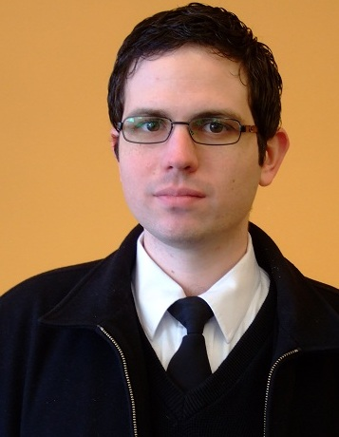

Ryan Stoker

Objective | High School ESL/EFL Teacher
Experience | English Teacher  09/2012-08/2013 Mulgeum Elementary School, Yangsan, South Korea  - Teach English grammar, reading, writing, and speaking  - Develop detailed lesson plans and teaching materials
English Teacher
03/2011-06/2012 American English Center, Zaporozhye, Ukraine
- Teach English grammar, reading, writing, and speaking
- Students age range from 12-70 years old, beginner to advanced
- Create detailed lesson plans for teaching grammar and conversation class
English Teacher
03/2010-03/2011 E-Bo Young’s Talking Club, Gimhae, South Korea
- Taught English grammar, reading, writing and speaking
- Students age range from 5-17 years old
- Helped develop curriculum for the academy
Teacher in Training
09/2007-06/2009 University of Oregon, Eugene, Oregon
- Taught English grammar and writing at the American English Institute
- Internship teaching German at Edison Elementary School
- Developed curriculum as well as that provided by the University
- Worked part-time as volunteer tutor
Geek Squad Computer Repair
07/2008-02/2009 Best Buy, Springfield, Oregon
- Computer repair and sales
- Hardware/Software installation
- Customer service
Education | University of Oregon, Eugene, Oregon  2004-2009  - Bachelor of Arts in German  - SLAT (Second Language and Teaching) Certificate in English and German  - University of Oregon SLAT requires over 400 hours of courses and training  - 4.00 on a scale of 4.00 in all linguistics and language teaching courses  - Dean’s List (students recognized for academic achievement during a semester by the dean of the college)
Interests | Reading, playing board games, and watching movies

