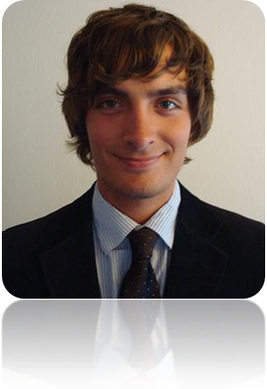
Ryan Gavin Brooks Telephone: (1)-770-401-2062
Email: Ryanbrooks@live.com
Date of Birth: 07/10/1984

Objective
I am currently seeking work as a qualified English language instructor in or around Seoul, South Korea. Teaching and learning have long been passions of mine. Hence, I enjoy the challenges and rewards of teaching not only as a job, but as a fun and creative way to interact with an international class. I have recently finished a one year English teaching contract in Madrid, Spain during which I taught all ages and levels of English. I wish to put my skills and qualifications to use in Korea. I am a hardworking, outgoing, professional and humble person with a great fascination of Korean culture as well as possessing a strong desire to work long-term in the country. I am a University graduate with a four year bachelor’s degree in addition to having attained an English teaching certification from Oxford TEFL in Prague, Czech Republic. I was born and raised in the United States and hence speak and teach American English. I also have a strong knowledge of British English after living for a time in the United Kingdom.

Education
1. Georgia State University - Atlanta, Georgia USA (2003-2007)
Bachelors Degree in History with a Minor in Philosophy

2. Oxford TEFL Prague - Prague, Czech Republic (2006)
Trinity TESOL Diploma and supervised teaching experience

Work Experience
1. Creative English School- Madrid, Spain 2008-2009 (2008-2009 academic year)
Teaching English Classes (First Certificate, All levels, Children and Adults)

2. Freelance Private English Instruction- Madrid, Spain (2008-2009) Maintained a steady group of private courses arranged with students individually and in small groups. English teaching for various levels and ages

3. Legal & General Assurance Society Ltd. – Brighton, England 2008
Personal Pensions, Account management

4. Expotechnik International - Suwanee, Georgia, USA 2007
Corporate Exhibition Designs

5. Edinburgh City Government - Edinburgh, Scotland 2006-2007
Debt collections, Interviews, Council Tax

6. Target - Duluth, Georgia, USA 2005-2006
Customer Service, Sales

7. Barnes & Noble - Irvine, California, USA 2002-2005
Books sales, Customer service

8. Best Buy - Buford, Georgia, USA 2000-2002
Computer Sales, Customer Service

Relevant Qualifications
-TESOL Certification and Bachelors Degree
-Experience teaching English to beginner, intermediate, and advanced level non-native speakers.
-Relevant training in corporate environment, experience with wide variety of businesses in office settings.
- Fast typing skills.
- Love of education, teaching, and working with people.
-Exposure to American and British English with corporate experience in both.

References
Kinga Ghimmesy- Director, Creative English School, Madrid- (34) 91 730 1862 and (34) 659 516 340 Gkreative@hotmail.com
Mathew Millett- Management, Expotechnik America- (001)-678-372-2987 McMillet@bellsouth.net
David Young- TEFL Instructor Prague Trinity Certification- (420)-226-211-900 Tesol@oxfordtefl.cz
Austin Gavin- Management, Legal & General Assurance Society Ltd. – (044) 08452-745007 Austin.Gavin@landg.com

