Salwa Gabr
salwa.gabr@gmail.com

Songdo yeuk , Incheon Nationality: American ,Korean, Egyptian
Cell:010 580 92228

OBJECTIVE:
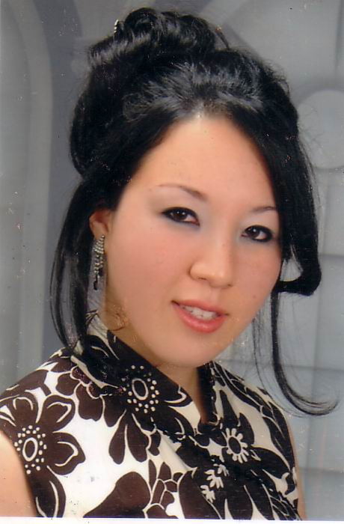
A challenging position in teaching English which will
increase my career in a positive direction.

EDUCATION:

• September 2003 – 2007
Specific Education
Bachelor’s degree in music department
Grade: Very Good

•September 2000- June 2003
El-Nasr Girls College
Senior school

WORK EXPERIENCE:

Worked in Pioneers Language school as an English teacher in 2007 - 2008
Alexandria, Egypt

Tutored English and french in Alexandria, Egypt 2004 – 2010

Tutored English in korea 2010 -2011

Tutored music in Alexandria Egypt 2002 - 2011

Summary of qualifications
- Demonstrate ability to interact and communicate effectively with both children and adults.
- Remarkable and ability to build good working relationships with both children and adults. This includes being able to give respect and understanding to all children and their families, whether their culture background
- Deep interest and joy in working with children .
- Sound knowledge of human behavior and performance; individual differences in ability, personality, and interests; learning and motivation.
- Proficiency at talking to others to convey information effectively.
- Expertise at selecting and using training/instructional methods and procedures appropriate for the situation when learning or teaching new things
- In-depth ability to monitor/assess/remediate student performance

LANGUAGES:
- : English ,Arabic , French, korean

