F&CIRRICULUM VITAE
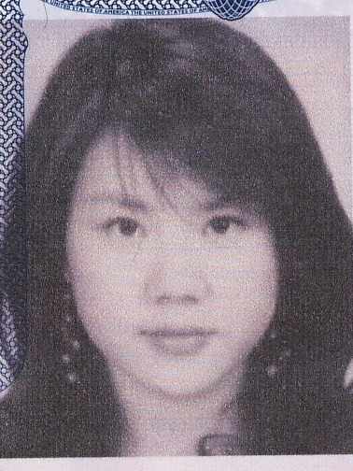
PERSONAL DETAILS
Name: Lena JEONG
Address: 719-10 B05
Ban po dong, Seo cho gu
Seoul Korea
Nationality: New Zealand/American
Mobile: (0082) 010 2579 9044
Email: sodami4u@hotmail.com

Training Course:
New Zealand Management Academy
National Diploma in Hospitality Management
October 2005~ April 2008
Qualifications:
- H.S.I Customer Service C.O.A
- H.S.I Hospitality Operations C.O.A
- L C Q
Penord College of Wine
International Wine advisor

Miami International College
July 2008~ (TO BE COMPLETED)
Bachelor of Arts

Employment History
May 2009~ Present
Brown International School Seoul Korea
Kindergarten / Elementary English teacher.

Jan 2009~ Present
Ritz Carlton Hotel Seoul Korea
F&B Supervisor/ Eden Lounge Manager

June 2008~ November 2008
The Walt Disney Company Orlando USA
Children Educations Promotion Team

September 2006~ April 2008
Stamford Plaza Auckland New Zealand
F & B Senior Attendant Knight Restaurant/bar, Banquets

March 2006~ March 2008
Korean school of New Zealand
Teaching English for immigrants of New Zealand

May 2006~ July 2006
Eureka Film Production Fox Studio Sydney Australia
Unit Manager & Assistant Coordinator (3 Month Overseas Contract)

June 2004~ September 2005
Grand Hyatt Hotel in Seoul Korea – Front Desk Assistant/Banquet Attendant

Other Educations:
Travel Careers Training
National Certificate in Travel and Tourism
March 2004~ September 2004

2002~2003 Dive HQ North Shore Professional PADI Diving School
International PADI Open water license
International PADI Advance Open water license
International PADI Rescue Diver license

Relevant Skills:
Languages
- Completed Japanese (Part3) Course at Private institution in Korea
- Native English and Korean

Computing
- Competent user of Microsoft
- Adobe Photoshop
- Studied ‘IT for Hospitality’

First Aid
- Currently completing NZQA First Aid Certificate

2005 School of Food and Beverage Arts and Design
- Create garnish designs for Food and Beverage
- Creative coffee making, designing patterns for coffee garnish
- Herbal tea studies

Interests:
- Snow boarding
- Wake boarding
- Scuba diving
- Travelling around the world

Verbal Referees

Peter Fullerton
Fulma International
Contact Details: 09 410 2680
Fulma@clear.co.nz

John Lee
Eureka Film Production Fox Studio Sydney Australia
Contact Details: 0061 422845632
Eureka@hotmail.com

