CURRICULUM VITAE
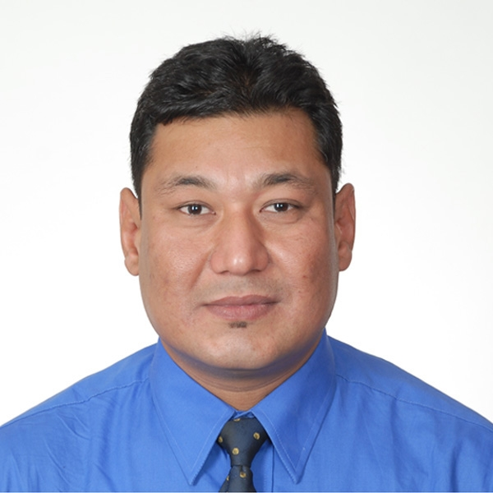

Name : Sushil Kumar Muna

Mailing Address : Sushil Kumar Muna
College of Commerce
Building No# 2
MIS Research Centre, Room No# 104
Chonbuk National University
P.O.Box # 561-756
Jeonju, Republic of Korea

E-mail ID : sushilmuna@hotmail.com

Contact Address : Sushil Kumar Muna
MIS Research Centre
College of Commerce, B.No# 2, Room # 104
Chonbuk National University, Jeonju
Mobile: 82-10-5833-3331

Nationality : Nepali

Date of Birth : 25th September 1970

Marital Status : Married

Publications 1. Kim, S.W., Muna, S.K., and Kang, H.T., 2007, “Understanding consumers intention to use mobile payment service: The Prospective of university students,” Review of Business & Economics, 20(4), 1739-1766
2. Muna, S.K., Kim, S.W., and Kang, H.T., 2008, “Predicting consumers’ intention to continue mobile Internet services usage: The integration of habit into the Expectation-Confirmation Model,” Korean Association of Business Education, ISSN: 1598-8651

Research interest Electronic commerce, Internet technologies usage and its effect on relationship of business organizations

Thesis Title Exploring the Role of Internet Technologies in the Collaborative Business Relationships Between Organizations & Their Suppliers

Education/ Qualifications

2004-2009 Chonbuk National University: PhD in Management Information System
1996-97 Mahendra Multiple Campus (TU): Master’s in Economics
1994-95 Mahendra Multiple Campus (TU): Bachelor’s in Management

Employment to date
2008/03- 2009/08 Part-time Researcher (Paid), Research Institute of Industry & Economy

Responsibilities:

-Conduct social or economic surveys on local, regional or national areas to assess development potential and future trends.
-Plan development projects and co-ordinate activities with representatives of a wide variety of industrial and commercial enterprises, community and business associations and government agencies.
-Review and evaluate commercial or industrial development proposals and provide advice on procedures and requirements for government approval.
-Conduct surveys and analyze data on the consuming habits and preferences of consumers.
-Evaluate customer services
-Prepare reports, research papers, educational texts or articles.
-Plan and develop e-commerce strategies.
-Provide consultation on planning and starting of new businesses.

2005/12 -2007/12 Part-time Researcher (Unpaid), Research Institute of Industry & Economy, Chonbuk National University, Jeonju, Republic of Korea.

2004/08-2007/08 Teaching Assistant (Paid), Chonbuk National University
College of Commerce, Jeonju, Republic of Korea

Responsibilities:

-Teach undergraduate students using a systematic plan of lectures, demonstrations, discussion groups, seminars, case studies, field assignments and independent or group projects.
-Implements instructional activities that contribute to a climate where students are actively engaged in meaningful learning experiences.
-Identifies, selects, and modifies instructional resources to meet the needs of the students with varying backgrounds, learning styles, and special needs.
-Assists in assessing changing curricular needs and offers plans for improvement and supervise independent or group assignments.
-Maintains effective and efficient record keeping procedures. For that, prepare administer and mark tests and papers to evaluate student’s progress.
-Provides a positive environment in which students are encouraged to be actively engaged in the learning process.
-communicates effectively, both orally and in writing, with students and other professionals on a regular basis.
-Collaborates with peers to enhance the instructional environment.
-Ensures that student growth and achievement is continuous and appropriate for subject area and program classification.
-Advise students on program curriculum and career decisions.
-Assumes responsibility for meeting his/her course and university-wide student performance and goals.
-Demonstrates gains in student performance and provide individualized tutorial or remedial instructions.
-Participates in training, presentations about online teaching and supervise teaching assistants.
-Meets professional obligations through efficient work habits such as: meeting deadlines, honoring schedules, coordinating.
-May provide consultation services to government, business ventures and other organizations.

2004/05-2006/12 Part-Time Management Coordinator, Pro-Power Communication Co. Ltd.
Bong-dong, Korea

Responsibilities:

-Maintain regular office hours.
-Work effectively with office staff and board; communicate freely and openly with other staff to support office activities.
-Communicate clearly, provide constructive feedback to others receive constructive feedback from others, and address conflict in a respectful and constructive manner.
-Prepare and deliver written reports on work activities to the Board of Directors one week in advance of Board meetings.
-Develop and manage operation systems as needed.
-Manage relevant information technology systems.
-Support and assist other staff’s work to ensure success of the staff collective.

2003/12-2004/03 Cashier in Account Department, Casino Tara (Hotel Hyatt Regency)

Responsibilities:

-Receiving and paying out money and keeping records of exchange transactions in the casino.
-Provide customer assistance through the exchange of various types of monetary notes, coins, credit and casino chips and helpful information.
-Responsible for smooth, efficient and accurate monetary exchange.
-Required to maintain cage security as well as well as accuracy of various reports regarding authorization forms, reconciliation of transactions and exchange summary reports.
-Provide excellent customer service by assisting and providing helpful information.

2000/11-2004/02 Night Auditor, Radisson Hotel Kathmandu, Nepal
(One of the joint venture of Radisson Hospitality Worldwide)

Responsibilities:

-Verified and balanced entries and records of daily financial transactions reported by hotel departments.
-Closed and balanced all occupied rooms account/voucher and analyzed out-of-balance situations.
-Balanced cash drawers, credit card receipts, direct bills and all other incoming payments.
-Completed bank deposits for cash transactions and prepared the month end reports.
-Made reservations over telephone, and ensured the customers were made aware of the hotel and its policies.
-Obtained all pertinent guest information, and ensured credit was established before check-in.
-Received and forwarded telephone calls to the designated extensions.
-Made sure the shift intake was balanced before cashing out.

Skills Computer literature: familiar with a number of design and DTP computerized, Fidelio (6.5), Management Package, SPSS (14 ver.)

Interests Singing, entertaining friends/ new cultures, traveling, reading research articles

Language Proficiency

Fluent in English, Korean, Hindi, Nepali, Awadhi

Date: 27 December, 2009.

