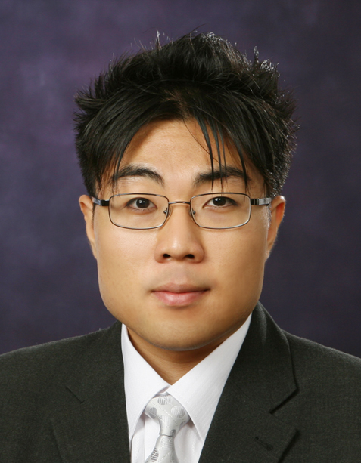
Sam S.K. ShiN
Education
Tyndale University College and Seminary (2012 – 2013)
Bachelor of Education

Wycliffe College, University of Toronto TST (2010 – 2012)
Master of Theological Studies

University of Toronto (2004 – 2008)
Honors B.A. : Joint Specialist in English and Linguistics

Summary of qualifications
- TRIBES Classroom Management Certificate
- Classroom Assistive Technology Certificate
- TESOL / TESL Teaching Certificate
- TOEFL / TOEIC Teaching Certificate
- RCM Level 5 Piano Certificate

Work experience
[July 2011 – June 2012]
Wycliffe Development Office – Alumni Liaison

[March 2012]
Wycliffe - ARISE Student Leadership Camp

[September 2011 – December 2011]
Wycliffe Reading Course Media Supervisor

[August 2010 – July 2011]
SEL Academy – TOEFL instructor

[ July 2008- August 2009] JeonJu, South Korea

SK Telecom (July 2008 – January 2009)
Blue Ocean Academy (October 2008 – August 2009)
Paul Church Daycare (April 2009 – June 2009)
Jeolla Buk-Do Sports Program (May 2009 – July 2009)

[ October 2003 – May 2008 ]
University of Toronto Toronto, Canada

- OISE - ESL Infusion Team (work-study) (Oct. 2007- May 2008)
- Linguistics Database Manager (work-study) (Oct. 2003 – April 2007)

Volunteer experience
- Windfields Junior High School – ESL Specialization (June 2013)
- Erindale Secondary School – Literacy Workshop (March 2013)
- Windfields Junior High School – Placement (Jan – May 2013)
- Silverstream Public School – Placement (Sept – December 2012)
- Young-Nak Church Hi-C grade 7 boys teacher (September 2009 – June 2010)
- Young-Nak Church EM Media team member (2008 – current)
- Ezemiah Camp 2008 - English Teacher (July 2008 – August 2008)
- University of Toronto Professional Essay Writing Center (editing) (2003 – 2008)
- Assistant English Teacher Overseas (2003 – 2005) – (South Korea)
- Young-Nak Church Saturday School Safety Supervisor 1999 - 2003)
- AWANA English teacher – Grades 1-6 (2001 - 2004)
- York Mills Collegiate ESL-A/B assistant teacher (2001 - 2004)
- Day-Care Babysitting (2001 – 2003)
- Missions Translator – The Growing Church (2000, 2001, 2003)
- Zion Heights peer-tutoring program for ESL (1998 – 2001)

Community activities
- AWANA St. James Town (September 2011 – current)
- York Mills Collegiate ESL Program (September 2009 – June 2010)
- Toronto City Mission – Tutoring Program (September 2009 – June 2010 )
Languages
English, Korean, basic French, currently studying Mandarin
Skills
- good interpersonal and communication skills
- optimistic, friendly, courteous
- willing to learn and learns quickly
- committed and punctual

Hobbies
Sports, Reading, Writing, Traveling, + hobbies acquired through interests
Interests
Interested in trying new things to gain experience and expand perspectives
References
Available Upon Request

