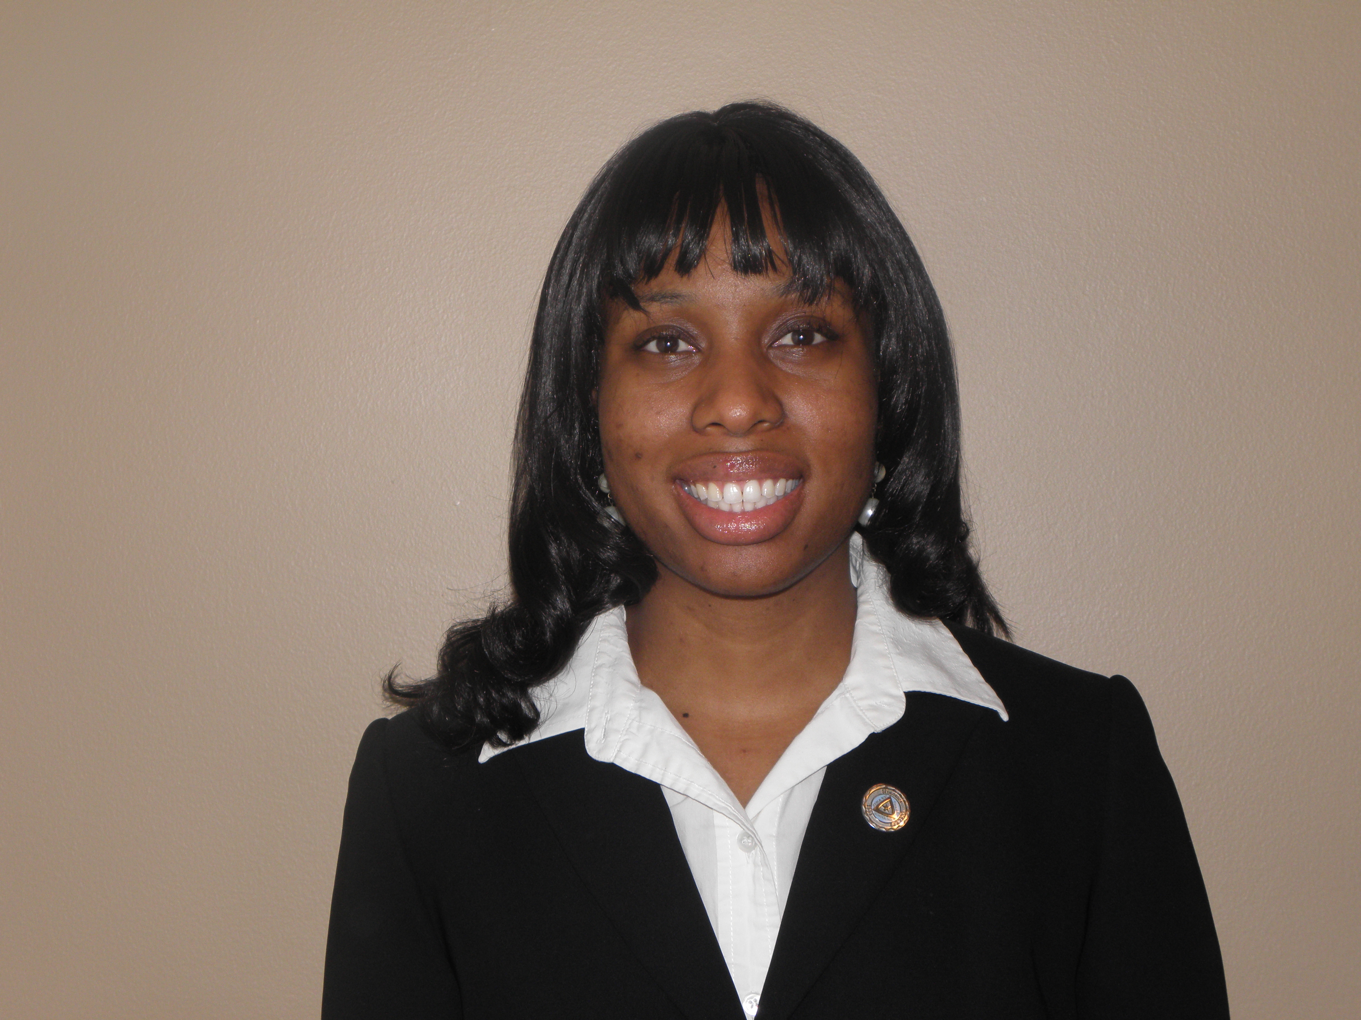
4781 Fieldgreen Dr, Stone Mountain, GA 30088
404-307-0204
Samanthahouston08@gmail.com
Samantha Houston
Objective
To obtain a job as an ESL teacher in Seoul, South Korea or the surrounding area at a private institution.
Experience
2009-2011 Peace Corps Volunteer Mali, West Africa
Environment Volunteer
- Taught English in the village secondary school
- Taught village about basic health and hygiene
- Taught villagers basic computer skills
Summer 2008 Howard Hughes Summer Program Atlanta, GA
Tutor and Mentor
- Preformed as a lab assistant in the science labs
- Mentor high school seniors interested in science
- Tutored the students in math, science, and lab techniques.
Spring 2008 10,000 Girls Initiative Senegal, West Africa
Volunteer
- Mentored and tutored young girls in the program
- Raised money to buy supplies for a local library.
- Helped to build a foundation for the library.
2006-2008 Student Health Associates and Peer Educators Atlanta, GA
Volunteer
- Trained on subjects of health and education.
- Taught local communities about health and education.
- Organized events to raise awareness.
Education
2004-2008 Spelman College Atlanta, GA
- B.S. Biology
- Minor: Environmental Science
Core Competencies
Creative Lesson Planning, Classroom Management and Discipline, Learner Assessment, Testing/Scoring, Computer Literacy, Oral Presentation, Positive Attitude, and Open Mind

