Defender Lane, redcliffs • christchurch 8081 • new zealand
PHONE mobile: (64) 3 3840403 • E-MAIL SEBWHO@GMAIL.COM
Sebastian Karl Vilhelm Enberg
Profile and Objective
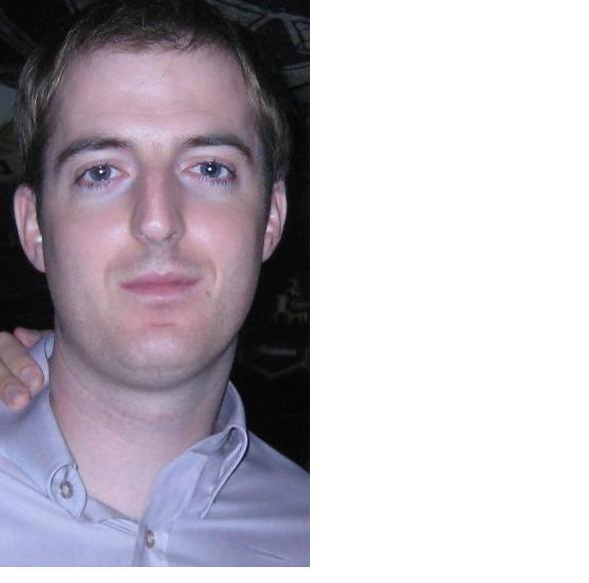  NEW ZEALANDER  MALE  28 YEARS OLD | I am a dedicated, experienced and dynamic English teacher, born and raised in New Zealand, but with a thirst for a teaching position in Seoul, South Korea.  My experience is diverse. I have worked with businessmen and professionals, airline crew, university/IELTS students and children.  My most recent post was with the reputable New Zealand Centre for Culture and Education in Seoul, South Korea, where I played a leading role in curriculum development and student retention strategizing.  Also, I held an instructional and advisory position with China Eastern Airlines, Korea. Here, I trained cabin crew in communication, occupational terminology and cultural affairs. I was responsible for developing the company’s curriculum.  My ambition is to be living and teaching in Seoul region. I hope to become fluent in Korean. I bring an unparalleled degree of enthusiasm, cultural sensitivity and professionalism to my teaching. I am confident that I will be a valuable and vital asset for any employer and my diverse experience ensures that I will be a popular, respected teacher amongst students.
University Education
[ 2005 – 2008 ] Victoria University, School of Government Wellington
Master of Strategic Studies, majoring in Intelligence and Diplomacy
[ 1998 - 2003 ] University of Canterbury Christchurch
Bachelor of Music with Honours, majoring in Composition

experience personal skills and abilities
[ 2007 – 2008 ] English Teacher, New Zealand Centre for Culture and Education, Seoul, Korea –
[ 2007 – 2008 ] Educational Advisor, China Eastern Airlines, Seoul, Korea
[ 2006 – 2007 ] English Teacher, Seoul University of Foreign Studies, Yeoju, Korea
[ 2003 – 2005 ] Professional and Private English Teacher, Christchurch, Canterbury.

TEAMWORK AND INDEPENDENCE – My positions with the New Zealand Centre and China Eastern Airlines necessitated varying degrees of collaboration and independence.
NZC demanded a high level of interaction and synchronization with fellow teachers and Korean administration staff, as the NZC’s identity was firmly linked to its syllabus and ‘teaching style.’
In contrast, my China Eastern Airlines position required a high degree of autonomy. As the sole Western ESL teacher, I was responsible for the style and direction of the curriculum which served to address occupational demands. Also, I provided detailed feedback and progress reports to students and management on a daily basis. I played a key role in the interviewing and hiring of new crew members during the 2007 intake.
COMMUNICATION – I place great emphasis on maintaining clear, constructive and sensitive communication between colleagues and students. I believe this to be vital for student satisfaction and retention. Thus, I make a concerted effort to ensure the needs of the student and employer remain complementary.

Second Languages
Arabic (Modern Standard) – currently studying, and aiming to be fluent in both spoken and written disciplines
German – to an intermediate level, and easily ‘refreshed’

travel experience
Korea – one and a half years living and working.
Japan – ‘Youth Ambassador’ at Kurashiki Sister City Festival
United States of America – living and working as a ski instructor, California/Nevada
Europe – extensive recreational travel – I am a citizen and passport holder of Sweden (as well as New Zealand)
Further travel throughout SE Asian, China, Hong Kong, Australia, Pacific Islands, Mexico, Egypt

THANK YOU FOR YOUR TIME AND CONSIDERATION.
Sebastian K. V. Enberg

