RESUME

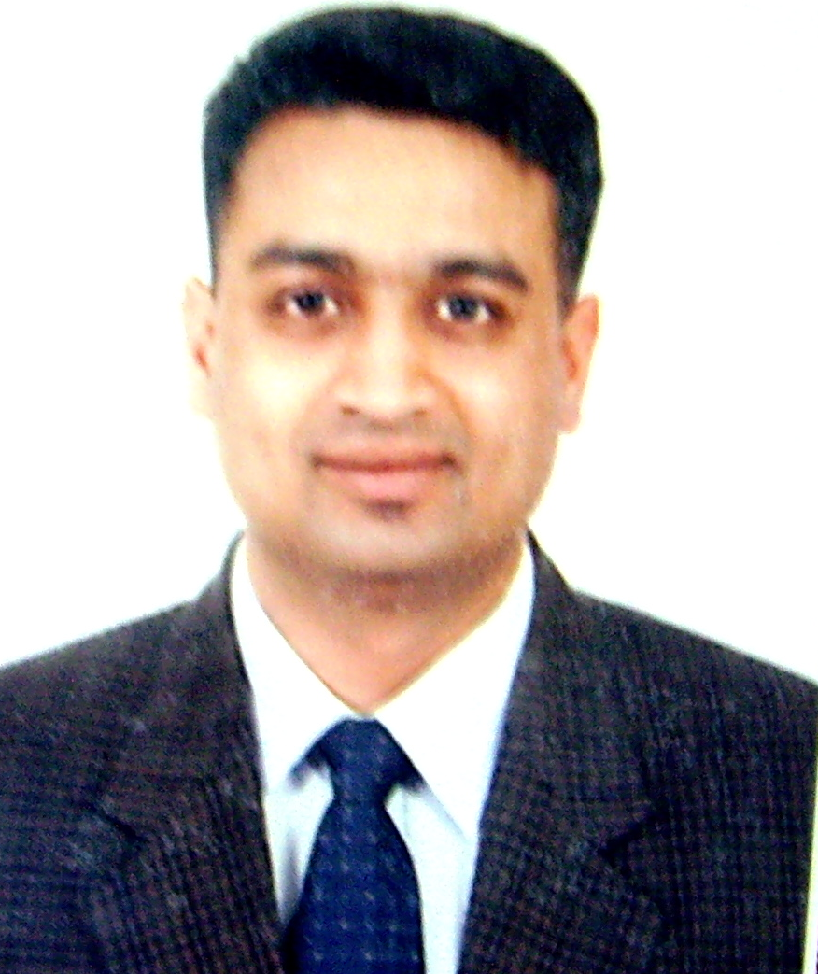

Shah Hussain
Date of Birth: August 10, 1975
Visa Status : F-2-1

Apt. 5th floor, 155-15, Shindang-5-dong, Jung-gu, Seoul
Cell. 010-2340-2796 / Home : 070-7574-2796
E-mail: englishvillage@hotmail.com

TEACHING POSITION SOUGHT

WORK EXPERIENCE

Since July 2009 to Seokgwan Giant English Center, Seokgwan Elementary School on the English Conversation
August 2009 for beginner’s and intermediate class.

Since November 2007  to May 2009 | English teacher at KTX Kwang Myoung English Village, Kwang-myoung City, Kyonggi-do  -Animating workshops for Kindergarten, Elementary School and Middle School students: simulating conversations in real life situations: supermarket, restaurant, bank office, hospital, police office, fire station, or immigration center ;  - Instructor for hands-on activities such as: painting & modeling, pastry making, furniture making & doll-making ;  - English camp animator at Jeollanam-do Kwangju (sport events, group games, campfires)
Since 2005 until now | - Domestic trading in South Korea : clothing, accessories, electronics & machineries
Since May 2005  to September 2007 | - Sale manager at Alibaba Accessories (importing and selling of Indian clothing and accessories) – Dongdaemun Theot wholesale plaza, Seoul
1997 to 2004 | - Trader in electronics & computer accessories. Exporting from South Korea to Pakistan
1995 & 1996 | - Trader in textile industry at Petunam, Thailand : exporting clothing and accessories from Thailand to Pakistan  - Regular business trips to Hong-Kong & Malaysia

EDUCATION

August 1993 | Provisional Certificate by Lahore Technical Training Center - Major in Electrotechnics
May 1993 | Training in Domectic Refregiration & Air Conditioning at the Punjab Board of Technical Education of Lahore, Pakistan
December 1992 | High-School Degree in Science (Mathematics, Physics, Chemistry & Biology)

ADDITIONAL INFORMATION

Native languages | English & Urdu (language of education in High-School & Training centers)  - Business English for International trade  - Technical English for electronics and textile industry
Foreign languages | Korean (advanced level)  - Working language for business in Korea)  - Language of communication with my wife  Hindi & Punjabi (languages of travel in the South-Indian Continent)
Favorite English  textbooks | -SDA Language Institute, You Too Can Speak English, Sijosa, Seoul, 1996  -Murphy Raymond, Basic Grammar in Use, Cambridge University Press, 1993  - Basic English, Man to Man English Education
Community involvement | Attending Bible study classes : history & geography of biblical lands
IT Softwares | Powerpoint, Word, Excel, Hangul
Sporting activities | Cricket, Hockey & Badminton

