Shane Mulvey  DOB: 11 August 1976  Hyekwang Happytel, A-104, 26-6 Seongwal-li  Seonghwan up Cheonan Chungnam  Cheonan, South Korea 330-800  Phone: 82 010 4164 8385  E-mail: ShaneMulvey@gmail.com | 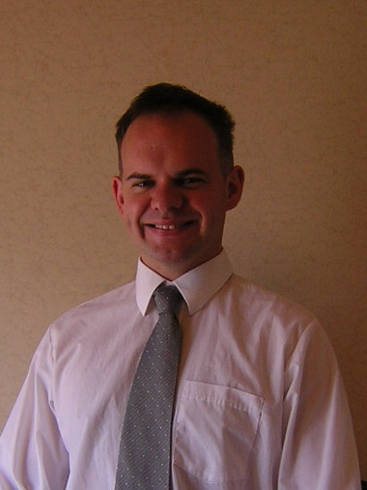

March – Present | Regularly volunteer teach in intercity schools where funding for teachers is not available.
Feb 08 - Present | Native English Teacher for Daehung, Doha, and Singa Elementary Schools. Seonghwan, South Korea.  Teach English in three different elementary schools in a rural, disadvantage school district.  Teach regular school program and coordinate after school program.
Aug 07 – Feb 08 | English Teacher, teach English classes to elementary through middle school students. Suwon, South Korea
Apr 06 – Sept 06 | Bar worker, Galway, Ireland.
Sept 05 – Mar 06 | English Teacher, teach English classes for ages Kindergarten through to middle school. Takamatsu, Japan.
July 05 – Sept 05 | English Tutor, Tutor English students from Spain. Galway, Ireland.
2001 – 2005 | Science Tutor, National University of Ireland, Galway. Part time science tutor.
July 04 – Sept 04 | Laboratory Assistant, National University of Ireland, Galway.
Jan 04 – June 04 | Fruit picking work across Australia.
 | English Tutor, Part time.
Sept 03 – Dec 03 | Shop Assistant, Hasty Tasty, Manigrida, Northern Territory, Australia. General store keeping duties and cash handling.
 | Child-care, Manigrida, Northern Territory, Australia. Took responsibility for Syme family’s two children, aged 2 and 7. Responsibilities include maintaining daily routines, educational activities, and general safety and well being.
May 03 – Aug 03 | Painters Assistant, Oak Ridge Tennessee, USA.
May 02 – Sept 02 | Bar Worker, Ballinrobe, County Mayo, Ireland.
Skills Profile:
Language Skills | Native English speaker.  Can speak Spanish to Intermediate level.
PC Skills | Good knowledge of Microsoft Word and Excel.  Knowledge of Internet Explorer and Firefox  Typing speed of 60 words per minute.
Driving License:  Education: | International driving license.
Feb 25 – Feb 29 08 | New Native English teachers orientation program Chungcheongnamdo Office of Education, Daejeon city, South Korea.
June 07 to Aug 07 | Certificate in Teaching English as a Foreign Language (TEFL),  www.onlinetefl.com.
Sept 01 to June 05 | B.Sc. (Applied Physics), National University of Ireland, Galway.
Graduated June 2005 with honours.
Optoelectronics, Microelectronics, Digital Signal Processing,
Communications, Radiation, Environmental Science, Medical Physics,
Thermodynamics and Computer Networking.
1999 to 2001 | Higher Certificate, (Physics and Instrumentation), Galway  Institute of Technology, Galway Ireland.  Graduated June 2001.
1990 to 1995 | Leaving Certificate (High School Diploma)  Ballinrobe High School, County Mayo Ireland.
Hobbies | Reading books, fishing, soccer, traveling, photography and listening to music.
Referees: | Provided on request

