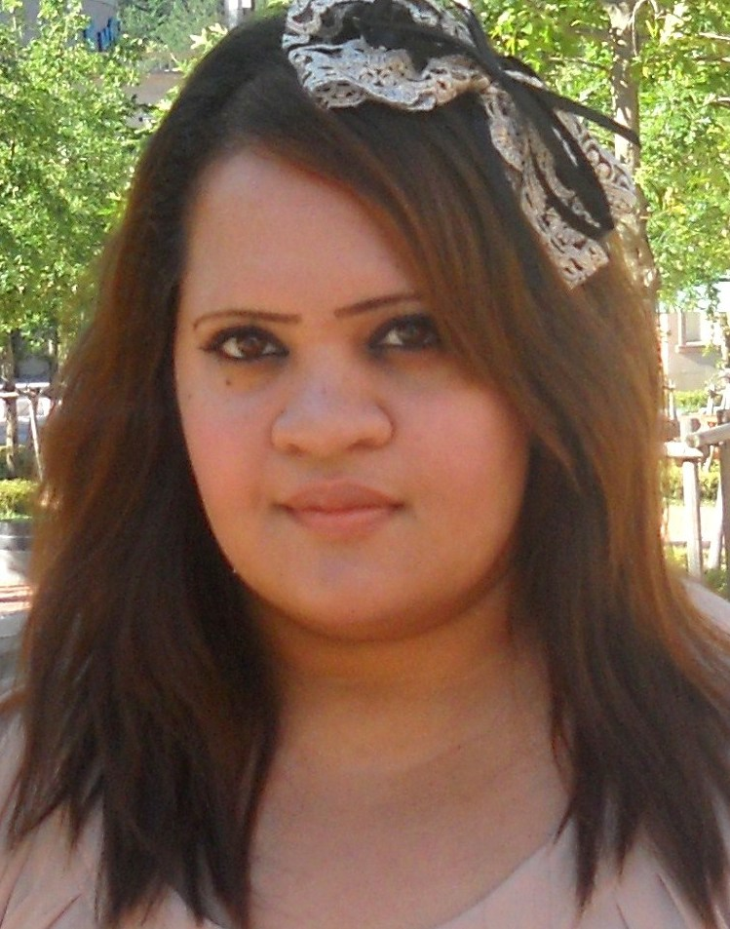
Shelley-Ann Ramsaroop

SKILLS:

-Excellent interpersonal, communication and networking
-Excellent with all levels of ability
-Outgoing, creative and fun
-Strong analytical ability with exceptional attention to detail
-Tactful and results oriented
-Mature, Trustworthy and Dependable

EDUCATION:

2006 Bachelor's Degree- University of Toronto St. George Campus Maj.: Equity Studies/ Min. Anthropology

2006 E-Certificate for Career Learning and Training, Career Center at the University of Toronto

2007 Attended Mini-Medical School, University of Toronto, Faculty of Medicine

February 2013 International TEFL and TESOL Training
TEFL Teaching English as a Foreign Language- 100-hour certificate.

WORK EXPERIENCE:

June 2013-August 2013 (Summer Camp)
Seoul English Village Suyu Campus, YBM Education
Teaching of Korean Kindergarten, Elementary and Middle School Students. Teaching Russian Elementary to College age students. Situational and Theme Based Classes. ESL Text Book classes. Curriculum development and Programming.

June 2010- October 2012 (Summer camp contract plus two full years)
Gyeonggi English Village Yangpyeong Campus
Teaching of Kindergarten, Elementary, Middle, High School and Korean Military (ROK) students. Homeroom After-school program teacher. Theme English Classes and Power Speaking for various five day, two week intensive programs as well as camps. Substitute teacher for Russian Student Camp. Worked with children and adults with special needs as well as Orphanage homes in special “Teach-Away” program. Curriculum development.

Nov 2008- Nov 2009
Y.E.S. Come and Play English Centre (Anyang, South Korea)
Homeroom English Teacher in the English Village
Summer and winter camp teacher.
Curriculum development for Y.E.S Come and Play English Centre

2007- 2008
UCAN T & G formerly New Zealand International School (Jeonju, South Korea)
Kindergarten (Ages 3-7) and Elementary School Teacher (8-14)
Prepared and executed professional lessons in accordance with the school scheme
Implemented weekly timetables and student portfolios
Evaluated student work; reports for parents and conducted interviews.

2007
Wanmar Consulting Inc.
I am a Freelance Editor/Writer working from home on articles and editorials for web content. The content consists of 500 word documents needing spelling, grammar and content correction.

VOLUNTARY:

2007-Januray 2008 Hyo Sa Rang Family Hospital
Volunteer (twice a month, Jeonju, Korea)

2007-January 2008 Hyo Sa Rang Jeonju Hospital
Volunteer (twice a month, Jeonju, Korea)

AIDS 2006 - XVI International AIDS Conference Time to Deliver
Worked with logistics, planning and hospitality. I was also a Toronto Ambassador to delegates.

Saint Columbus Centre
Worked in the Elderly Person Centre where I assisted in activities, crafts, records clerk and companionship.

Dante Alighieri Academy-Peer Tutor
I assisted and taught both large and intimate groups. As a peer tutor, my primary role was to assist students with learning difficulties in various subjects. Many of the students included both ESL and native speakers of English.

Sisters of the Good Shepherd
Office work, priced merchandise, filled shelves with goods, shipping and receiving. Through this organization, I worked with the understanding and the promotion of awareness of cultural societies and global issues.

St Alphonsus Day Care
Supervisor for children during play, activities and nap time.

INTERESTS:

Travel, cultures, spirituality, nature, animals, reading, learning, alternative health and medicine, ancient teachings and cooking.

REFERNCES in KOREA:

Manager of Education Department, Yangpyeong English Village , Jo Shin-Jong 010-8399-0877
After-School Manager, Yangpyeong English Village, Kim Mi Hyoun 010-9423-2564
Former Principal of UCAN T&G, Oh Kap Taek 011-653-2897
Former Manager at UCAN T&G, Ra Wan Sik 010-5635-5805

