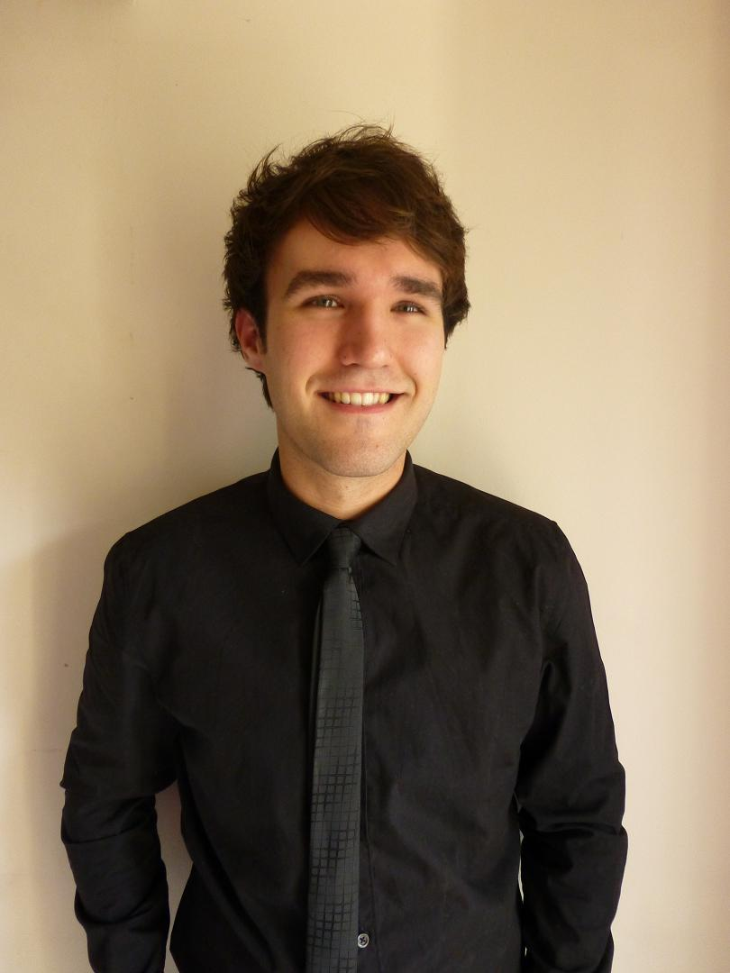

S I M O N L A S S E N
1 HILDEGARD PL • BAULKHAM HILLS NSW 2153 • AUSTRALIA
MOBILE 0448 003 096 HOME (02) 9680 3848 • E-MAIL LASSEN.SIMON@GMAIL.COM

CURRENT OBJECTIVE
To teach in Korea for another year and continue my experience of a whole new culture, language, and level of independence that I believe will make me a better person and help my future career prospects. To improve as a teacher and teach children to the best of my abilities

EDUCATION
2008-2011 Bachelor of Economics - Majoring in Economics & Marketing
University of New South Wales (UNSW).
- Received my Bachelor’s Degree on March 12th 2012
- Distinction in Marketing Research
- Studied Italian as a Secondary Language
- Extensive group work in all Marketing-related subjects

2002-2007 Baulkham Hills Selective High School
UAI: 87.05
English (Advanced), Mathematics (Advanced), Economics,
Mathematics (Extension 1), Biology, Physics

EMPLOYMENT HISTORY
Apr 12 – Mar 13 Kindergarten Teacher in Korea
Bambini Mokdong
- Taught children from ages Four to Seven (Korean Age) in Science, Reading and Art.
- Completed Lesson Plans each and every week, and attended weekly meetings with our supervisor.
- Ate lunch with the children and cleaned my classroom each day.
- Completed quarterly student evaluations.
- Supervised the children on monthly field trips, including one Saturday field trip.
- Assessed each student’s performance for Parent Teacher interviews.
- Attended quarterly training sessions for my designated subject (CDP) at the Hannam Bambini branch.
- Helped to train the new employee who would be taking over my subject for the new year.
Aug 11 – Feb 12 Assistant Accountant
Atlas Copco Australia
    - Completed Inventory, Fuel, Phone & Electricity expenditure reports every month, and scrutinized any questionable figures
    - Analysed company credit card bills and signed off on them so they could be processed.
    - Wrote a guide on how to extract phone bill information, as the company had just introduced new software that held all the information and it was unfamiliar to my co-workers, so I used trial and error to figure out what information was needed and how to get it, whilst recording my findings along the way
    - Created tax invoices for customers and sent them out to receive payment
    - End of month reporting to a strict deadline
    - Attended various meetings and completed volunteer stocktake

Feb 11 – Apr 11 Marketing Team Leader
Student Marketing Australia
- Was chosen from 6,000 applications, which was whittled down to just 300 through a comprehensive interview process
- Successfully completed training at Fairfax Media in order to be fully equipped to undertake their Sydney Morning Herald campaign for 2011
- Formulated a Marketing Campaign for ‘The Sydney Morning Herald’ that would appeal to students at the University of New South Wales
- Successfully worked as a team of three to communicate with on-campus newsagencies and sell annual subscriptions staff and students
- Was one of three teams to have our campaign duration extended due to the successfulness of our campaign and the level of sign-ups we received
- Was the recipient of a special reward from Student Marketing Australia for going above and beyond what was required of me by making an original song & video for our campaign.

Jul 08-Dec 10 Sales Assistant
David Jones, Parramatta
- Completed in-house customer service training course
- Trusted with inducting new employees into the workplace by showing them the functions and assets of the business
- Consistently met & exceeded monthly sales targets
- Received a ‘Thank You’ letter from a family for going out of my way to make sure they got the product they were looking for
- Assessed by a secret shopper who completed a survey based on my performance, achieving a final score of 94%; one of the highest results of the year and featured in the monthly national David Jones newsletter.

KEY ACCOMPLISHMENTS, SKILLS & INTERESTS
- Accomplished user of Microsoft Word, Excel, SPSS [Statistical Analysis Software], MATLAB, Adobe Photoshop Pro, Sony Vegas Pro, Windows Movie Maker
- Election Official for the 2011 State Election – responsible for helping run a tight operation during the polling day.
- My interests include: classical literature, art, learning languages (especially Korean), independent and alternative music and live performances, tennis, different cultures, films, videogames, and staying fit and healthy

REFEREES
- Claire 선생님 – Supervisor, Bambini Mokdong: 2648-4800, 010-4618-8316
- Ann Parker – Management Accountant, Atlas Copco Australia: 9621 9754, 0424 170 476

