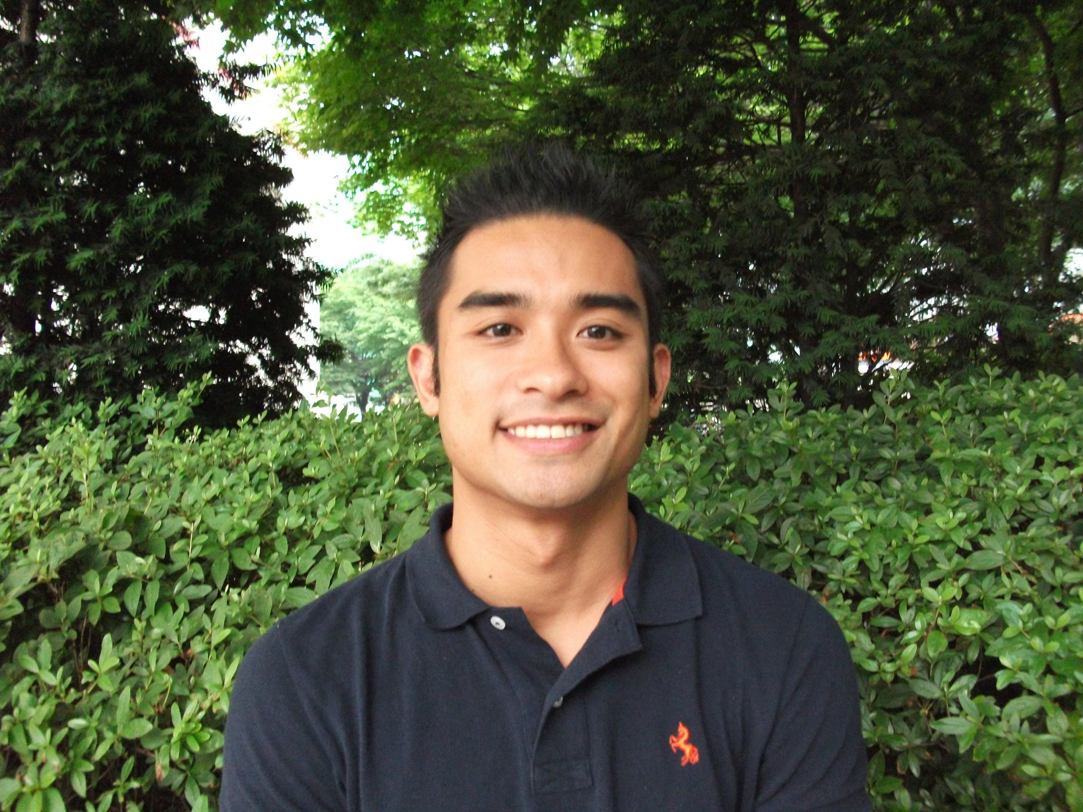
Raymond Martinez
Email: raymartinez.09@gmail.com
Seoul, Jongro-Gu
Myeong Ryun 2 Ga
86-8 Areumdaoon House #103
110-522
Cell: (010) 8050-9179

PERSONAL DETAILS
Birth: Riyadh, Saudi Arabia 07/08/1986
Canadian Landed Immigrant: 29/06/1994
Marital Status: Single
Citizenship: Canadian
Mother Tongue: English

EDUCATION
2004-2008 McMaster University
Hamilton, ON, Canada
- B.Sc Life Science

TESOL/TESL TRAINING
2008 Oxford Seminars
Toronto, ON, Canada
- Oxford Seminars TESOL/TESL Training

EXPERIENCE
English Teacher, (SMOE) Seoul Metropolitan Office of Education - Suyu Middle School
Aug 2009 – Aug 2010
- Teaches a full class of 35-40 students aged 13-15 English Language instruction focusing on speaking skills
Special Services Associate, Home Depot Canada Aug 2008 – Aug 2009
- Handles Customer Care, special orders, returns and provides information and training in a Home Improvement environment
Border Services Officer, Canada Border Services Agency May 2007 – May 2008
- Analyzes and inspects cargo and cargo manifests being imported and exported from the Canadian Border
Event Planner, HMU Entertainment June 2006 to Present
- Working in a professional team in hosting special events, exclusive parties and weekly events at various Toronto Venues
Asian F.O.C.U.S. (Federation of Charitable University Students) President, McMaster University Sept 2006 – Apr 2008
- Organized, planned and facilitated social events to fundraise money for various charities. Led an exec team of 25 individuals catering to almost 700 club members

RELEVANT SKILLS & EXPERIENCE
Languages: English (First Language), Tagalog (Fluent), French (Survival Skills)
Certifications: Standard First Aid with CPR Level A – St. John Ambulance
Travel Experience: USA, Mexico, Philippines, Japan, Thailand, Singapore
REFERENCES
Available Upon Request

