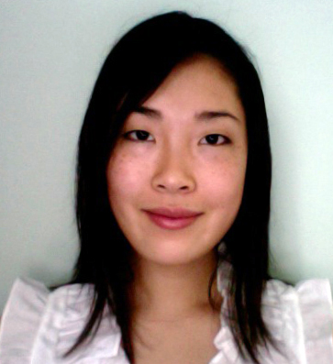
Sunny Winkel

Nationality: USA
Date of Birth: May 9, 1987
Telephone: 010 4876 8952
Email: sunny.winkel@yahoo.com

OBJECTIVES
Creative, outgoing, goal-oriented individual seeking a full time position in Seoul, South Korea

EXPERIENCE
Bismarck Phillips Communications & Media Paris, FRANCE
Public Relations Assistant 2009 (6 months)
• Wrote daily press reports for clients and press releases
• Managed and tracked designer products sent to the US and UK markets
• Created books, a compilation of all major press received by individual designers
• Translated French articles and designer biographies for foreign clients
• Organized various runways and presentations during the Paris Fashion Week (March 09)
and Haute Couture Week (July 09)

Travel + Leisure Magazine (American Express Publishing) New York, NY
Art & Marketing Intern 2008 (6 months)
• Communicated with sales staff to compose monthly Explorer pages published in Travel + Leisure
• Assisted sales teams for Travel + Leisure clients
• Administered selection and input of photography in presentations and art projects
• Assisted with planning, organizing, and running “Design Awards” and other promotional events

GfK Custom Research North America New York, NY
Intern 2007 (4 months)
• Reviewed and edited monthly research reports for various clients
• Assisted in designing and developing research questionnaires and procedures
• Conducted research needed to launch client-specific studies

EDUCATION
Northeastern University Boston, MA
Bachelor of Science Degree in International Business 2005 – 2010
Concentration: Marketing // Minor: French
Honors – Dean’s List
Activities – International Business Club (Public Relations chair), Northeastern University Culture
and Language Learning Society, Sigma Alpha Lambda Honor Society

Reims Management School Reims, FRANCE
Semester Abroad – International Management 2008 – 2009
CESEM (Centre d’Etudes Supérieurs Européennes de Management)

SKILLS AND ADDITIONAL TRAINING
• Fashion Retail and Merchandising – French Connection (Sales Associate), Club Monaco (Stylist)
• Computer – Microsoft Office (Word, Excel, PowerPoint, Outlook), Adobe Photoshop and InDesign
• Language – Fluent in English, Proficient in French, Intermediate Korean

INTERESTS
Photography and traveling

