To Whom it May Concern:

I am a certified teacher with an Honors degree in Elementary Education, and both English and Special Education teaching endorsement, from the University of Texas at Austin. As well, I have earned 18 credits towards my Master’s degree, with a 4.0 average. I have spent the last 5.5 years teaching English in Seoul, South Korea, where I taught in both the public educational sector and in the private sector (Samsung, Inc.) I also wrote the Business English book, Biz English for ECC Korea. Finally, I have been an instructor and curriculum developer in Cross-Cultural Awareness programs.
I have taught within the private sector, university, high school, middle school, elementary, and kindergarten-age students. I have been the lead teacher for several public education programs, acted as a teacher-trainer, and have administered pilot teaching programs. I have experience in modifying and developing educational materials so that each student is able to learn at his/her own level by basing instruction on the individual strengths of each student. My greatest strength as a teacher is my ability to "connect" with my students and help them to overcome hesitation to speak thereby enabling each student to reach his/her highest learning potential. I consider myself a flexible person and am able to build quick rapport and communication with my students, administration and co-workers. I feel I am also adaptable in my ability to deal with change and adjustments and enjoy new challenges.

I have experience with professional writing and editing of both publications and professional/educational literature. As well, I developed the Business English curriculum for the Samsung Global Management Institute for the intermediate and higher level classes.

I am married to a Korean national and deeply appreciate the importance of the diversity of cultures that make this world whole. Working with students and helping them to succeed is a passion I carry in my heart and one of which I both enjoy the process and results of the challenge.

I hope you will consider my application and I look forward to your reply.

Yours truly,

Susan Fitch
306 San Diego Loop
PO Box 239
Jemez Springs, New Mexico 87025
505 829 3828

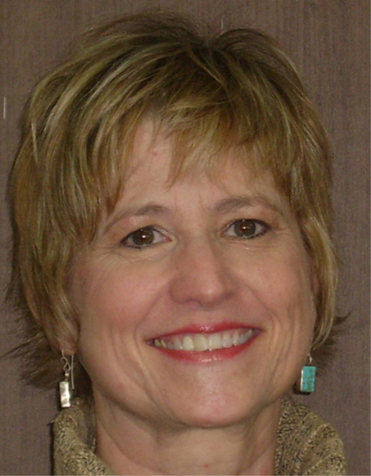

Susan Fitch
P.O. Box 239
Jemez Springs, New Mexico 87025
1 505 829 3686

Education

Honors graduate University of Texas at Austin
Bachelor in Elementary Education (NM and Texas Certificates, grades
1-8)
English teaching endorsement
Special Education endorsement (NM and Texas Certificates, grades - all
Levels, including Gifted and Talented Programs)

Graduate School - Graduate Scholars Program (scholarship)
Trinity University, San Antonio, Texas

ITC – Prague, Czech Republic (TEFL Program)

Work History - Korea

Samsung Global Management Institute: March 2006 – February 2008
Taught Conversational English, Effective Listening, Listening Comprehension, Business English, General English, and Cross-Cultural Awareness

Chung Hun High School, Anyang City: March 2004 – February 2006
Taught Conversational English and sponsored English Conversational Club

Ewha Girls Foreign Language High School: August 2003 – December 2003 (left early due to marriage)
Taught Conversational English, English Literature, English Essay Writing, International Topics

International Home School: August 2002 – August 2003
Taught all levels of English Conversation and Writing

Work History – US

Taught High School, Middle School, Elementary School, Adult Education, and Special Education, in public schools in Texas and New Mexico. Most teaching has been in the areas of English, Language Arts, and Social Studies. Districts in which I have taught include:

- Fredericksburg Independent School District, Fredericksburg, Texas
- San Antonio Independent School District, San Antonio, Texas
- Judson Independent School District, San Antonio, Texas
- Brownsville Independent School District, Brownsville, Texas
- Los Alamos Public School District, Los Alamos, New Mexico
- Jemez Valley Public School District, Jemez Pueblo, New Mexico
- Camino Nuevo Youth Center, Albuquerque, New Mexico

Responsibilities have included writing and administering educational plans for individual students and supervision of educational assistants. Majority of students taught were those for whom English was a second language. Team taught several semesters and was lead teacher at Brackenridge School (San Antonio) and Camino Nuevo Youth Center, Albuquerque, New Mexico. I also did teacher training for the San Antonio Independent School District in the areas of Cultural Awareness, Language Arts and Special Education. Taught and specialized in Cross-Cultural Awareness training and wrote curriculum across the English language spectrum

Professional Writing and Editing

- Wrote Biz English, an Business English language book, published by ECC Korea
- Wrote and developed English as a Second Language curriculum for both the private and public educational sector in Seoul, South Korea
- Participated and developed the first Jemez Valley Elementary National “TV Turn-Off Week,” in which participating students and their families pledged to NOT watch their televisions for one week. Helped to set up family activities, such as Chess Nights and Library Nights, to help families engage in family-related time and activities without engaging in watching television. The week culminated in a valley-wide pancake breakfast in which many, many families attended.
- Wrote adult-training manual for HDA, Inc., a private company that contracted with the state of Texas to provide training and education to adults in Harlingen, Texas
- Was primary grant writer for HDA, Inc., Harlingen, Texas
- Wrote curriculum for Mi Casa of San Antonio, a private school that contracted with North Side Independent School District to provide educational, and special language needs services for students, ages 3-22.
- Wrote grant proposal for Jemez Valley Business Association
- Edited private doctoral theses and other professional work
- Edited curricula for private educational training manual (HDA)

Korean References
Jackie Hwang, Supervisor, Samsung Global Management Institute
011 9992 1675
Shin Dong Yuk, English Department Head Teacher, Chung Hun High School, Anyang, Kyounggi-do
011 9892 5413
Mr. Gye, Principal, Chung Hun High School, Anyang, Kyounggi-do
031 472 5383

Mr. Jang, Principal, Ewha Girls Foreign Language High School
016 816 1110

Augustine Park, Supervisor, International Home School, San-bon, Kun-po shi, Kyoung-gi do
031 398 6779 or 019 279 2065

Kim Joon Sup, Former Supervisor, International Home School, San-bon, Kun-po shi, Kyoung-gi do
018 225 8033
US References

Lori Rogers Cole, Former Lordsburg High School, Principal
Former Principal/Vice-Principal Camino Nuevo Youth Center
505 542 8045

Sandy Erlich, Mi Casa of San Antonio, owner
210 699 0162

