Curriculum Vitae
E.C. Jooste

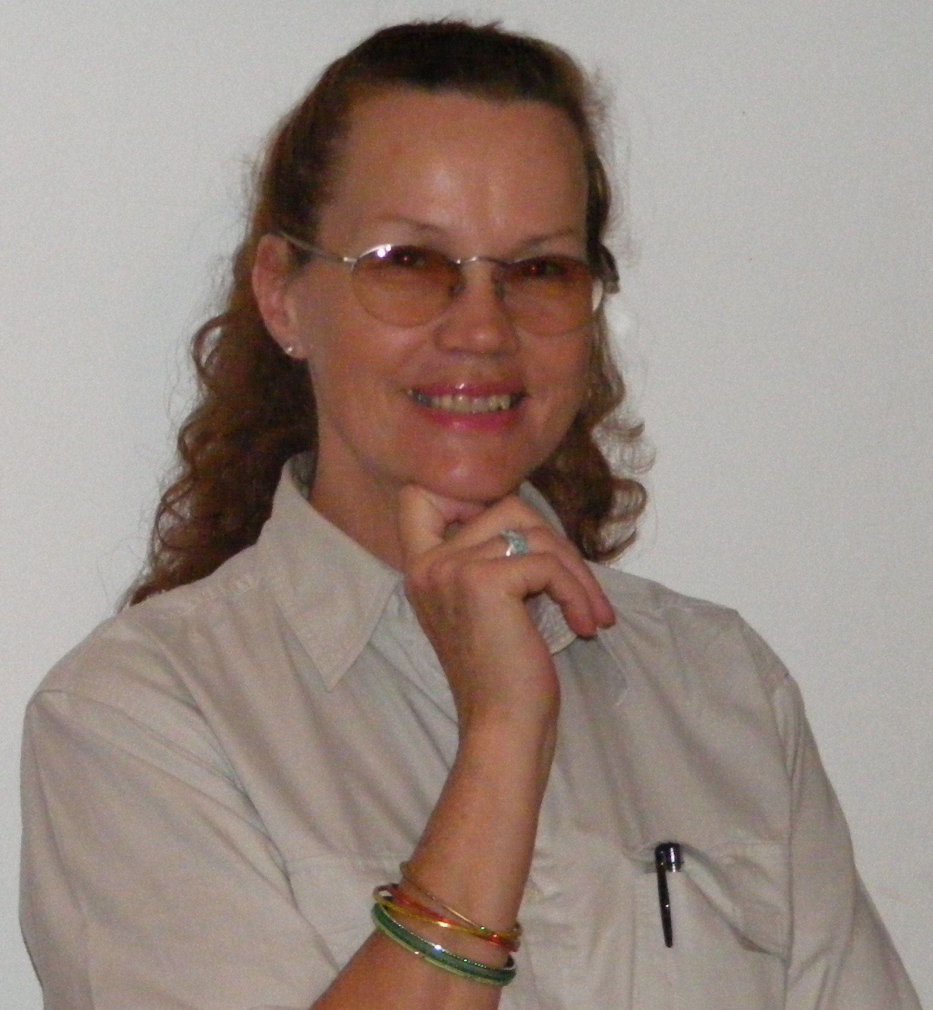

Contact Information:

Tel: 0445332621 (Emergency #) Postal Address: P.O. Box 1904
Cell: 0741018615 (24/7 #) Plettenbergbay
Passport: South African (Valid) 6600
Drivers License: Code EB (Valid)

Vacancy Related Qualifications:

From To Institution Qualifications

2000 2000 Damelin College Diploma Project Management

1990 1999 UNISA (Capped 2000) BA Maj. Anthropology
Min. History of Art with
Psychology II, Sociology I and
Conversational French I

1989 1989 Damelin College Mature Age Matric Exemption
(English, Afrikaans, Criminology and Biblical Studies)

Valid HPCSA Member Reg # BAA0351725 Basic Ambulance Assistant

2009 2009 Inlingua Language Trng Ctr. TEFL Course (Teach English to Foreign Language Students)

Last two Places of Employ:
- Zurich/SA Eagle Insurance Company Jhb where I served in the Executive Wing for three months as PA to the General Manager Finance to relieve the permanent PA during an extended period of illness/ sick leave. Thereafter I was placed as PA to the Senior Internal Auditor until he left the Company, whereupon I became the PA to the Research and Development Manager who later became the eCommerce Manager. Commenced 01.01.1993 until 03.12.2007 (15 years)

- University of Witwatersrand as Half day Team Assistant and relief PA in the Faculty of Hydrology aka Water Systems Research Group for Professor David Stevenson where I executed the drawing and filing of Topographical Maps, recorded Digital Rainfall data onto system and produced all diagrams and illustrations required for the Professor's lectures, papers and pamphlets. Commenced 1988 to 1992 (5 years)

Contactable Reference: *Linda le Roux Human Resources - Zurich/ SA Eagle Insurance Company Jhb Ph +27113709111
*Jane Diesel – Inlingua Language Training College – TEFL Instructor, Cape Town. Ph +27214190494

*******

Additional items of interest
Languages:
English, Afrikaans, Conversational French, German and Dutch

General Abilities:
General Computer Skills/ IntraNet and Internet Literate/ Basic Computer Graphics/ MS Projects/ Supervisory Experience/ First Aid/ Health and Safety

Experience in the following fields which will enable me to converse about and around these fields with students:
Life Skills in General/ English Language/ Anthropology/ History of Art/ Maths/ Architecture/ Civil Structural and Hydrological Engineering/ Interior Decor/ Financial and Insurance Institutions/ Biology and Hygiene/ Fashion/ Ice Skating/ Sports in General/ Dancing/ Travel/ Martial Arts/ Bodybuilding/ Health and Fitness/ Hospitality.

Teaching Experience:
First Aid Instructor's Certificate - Red Cross Society Johannesburg
TEFL/ TESOL Certificate Course - Inlingua Cape Town
5 months of English Teaching to 5yr to 16 yr old Foreign Students in Korea – Ave Stud. Test results = 83%

Additional previous experience with school children:
Worked as Junior Matron at Klipriver Junior School (1986) in Ladysmith KZN for about one year, then at Durban Boys High (1987) for one year, then at a Co-Ed High School (1988) [Name of that school now escapes me), also in Durban, for half a year. Duties included First Aid Duty, Assisting with sorting already ironed laundry once a week, Kitchen Supervisory Duty and Dormitory Cleaning Supervision.

