RON ROOSEVELT

Email: ronroosevelt@gmail.com
9541 Winterset
Plymouth, MI 48170 USA
Phone: 734-414-0529

PERSONAL PROFILE
Birth: USA, 08-September-1983
Citizenship: US
Mother Tongue: English
Marital Status: Single
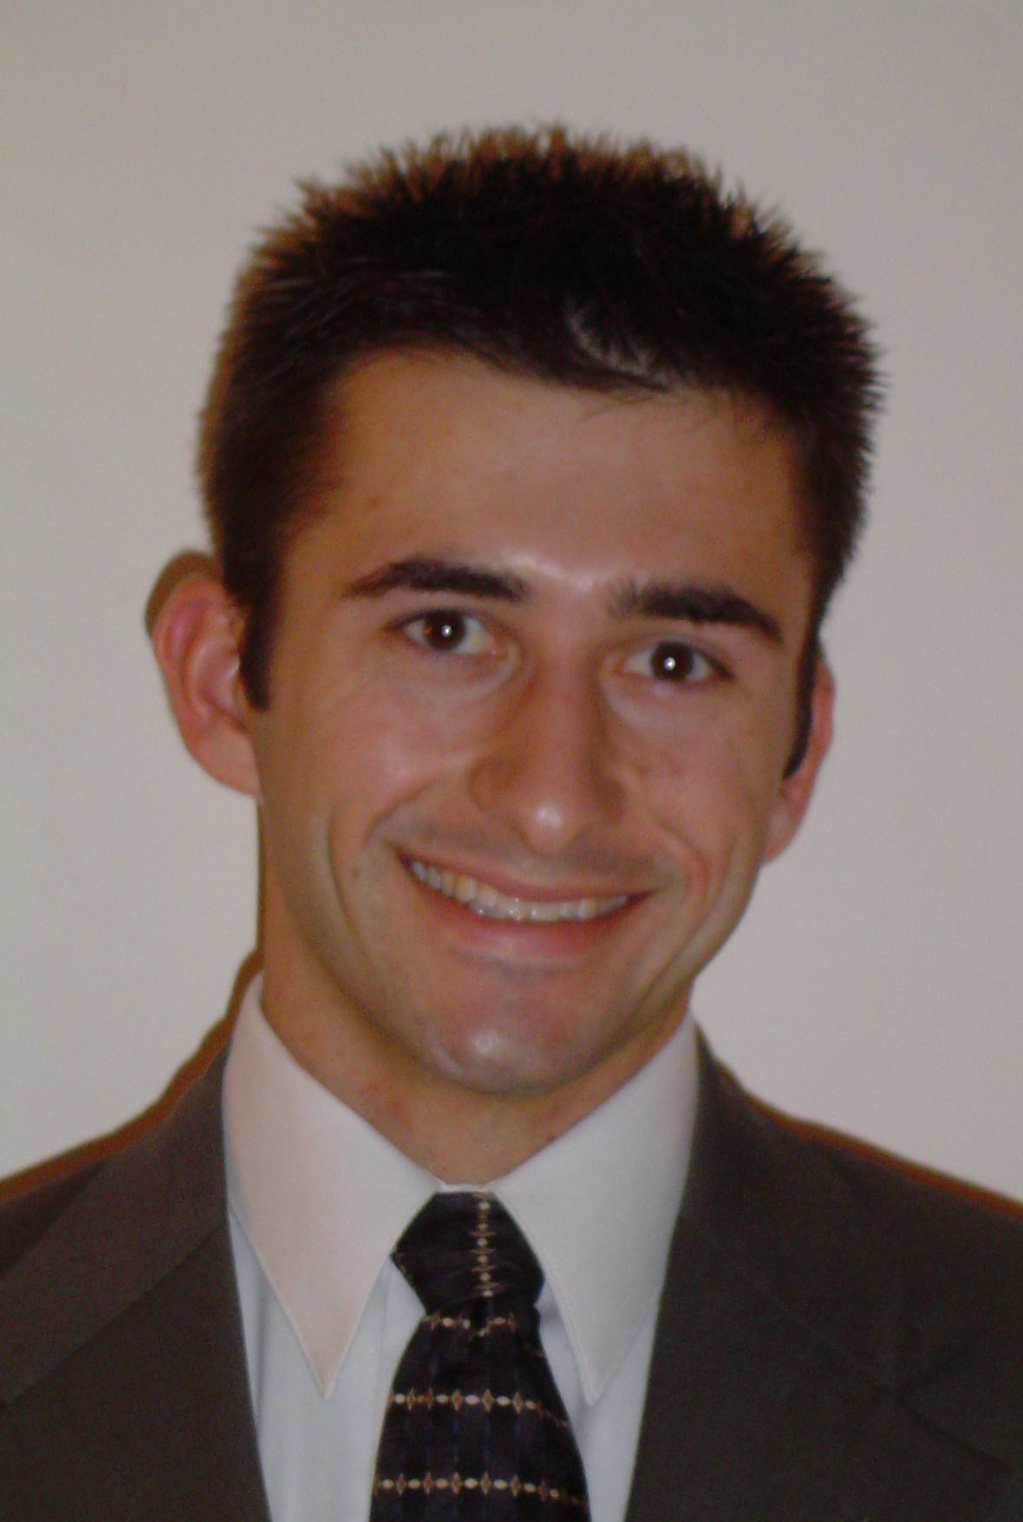

EDUCATION
Indiana University, Bloomington, IN, USA 2001-2006
Bachelor of Arts, Germanic Studies and Spanish

TESOL/TESL TRAINING
Oxford Seminars, London, ON, Canada 2006
Oxford Seminars 60 hr. TESOL/TESL Certification
- Familiar with: teaching methodologies, theories of second language acquisition, mixed level classrooms, age-appropriate curriculum, assessment and placement, lesson planning, grammar, skills, and pronunciation

EXPERIENCE
Sol Education Abroad, Capital Federal, Buenos Aires, Argentina 07/07 – 08/08
Resident Director
- Provided guidance and support to university and high school students during their study abroad programs 24/7
- Organized and led activities such as museum visits, weekend long trips, and travel to another country
- Acted as a liaison between the local learning institution in Buenos Aires, the students, and the company’s headquarters located in the US
- Managed expenses
- Trained and supervised an employee

English Training Systems, Capital Federal, Buenos Aires, Argentina 08/2007 – 08/2008
Brooklyn Bridge, Capital Federal, Buenos Aires, Argentina 03/2007 – 07/2007
English Teacher
- Instructed business personnel in American culture, conversational English, pronunciation, and grammar
- Taught in companies such as Citibank, Philips, Johnson & Johnson, Swiss Medical, Repsol, Raffo, Gestion, and Givaudan
- Planned and conducted lessons for various levels of English proficiency, from elementary to advanced
- Conducted a two day seminar on speech delivery
- Used different types of multimedia in lessons
- Prepared students for level proficiency exams

YMCA, Bloomington, IN, USA 9/2002 – 5/2006
Youth Sports Department Assistant
- Coached, refereed, and clarified rules and policies for fall, winter, and summer sports programs
- Managed and organized equipment
- Coached a minimum of one team consisting of no less than nine children per sport per session for multiple age groups
- Provided constant and attentive interaction with both parents and children
- Acted as a role model and instructed good sportsmanship and teamwork

Indiana University, Bloomington, IN, USA 2004, 2006
K201-Computers in Business Peer Tutor
    - Provided students with in-class help with the Microsoft Access and Excel

Freiburg im Breisgau, Germany 10/2004-03/2005
Conversational English Tutor
    - Conversed in English with two native German speakers once a week
    - Helped improve pronunciation
    - Gave insights into American culture

Bernie Holowicki’s Basketball Camp, Livonia, MI, USA 06/2000
Basketball Camp Counselor
    - Provided instruction to children ages nine to thirteen for the development of their basketball skills

St. Robert Bellarmine School, Redford, MI, USA 10/1997-12/1998
Assistant Basketball Coach
    - Instructed the 7th/8th grade girls’ basketball team

RELEVANT SKILLS & EXPERIENCE ABROAD
Foreign Languages: Spanish, German, Portuguese
Residency: Argentina (21 months), Germany (11 months)
Travel: Argentina, Austria, Belgium, Brazil, Canada, Czech Republic, France, Greece, Ireland, Italy, Peru, Slovakia, Switzerland, Uruguay

