Catriona Davie

5 Appaloosa Trail, Carlisle, ON, Canada, L0R 1H3
Cell phone: +1 (905) 906-8533
Home phone: +1 (905) 690-4779
Email: catriona.davie@gmail.com

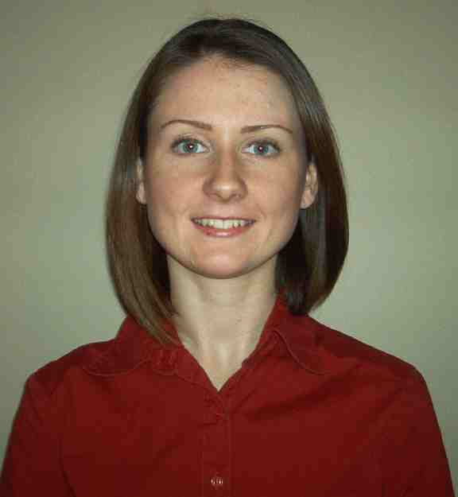
PERSONAL
Citizenship: Canadian
Mother Tongue: English
Birth: Israel, 11/24/1983
Marital Status: Single

EDUCATION
University of Waterloo, Canada: 2002-2006
  - Honours B.A., Political Science

TESOL/ TESL TRAINING
Oxford Seminars TESOL/TESL Certification: 2006
Waterloo, ON, Canada

EXPERIENCE
SLE English Instructor
Pagoda/Direct English, Seoul, South Korea, January 2008 – June 2008
- Taught conversational English to students of varying proficiency levels
- Conducted one-to-one and group classes for adult students
English Teacher
York School of Foreign Languages, Fuzhou, PRC, March 2007 – December 2007
- Taught English to students of varying ages and proficiency levels
- Completed various administrative tasks and promotional activities
Summer Student Tour Guide
Springridge Farm, Milton, ON, Canada, April 2006 – December 2006
- Gave guided tours of the farm to children ages 3-8 and adults
- Taught school children and their parents about nature and farming
Student Coordinator
SSWE, Toronto, ON, Canada, March 2004 – September 2004
- Taught English to teenage French exchange students
- Planned activities for students so they could learn about English culture
SKILLS
- Foreign Languages: intermediate-level Spanish and French, basic Chinese
- Overseas Residencies: Israel (1 year), Spain (5 years), Scotland (2 years), China (10 months)
- Interests: making jewelry, running, hiking, painting, playing piano

REFERENCES & DOCUMENTS
Available upon request.

