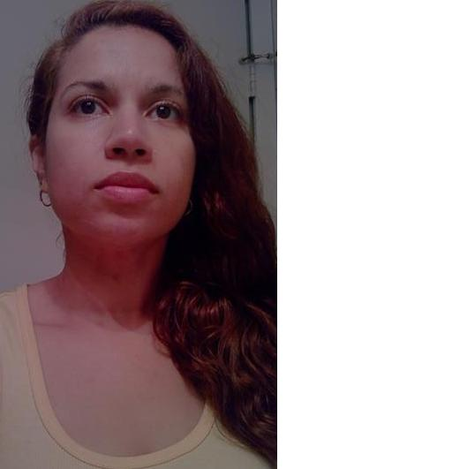
Stephanie, Collado
85 Judith Drive • Coram • N.Y. • 11727 • U.S.A.
Stephanie07@hotmail.com • (631) 871-2162

Birthday • July 7, 1977
Marital Status • Single
United States Citizen •

Objective

To teach students English abroad while immersing myself in another culture and sharing my expertise in learning other languages.

Education

May 2007
C.W. Post Long Island University, Brookville, New York
Masters of Business Administration, AACSB Accredited
•Major in International Business and Finance

December 1999
State University of New York at Stony Brook, Stony Brook, New York
Bachelors of Arts in Psychology
•Major in Psychology, minor in Sociology

Teaching Related Experience

- Babysitting the children of friends and family
- Psychology training with an emphasis on Behavioral Modification
- Mary Haven Direct Care Counselor for disabled children- One on one teaching and behavior modification to obtain daily and weekly goals March 2000- May 2000
- Swimathon volunteer at Brookhaven National Laboratory for Cancer Charity 2000
- Clothing drive for Salvation Army- Angels Charity Program during Christmas 2002-2004
- Collected food during Thanksgiving for Island Harvest Charity 2006
- School Presentations- Have participated in several class presentations as part of the M.B.A. curriculum
- Class Teaching for Management Information Systems. Required to teach Two chapters and Articles from the text book

Work Experience

Bilinguals Inc., Huntington Station, N.Y. August 2004-December 2006

Billing Coordinator
- Helped department reduce payment rejection rates to almost 0%
- Consistently met monthly deadlines
- Established coordinated intra-department record keeping
- Audited paperwork and processed payment for over 210 independent contractors monthly
- Created and signed off on invoices billing the counties and the state worth thousands of dollars each

InterCounty Appliance Corporation, Commack, N.Y. May 2002-March 2004

Receiving Clerk
- Created and entered new model descriptions into the computer system
- Managed inventory of products ensuring the warehouse and the computer were in sync
- Input purchase orders for the most important accounts: GE, Maytag, Whirlpool and Frigidaire/Electrolux

American Home Mortgage, Melville, N.Y. December 2001-May 2002

Assistant to Director of Risk Management and Accounting Department
- Helped with project to reduce fraudulent mortgage applications
- Helped with Mortgage Application audits by researching social security numbers and their validity
- Assisted with meetings and conference calls with other offices across the country
- Posted invoice payments and mortgage checks

Language Skills

•Fluent Spanish
•Fluent Italian
•Basic French

Travel Experience

•Europe, 2 months (England, Scotland, Belgium, Germany, France, Italy Greece, Switzerland, Austria, Spain)
•Australia, New Zealand & Fiji, 1 month
•El Salvador, 1 month
•Mexico, 1 month
•Dominican Republic, 1 month
•Argentina, 1 week

References

Available upon request

