Bart C. Carhart
Contact information- e-mail bart.carhart@maine.edu phone # 010 6860 1764
Kyoung Kee Do, Gunpo O-kuemdong Twei-Gye Apt 365-1303

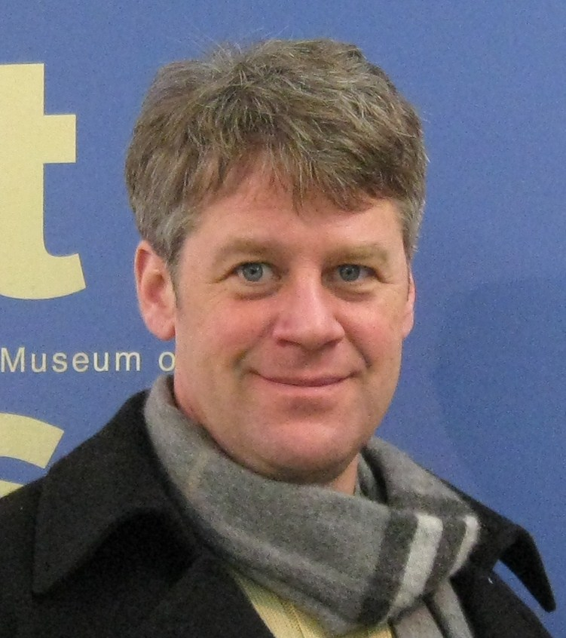

Objective
Enthusiastically active in seeking an opportunity in which I can use my personal qualities of openness, independence and reliability to bring the joy of education to others.

Experience

Sept 1st –Present Best Kids Bun-dang
English Teacher Responsibilities include teaching kindergarten
And 1st grade student. Reading comprehension
Speaking, science and writing.
July 26th –August 25th  English Teacher  May 2008-July 2010 | Yongsang Sogang English Camp  Responsibilities include Teaching 3rd through 6th grade basic to advanced English speaking,  Kim Hyo Jung  English Academy | Pyoungchon, Anyang.
Elementary/TOEFL Instructor
- Responsibilities include Teaching 3rd through 6th grade basic to advanced and TOFLE level English speaking,, grammar and writing. Overseeing foreign employees and implementing new curriculum.
October 2003-May 2008 | University of Southern Maine Telecommunications | Portland, Me.
Student Supervisor
- Responsibilities include overseeing operations of the front desk, customer service, answering information phone as well as directing phone calls within the department, issuing identification cards, filing, operating the USM operator switch board, creating the hold events message, word processing, data entry using both excel and access.
November 2001-October 2003 | The Village Store | South Freeport Me.

Deli Owner Operator Manager
- Responsibilities included overseeing daily operations of store including, ordering merchandise and supplies, hiring employees, administrative duties such as banking, money reconsolidation, data entry of sales and accounts payable, employee payroll and other general duties such as customer service, cooking, baking, fulfilling costumers orders.

July 1998- November 2001 | Starbucks | Brookline Ma.

Store Manager
- Responsibilities included overseeing daily operations of store including, ordering merchandise and supplies, hiring employees, administrative duties such as banking, money reconsolidation, data entry of sales and accounts payable, employee payroll, training and customer service.

March 1990- June 1998 |  |  | Dani & Jonnys Cappuccino | Clinton NJ

Coffee Shop Owner Operator Manager
- Responsibilities included overseeing daily operations of store including, ordering merchandise and supplies, hiring employees, administrative duties such as banking, money reconsolidation, data entry of sales and accounts payable, employee payroll, and fulfilling costumers orders.

Education
1979-1983  1987-1991  2003-2007  2003-2008 |  |  | North Hunterdon H.S.  Raritan Valley Community College (associates degree in Computer Art)  University of Southern Maine Bachelors In Social Work  University of Southern Maine  Bachelors in Political Science | Annandale NJ  Branchburg NJ  Portland Me.  Portland Me.
Other experience  2004-2006  2005-2007  Summer or 2005  2005-2006  2003-2007 |  |  | Teen Center  -Worked with disadvantaged teens helping them to connect with services within the community to help improve the quality of life  After school Program teaching Somalia immigrants English at the Portland city high school.  Save Passage Worked in a private school setting in Central America Guatemala Grades preschool -3rd grade  Preble Street Consumer Advocacy Project  -Illegal eviction campaign  -Crimes against homeless  -organized Candidates breakfast  -Health Care Issues  Student Involvement  -Social Work Student Organization Secretary  -PIRG  -Political Science  -Campus no on one campaign- Discrimination
 | References | Kim Hyo Jung, Rose 031-382-0700  Yongsan-sogang, Seo-Jin Kim 010-903-61217

