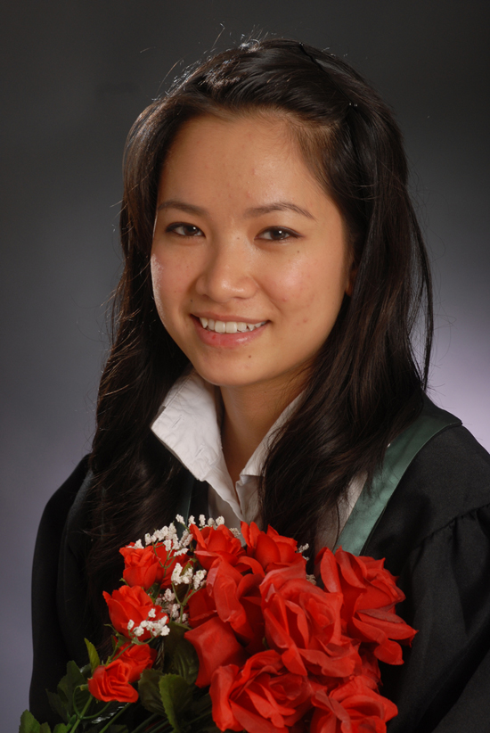
Na Ro Thi Hoang
EMAIL: NA-HOANG@HOTMAIL.COM
133 LEXINGTON, ON
CANADA, M9V-2H1
PHONE: (416) 741-5322

PERSONAL DETAILS ______
Birth: July 13, 1987
Marital Status: Single
Citizenship: Canadian
Mother Tongue: English
EDUCATION
  - Ottawa University and Algonquin College
Ottawa, ON, Canada
Bachelor of Arts, Journalism-print
- Obtained baccalaureate, May 2009
EXPERIENCE ______
2009 Journalist/Reporter, Canwest News Service,
Ottawa, ON
- Reported on the national desk, arts/lifestyle desk, and on breaking news
- Wrote and published research intensive stories for the wire
- Conducted phone interviews, copy edited, and compiled news briefs for broadcasting (Global TV)
2008 Electronics Services Promotion Clerk, Service Canada
Toronto, ON
- Contacted and encouraged employers to sign up for Records of Employment (ROE) Web
- Initiated creative outreach opportunities such as door-to-door sales and employer visits
- Worked the front end helping clients fill out Employment Insurance applications and answering questions for SIN, Passports, CPP, Job Bank, and various other government programs
2007-2009 Server, Bubblicity Tea Shop
Ottawa, ON
- Provided excellent customer service skills
- Utilized the store’s information system and handle direct transactions
- Cooperated with co-workers and help maintain cleanliness of the store
2004 Assistant Floor Director, OMNI TV
Toronto, ON
- Floor directed live news broadcasts and studio tapings
- Set up equipment and maintained checks in studio operations and in the newsroom
- Worked with professionals in the field including technical (sound/light) workers, anchors, journalists, and television personalities
2002 Preschool Camp Facilitator, Parks and Recreation
Toronto, ON
- Organized and planned various activities and crafts for campers
- Interacted with parents and children of all age groups
- Cooperated with other volunteers and worked responsibly in various environments (parks, carnivals, amusement parks, classrooms)
INTERESTS ____________________________________________________
Writing, reading, being around family, children, my dog, taking walks, listening to music, eating out, and learning new things.
REFERENCES
Available upon request

