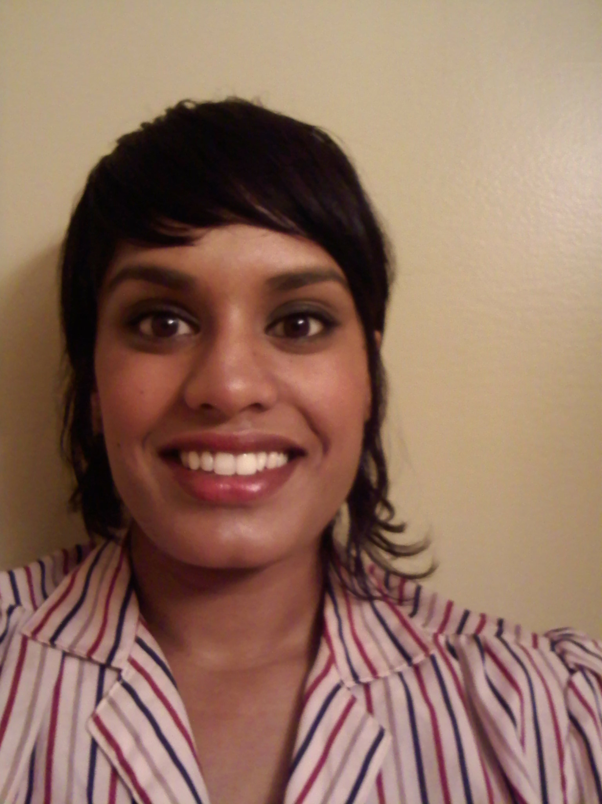
Stephanie Yost
2214 Wildflower Ct., Buffalo, MN 55313
Tel: 515.450.8602
E-mail: stephyost@hotmail.com

PERSONAL
Birth: Kolkata, India 08.09.1981
Citizenship: American
Mother Tongue: English
Marital Status: Single

EDUCATION
2009: TESOL/TEFL Certification, Oxford Seminars, St. Paul, MN, USA
2008: Esthetics License, W. Valley Occupational Center, Woodland Hills, CA, USA
2005: Make-up Artistry Certification, Make-up Designory, Burbank, CA, USA
2003: Bachelor of Arts Degree – Journalism & Public Relations, English Minor, Women’s Studies Minor, Iowa State University, Ames, IA, USA

EXPERIENCE
2006-2009: Front Desk Manager/Make-up Artist, Steam, Los Angeles, CA, USA
Managed stylist schedules, promoted and sold services and retail, oversaw inventory and retail sales, assisted salon owner, trained and supervised front desk staff, performed make-up and skin care services

2007-2008: Make-up Artist/Assistant, Puff Beauty Studio & Senna Cosmetics,
Los Angeles, CA, USA
Performed make-up and skin care services, managed make-up artist schedules, promoted and sold services and retail, assisted senior make-up artists

2003-2005: Front Desk Staff, The Salon Professional Academy, Ames, IA, USA
Managed stylist schedules, promoted and sold services and retail, trained and supervised front desk staff and students

2001-2003: Writer, Iowa State Daily, Iowa State University, Ames, IA, USA
Wrote articles for the arts and entertainment section

1999: Spanish Teacher, NIACC Community Education, Lake Mills, IA, USA
Taught basic Spanish to 3rd-5th graders

SKILLS
Languages: 4 years of high school Spanish and 1 year of university Spanish
Travel: USA, Mexico, Canada
Computer: Microsoft Word, Microsoft Excel, Microsoft PowerPoint, WordPerfect, Quattro Pro, 55 wpm, PC and Mac proficient
Interests: writing, reading, history, beauty, fashion, fitness, cooking

REFERENCES & TRANSCRIPTS Available upon request

