RESUME

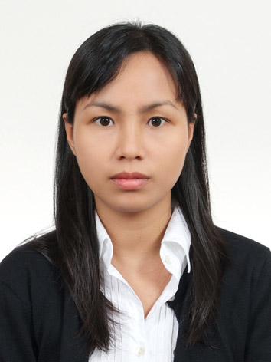
PERSONAL DATA:

NGUYEN THI THANH HANG (Mrs.)
Nationality: Vietnam
Birthday: 19-Nov-1977
Certificate of Alien Registration: 771119-6102497

Cell: 010 3168 1911
Home: Kyungkido Yongin City Sujigu Jukjundong Byuksan town 2nd 208-803
Email: thanhhangnt@hotmail.com

PROFESSIONAL STRENGTH: | Technical skills:  - Platforms: Windows, OS400 and UNIX.  - Programming language: Visual Basic, C, ProC.  - DBMS: Microsoft SQL Server, Oracle, DB2.  Language skills:  Characteristics:  - Able to work independently or within a team. Served as team leader before.  - Willing to study from my colleagues as well as to share with them my experiences, knowledge...
   | Speaking | Reading | Writing
  English | Excellent | Excellent | Excellent
  Korean | Intermediate | Intermediate | Intermediate
  Vietnamese | Native | Native | Native
EMPLOYMENT RECORD: | I. May 2008 to Oct 2008: Iritech Korea – This Company provides biometrics security solution based on iris recognition technology. I was a member of Collaboration Team, whose main responsibility was to contact with customers, study requirements, packet the software, make technical manuals, and all training documents.  II. Sep 2003 to Feb 2008: Stelecom Vietnam (This is a cooperation project between SPT and SLD Co. (established in Singapore with founders being SK Telecom, LG Electronics, and Dong Ah Elecomm) – Rating and Data Analysis Team Leader  I was a member of Operating Support System, whose main responsibility was to manage Rating System Program, International Roaming Billing System, and to analysis data.  Main Responsibilities:  - Implement tariff packet.  - Implement new promotion policy.  - Ensure the accuracy of rating.  - Develop new program based on requirements...  - Maintain application program.  - Process and analyze data for Marketing, Accounting preparing for new tariff packet or new promotion plan…  - Manage roaming billing.  Achievements:  - Employee of the year, Stelecom, 2005-2006  - Leadership skills:  - Supervise working process to meet job deadlines and quality requirement.  - Allocate assistants to assignments appropriately.  - Provide clear instructions to assistants.  - Teamwork skills:  - Acquire good interpersonal skills.  - Build up the teamwork spirit with proper encouragement and recommendation.  Projects:  - Develop Settlement System, HCMC, 2007  - Improve Postpaid Billing System, HCMC, 2007  - Improve Roaming Rating System, HCMC, 2007  - Hanoi LG MSC, HCMC, 2007  - Da Nang LG MSC, HCMC, 2007  - New SCP – Develop loading Prepaid CDR system, HCMC, 2006  - Samsung MSC, HCMC, 2006  - International Roaming Billing System, Seoul, 2005-2006  III. Jun 2002 to Apr 2003: KPMG Vietnam Ltd – Consultant  I was a part of the Specialized IT Consulting services line, whose main responsibility was to provide Business Intelligence System Implementation, Information System Design and Planning, and AS/400 System Consulting.  IV. Aug 2001 to Jun 2002: Arthur Andersen Vietnam Ltd – Consultant  I involved in Software Development, Information Systems Design. I had gained skills of AS/400, and Business Intelligent tools named Cognos Impromptu.
TRAINING: | - Korean - Seoul National University, Seoul Korea, Dec 2008 – present.  - Oracle - Fundamental II, Stelecom, Ho Chi Minh City, Dec 2004  - Oracle - Fundamental 1, Stelecom, Ho Chi Minh City, Oct 2004  - Andersen Business Consulting, Andersen Vietnam, Vung Tau, Vietnam, Oct 2001.  - AS/400 System Operation, Andersen Vietnam, Ho Chi Minh City, Aug 2001.
EDUCATION: | University of Natural Science, Ho Chi Minh City, Vietnam  B.S. Degree in IT  1996 – 2001  During my university I found myself strong at and interested in Artificial Intelligence (using C), Assembly language, Object-oriented software development (using Visual Basic, SQL Server) and PC hardware know-how.
Essays completed:
- Develop the Graphic Tools: Graphic subject, using C language.
- Develop the air-ticket sales management software system, using Visual Basic and DBMS is SQL server.
- Develop the University entrance examination management software system for HCMC National University, using Visual Basic and DBMS is Oracle.
- Develop the transport of goods by river business management software system, using Visual Basic and DBMS is Microsoft Access.
- Develop the transport of goods by river business management software system, using Visual Basic and DBMS is SQL Server.
- Develop the Tourist WEB site, using Frontpage, HTML, ASP, Photoshop, CorelDraw.

Graduation thesis: Develop the sales management software system for Kinh Do Bakery, a leading bakery company in Vietnam.

HOBBIES: | I like traveling, reading, and watching movies, singing…

