
이에스엘 에이전트
장재웅 (Jay Jang)
02-2675-0582

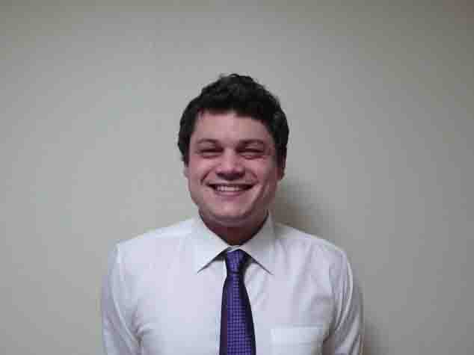
Thomas Newman
Objective | I have been teaching in Korea for the past 6 years. I am recently married and have an F2 visa. Subsequently I bought a new house and am looking for work closer to my new home.
Related Skills | In addition to work experience my time living in Korea has provided me with the following skills and advantages:  - I am comfortable with the Korean language to the point of practical conversation.  - As a long-time resident of Gyeonggi-do, I am familiar with practical day-to-day life in the area.  - F-2 Visa holder

Work Experience | 2007 - 2011 Wing Wing/Kids Village Yong in, Korea  English Teacher (Kindergarten)  • Parent teacher conferences, Impromptu instruction  2010 - 2011 Engineering Firm Suwon, Korea  English Teacher (Adults)  • Business English  2007 - 2010 Grace English Academy Bundang, Korea  English Teacher (Kindergarten-Middle)  • Run school activities, lesson planning.  2004 - 2007 Jung Chul English Suwon, Korea  English Teacher (Elementary-High)  • Head Teacher, lesson planning.  2002 - 2003 Shane English Academy DongHae, Korea  English Teacher (Adults)  • Curriculum creation, proof reading textbook.
Education | 2002 Newstead College Launceston  Cisco course  1999 - 2002 NDA Computing Launceston  Network Support Accreditation  1999 - 2002 University of Tasmania Launceston Campus  Bachelor of Computing  History minor  Arts minor
Extracurricular Activities | Judo, Hapkido, Reading

