Tintin (Miss.)

206 Hyeseong Ville
136 Daesin-dong, Seodaemun-gu
Seoul – South Korea
Contact phone: 010-4270-9697
Email: tintin1077@gmail.com
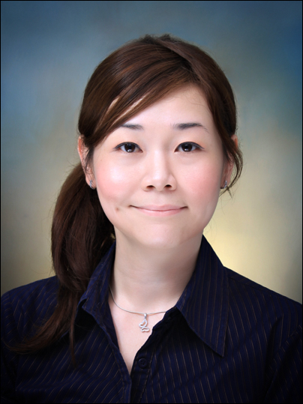

Objective:
To positively contribute my skills and experience by teaching English as a second language.

Education

Korean Language Course - 2010 Yonsei University Korean Language Institute (levels 1 and 2 - 400 hours), Seoul, South Korea.

Certificate III in TESOL (110 hours – including practice teaching) – 2009 Teach International, Melbourne, Australia.
Bachelor of Science (Materials Science) – 2002 University of Technology Sydney, Australia.
Diploma of Scientific Practice – 2002 University of Technology Sydney, Australia.

Experience
2007 – 2009, VIPAC Engineers & Scientists Ltd, Melbourne, Australia.
Position: Quality and Compliance Analyst.
I was responsible for checking, analysing and verifying of testing data; determining conformity; overseeing report generations; and managing implementation of various requirements as well as generating and updating procedures. I also liaised with customers on daily basis. In this position, I trained and taught other staff members who come from diverse cultural backgrounds and age groups.

2004 – 2006, CSIRO Manufacturing and Materials Technology, Sydney, Australia.
Position: Experimental Scientist.
I managed the Sydney operation of flooring material testing and consultancy. My tasks include determining feasibility of projects, negotiating and executing contracts with clients, project planning and scheduling, project execution and providing advice on various testing methods to clients and the industry. I interacted with clients and other stakeholders from various countries which include Asia, Europe and the Middle East.

2002 – 2004, CSIRO Manufacturing and Infrastructure Technology, Sydney, Australia.
Position: Technical Officer.
I conducted scientific experiments for research projects. In this role I developed my analytical and communication skills. I also trained and taught new staff members who are new graduates and/or who are employed as work experience students.

Awards
Performance Award – 2006 CSIRO Manufacturing & Infrastructure Technology.
Loctite Australia Prize (Winner) – 2002 University of Technology Sydney.

Computer Skills
Microsoft Word, Excel, PowerPoint, Email / Internet, Mathematica.

Additional Information
I have a big interest in different cultures, histories and languages. I love interacting with people from a diverse background. I am very fortunate to have experienced learning a few languages and TESOL. Because of these experiences I am inspired by my Italian, Japanese, Korean and TESOL instructors to not just simply giving information but to always motivate, facilitate, interact and help students in the classroom.

References
Mr Tony Wilson
Managing Director Cal-Tech Solutions
Telephone: 61 3 8790 1808
Email: cal-tech@optusnet.com.au
Ms Teresa Fitzgerald
Member Relationship Executive AIG
Telephone: 61 2 9466 5526
Email: teresa.fitzgerald@aigroup.asn.au

