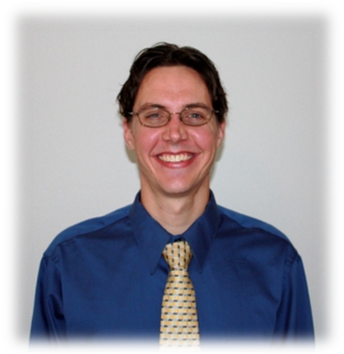
TOBIN STUTLER

Date of birth: February 12, 1981
Citizenship: USA (Native English Speaker)
Email: tobincw@hotmail.com

PROFILE

I have a passion for written and spoken English, and I have the ability to engage with people and children of different ages and skill levels in creative ways. Because of my passion for language and teaching, I think I am especially suited for teaching English as a foreign language. I have varied experiences with teaching non-native English speakers and I believe I have many skills and resources to offer students and the many needs within a school. With my unique background and open mindedness towards others, I am determined to make a positive impact on the lives of my students.

EDUCATION

- Bachelor of Arts Degree: Majoring in English Graduated September 2006 California State University, USA
Cumulative GPA: 3.8 / 4.0
- Sigma Tau honors society 2006 (Honor given to U.S. University Students with outstanding grades)
- Dean's Honor Roll CSUSB 2005/2006 and Dean's Honor Roll UNC Spring 2001

- 120 hour TEFL Certification (Teaching English as a foreign language certificate)
TEFL Institute, Chicago, Illinois, USA Certified March 2008

TEACHING EXPERIENCE

Aug 2009- English Teacher, Fun Language International
Feb 2010 Bangkok, Thailand

- Inspired students to engage with the English language through a variety of activities and lessons.
- Wrote lesson plans, conducted lessons and monitored student progress at separate schools during the week.
- Taught extra lessons each Sunday for parents who wanted their children to have extraordinary abilities in English.

May 2008- English Language Instructor, Ilsan SLP
May 2009 Ilsan, South Korea

- Worked with all age levels to enhance conversational, grammar, reading and writing abilities.
- Multitasked by developing lessons and instruction for students from 6 to 10 years of age.
- Assessed student performance and constructed quality feedback in order to enhance performance.
- Counseled and cared for students, fed them lunch and taught them activities such as science, drama and gym.

Fall 2007 Program Leader, THINK Together after school program
Banning CA, USA

- Assisted students with their full range of homework subjects (Mainly writing, math and social studies)
- Monitored and coached a daily outdoor physical activity.

VOLUNTEER WORK

Spring 2008 Practicum/Volunteer work, Palm Springs Adult School
Desert Hot Springs, USA

- Communicated with a head language instructor and helped facilitate lessons.
- Oversaw student work and advised students with their individual assignments
- Informed students of correct language usage, spelling, and cultural information.

WORK EXPERIENCE

Aug 2003 Lead Bookseller, Barnes and Noble
May 2008 Palm Desert, USA

- Proved myself to be a valuable employee with many entrusted responsibilities for this successful corporation.
- Trained new employees for customer service and merchandising tactics.
- Oversaw the bargain book department in a top regional store and ensured that sales were consistent and improving.
- Communicated with the store managers about upcoming promotions and sales strategies.

Aug 2003 Columnist, High Desert Star newspaper
Jan 2004 Yucca Valley, USA

- Met a weekly deadline with my own original material for a Saturday column from week to week.
- Gave readers a fresh, insightful and humorous perspective on current events (I.E. Elections, Strikes)
- Researched topics and produced articles with relevant and potent information.

ACHIEVEMENTS AND PERSONAL INTERESTS

Writing:
I am a dedicated writer with high aspirations in fiction and poetry.

Reading
I am a voracious reader with an unquenchable desire to gain understanding through all types of books.

Running:
Completed the Los Angeles Marathon; half marathons in Long Beach, Huntington Beach and Carlsbad; and 5km race in Ilsan, South Korea.

REFERENCES

- Beth Waddil: TEFL Advisor Email: bwaddill@teflinstitute.com
- Matt West: Store Manager at Barnes and Noble. Phone: (1) 760-346-0725
- Steve Schwartz: California State English professor. Email: shwa2201@aol.com

