Profile
I'm an experienced English teacher. I spent over four years teaching English in Seoul, Korea at private institutions. I adapt well to other cultures, and I am looking for a new opportunity.

Experience

TEACHER, AVALON ENGLISH ACADEMY, SEOUL, KOREA -- 2011-2012
I taught listening and writing to several different levels of elementary students. Most of my students were in 5th or 6th grade, and I also taught the highest level in a special speech and debate program that I helped to design.

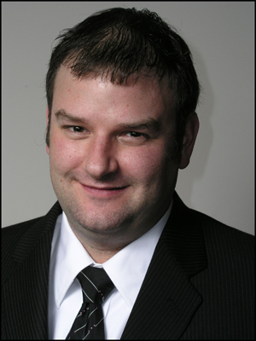

Teacher, Ginius Academy, Seoul, Korea -- 2009-2010
Todd Bruns
I taught listening and speaking to elementary and middle school students. I also largely designed the curriculum for Wednesday classes. I selected all foreign-teacher books and wrote syllabi.

Teacher, English Castle Academy, Seoul, Korea -- 2006-2008
In my first teaching position, I learned the job on the go and developed my style. I mainly taught elementary students.

Education
University of Kansas, Lawrence, Kansas, USA, Bachelors in Journalism

Skills
TESOL 120 Hour Certificate, July 2010

Referrals
Available Upon Request

