Tom Laskowski

Objective: I want to gain international work experience and provide quality education to enthusiastic students of the English language.

Education: Elementary School Diploma 1989-1999 St. James the Apostle

High School Diploma 1999-2003 Bishop Ryan H.S.

Graduated with Honours all 4 years.

Bachelor’s Degree 2003-2007 Wilfrid Laurier University
Majored in Archaeology and Forensics

Other Education: 2001-2003 New School of Drama
Advanced Theatre and Acting Workshop Certificate

- College Pro Painters
Basic Job Site Manager Certification

Current American TESOL Institute
Working on TESOL certificate

Experience:

Elite Athletes International Instructor 2007 (4 Months)

Soccer Instructor: worked with a team of qualified instructors and coaches to help young soccer athletes to reach their potential. Had to develop skill specific training programs for teams and individuals. Tasks ranged from physical work to coaching philosophy to team managers and coaches.

Talkster Language Institute 2008-2009 (March 2008 to March 2009)

English Teacher: work individually and sometimes in a pair to effectively teach English as a second language. Have to prepare effectively themed curriculums for classes that range from Kindergarten to Grade 6. Have to use good awareness, insight, communicative skills in order to teach effectively to students of this age. Tasks range from developing lesson plans to administrative duties and instruction.

Korea Herald N.I.E Academy 2009-2010 (April 2009 to March 2010)

English Teacher: helped to build a curriculum and effectively instruct English as a second language. Tasks included teaching phonics, spelling, grammar and preparation for entrance exams into High schools and University.

Lingua International Academy March 2010-March 2011
English Teacher: helped to develop a productive working environment within the academy. Tasks included teaching phonics, spelling, and grammar to Kindergarten and elementary school students.
Poly School Academy Mapo April 2011-Present
English Teacher: instructed high level students in areas of phonics, grammar, vocabulary, science and project based learning. Worked in a highly structured environment with many teachers and co-workers to produce effective results in student’s English speaking and comprehension.

Hobbies: I have a great passion for the game of soccer, otherwise known
as football. I have played every level of football throughout my life, and plan on passing on some education and skill to fellow South Koreans. I have professional and international experience from Poland and Germany in soccer and want to harness some of the passion for the beautiful game that is exuded by South Koreans.

My handphone number: 010-4633-0315

My current work schedule is 9:00 am-7:30 pm everyday.

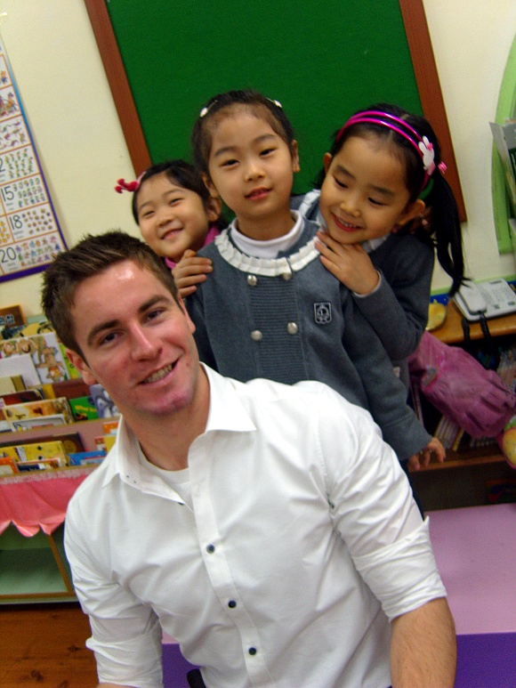
Picture taken in 2008 at my first job Picture taken in 2010 at my current job

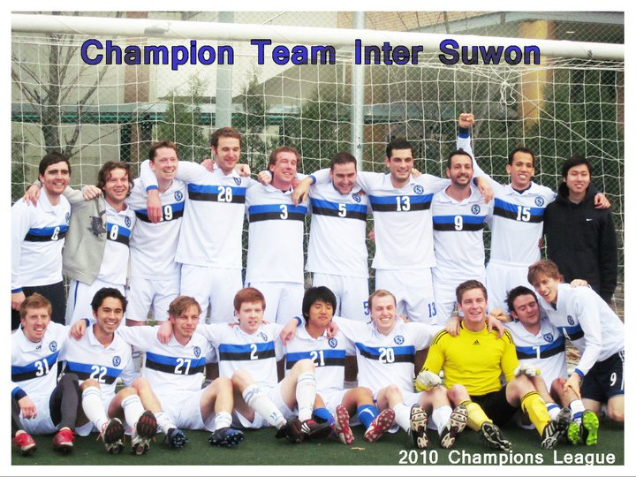
Picture taken in 2010 with my team. (I’m the goalkeeper)

