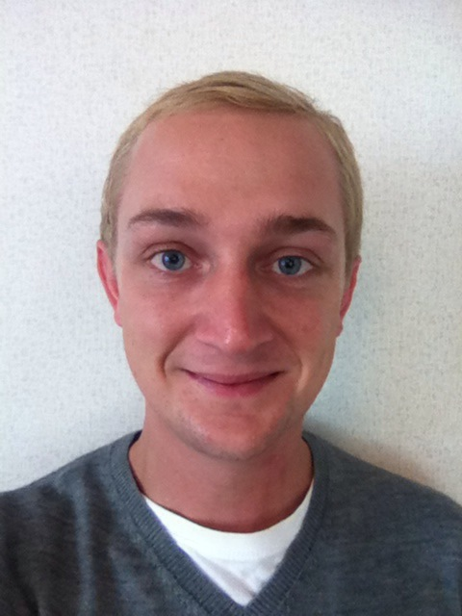
Tom Rigby
CONTACT DETAILS

Address: 양산시 Date of Birth: 1985.05.15 (28 years old)
중부동 660-6 E-mail: tgrigby@hotmail.com
양주3길 43-15 Skype: tgrigby
201호 Nationality: British
대한민국

EDUCATION

University of Leeds
2006 – 2009 | BA Joint Honours - Politics & Asia-Pacific Studies - 2:1  Dissertation Topics:  - Asia-Pacific Studies - Do China’s Investments in African Oil Pose a Threat to American Interests?  - Politics - Implications of Possible Korean Reunification.

Llanfyllin High School Sixth Form, Powys
2001 – 2004 | A-Level: Media Studies AS Level: English  French  Computing
Adams’ Grammar School, Newport, Shropshire
1998 – 2001 | GCSEs: Biology Geography  Business Studies Graphic Products (Design Technology)  Chemistry Mathematics  English Physics  French Religious Studies
COURSES

Graduate Entrepreneurship Project, Hull
2010 Yorkshire Universities’ Young Entrepreneurs Boot-camp

Windsor Schools, London
2005 | Trinity Teaching English to Speakers of Languages (TESOL) Certificate – 120 Hours

TEACHING EXPERIENCE

1/2012 – 1/2013 Native English Teacher, Kookje Foreign Language Institute, Yangsan, S. Korea
My work here was teaching extra-curricular classes to elementary, middle school and adult and University students. All school age students were advanced level. I prepared discussions and games around set topics. Adult classes were developed around relevant needs or issues, such as for academic and business purposes. The role required me to be aware of students' needs, employing superb and grammatically advanced English, necessarily adapted to engage students. I prepared challenging, communicative lessons bespoke to each class.

1/2011 – 1/2012  7/2010 – 8/2010 | Native English Teacher, Yangsan Elementary School, Yangsan, S. Korea  I led the after-school ESL program. I worked with a Korean co-teacher, preparing lessons unique to each class’s needs. We focussed on communicative, responsive lessons with student-student linguistic interaction. Other responsibilities included preparing and marking exams (reading, writing, listening and speaking), providing individual student reports, maintaining and marking students’ English Journals and Book Reports.  Native English Teacher, Action in English, York, UK  An ESL Summer Camp with pupils aged 8-16 from a range of cultural backgrounds,. I also taught elementary Business Studies to pre-fluent students. I employed my Trinity TESOL training and drew on my previous experiences to keep lessons engaging and suited to each class’ ability. I aided sports activities, as well as helping organise and supervise excursions. The role required authority, organisation and maintaining decorum whilst sustaining a positive rapport with my students and colleagues.
5/2006 – 9/2006 | Native English Teacher, Milo Kindergarten, Guangzhou, PR China  Teaching English to 3-7 years old. Involved: preparing lessons that were fun and engaging; utilising Total Physical Response techniques; teaching students and controlling classes; providing individual reports and constructive feedback to parents and the head-teacher; working with fellow teachers and giving sports classes. I also tutored pupils one-to-one.
INTERNSHIPS
9/2009 – 3/2010 | External Relations Intern, Emerald Group Publishing, Bingley, UK  I was seconded to the publishing industry, focussing on External Relations. I worked closely with scholars and authors to ensure Emerald was well represented externally and internally. Became adept with MS Office and databasing.
OTHER EXPERIENCE
6/2008 – 8/2008 | Taught Postgraduate Admissions Assistant, University of Leeds, UK  Generating and proof reading letters for grammatical or linguistic errors. Organising and distributing letters to post-graduate applicants across departments.
PERSONAL INTERESTS

- Writing - experienced in amateur, freelance journalism and creative writing. My work has been published in music and culture magazines, both in print and online. I was also a key figure in a UK-based radio station FM broadcasting application.
- Music – I hosted a radio show for 5 years, interviewing new and established artists, engaging listeners and promoting new music. I anchored the show for 2 hours twice a week, engaging the audience and generating responses. Before each show, I prepared topics, approached interviewees and selected music that would be aired.

REFERENCES
Stanley Park Dr. Jinho Shin
Kookje Foreign Language Institute Mirae Surgery
Narae Plaza 7th Floor Beomeo-ri 773-1
Jungbu-dong 692-3 Mulgeum-eup
Yangsan-si Yangsan-si
Gyeongsangnam-do Gyeongsangnam-do
South Korea South Korea

(+82) 055 3638505 (+82) 055 3625592

