Tommy, Chan Chi Wai
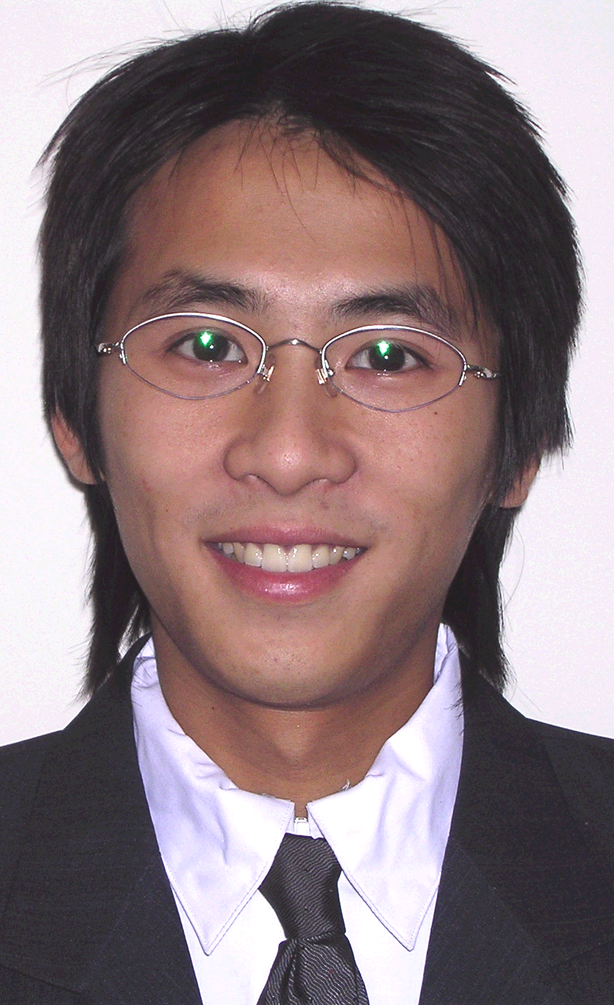
Email: tommychanchiwai@yahoo.com
Address: 168 Bonis Ave, #1615, Scarborough, ON, M1T3V6
Current location: Daejeon; South Korea
Tel: 010-7546-9979

PERSONAL INFORMATION:
Birth: 22-Feb-1983
Citizenship: Canadian
Mother Tongue: English
Marital Status: Married
Health: Good

EDUCATION BACKGROUND:
2005: TESL/TEFL Certification, Oxford Seminars, Toronto, Canada
2006: Bachelor of Art - English Studies, - York University, Toronto, Canada

EXPERIENCE:
2007 December – Present: English translator and clerk,
Tai Seng Co. and Ltd., Hong Kong
2007 June - 2007 November: English Teacher, Sujeong Elementary School, Daejeon, South Korea (1 semester contract)

2006 November - 2007 November: NET, REI English Academy, Daejeon,
South Korea (1 year full-time contract)

2006 August – 2006 September: Volunteer teacher for children with special education need, Under the Banyan Tree, Toronto, Canada (One month volunteer)
HONORS & RECOGNITION:
Life Saving III
Teaching English as a Second/Foreign Language Certificate

SKILL AREAS:
Patience with children and teenagers, excellent discipline skill, fully bilingual in Chinese and English, work well in groups or independently, excellent communication skills, excellent IT skill, excellent swimming skill

OVERSEAS TRAVEL:
Japan, Hong Kong, China, Korea, U.S.A., Canada, Italy, Switzerland, U.A.E., Thailand, Germany, France

REFERENCES & TRANSCRIPTS:
Available upon request:
Copy of Degree
Copy of TESL/TEFL Certification
Copy of Canadian Passport
Copy of Criminal Background check
Copy of Transcript
3 reference letters

