Vanessa Farish  #443-470, Family Tower 614  Yeongtong-dong 958-2 Bungi  Suwon-si, Gyeonggi-do  cell: 010-5848-1107  vanessafarish@gmail.com | 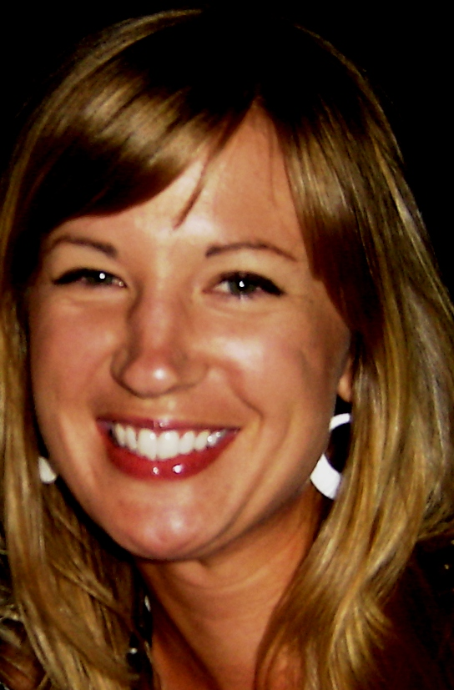  Objective
To obtain a challenging and rewarding position as a university
professor teaching English to native Korean speakers.

Education

8/1994 – 6/1996 Biola University, La Mirada, California
9/1996 - 6/1998 University of California at Irvine, Irvine, California
- Bachelor's Degree in Theater Arts
 | Work Experience

English Teacher
06/2009 – Current DYB Choisun, Yeontong-dong, Suwon-si, Gyeonggi-do
- Work as “Foreign Teacher” at DYB, which is one of the most widely respected and established English hogwans in Korea. In this position, I am responsible for up to 9 classrooms per day with children from elementary to middle school age of varying ability levels. Using DYB generated materials, I am responsible to create lesson plans for each class, and to elicit as much communication from students as possible.

Administrator/Director
11/2007 – 1/2009 KIDA, Kids Institute for Development & Advancement, Irvine, CA
- Responsible for development of this brand-new autism therapies clinic from the “ground up”. Wrote business plan and operations manual, designed systems for A/R, office management, and curriculum, created marketing materials including website and brochures, proof-read and edited sensitive company documents, planned events both on- and off-site for VIP’s and prospective clients.

Substitute Teacher/Singer-Songwriter
9/2005 – 11/2007 Moreno Valley Unified S.D., Moreno Valley, CA
Huntington Beach Union H.S.D., Huntington Beach, CA
- Substitute teaching requires immense flexibility as everyday is a new experience with new kids, a new school, and new challenges. I supported myself as a part-time singer/songwriter during this period, as well, using the name “Vanessa Jourdan”. Created my own website and self-produced three full-length cds, did all my own marketing and promotion, and acted as manager for my band.

Center Director
10/2001 - 3/2005 Sylvan Learning Center, Riverside, CA
- I began at Sylvan as a Director of Education (designing student programs) and was later promoted to Center Director. As Center Director, I was responsible for all aspects of center management, including staff management, program sales and marketing, accounts receivable, and all parent/school related contacts.

Temporary Office Worker
7/2001 - 10/2001 Apple-One, Riverside, CA
- Administrative assistant work in the Human Resources Dept. of Kaiser Permanente in Riverside through Apple-One.

High School English, Drama and Music Teacher
8/2000 - 6/2001 Bethel Christian Center- High School, Riverside, California
- Taught 9th-12th grade English, as well as two Drama classes and one Music class.

Production Assistant/Office Manager
5/2000 - 8/2000 Arsenal Productions, Los Angeles, California
- Assisted in all aspects of music video and commercial production, including regular contact with record label executives and high profile directors. Solely responsible for management of files, mailing and all other office duties.

Communications Manager
3/2000 - 5/2000 Modern Video Film, Burbank, California
- Constructed daily schedule, managed all receipts and managed communications for this post-production facility.

Teacher
6/1998 - 3/2000 Sylvan Learning Center, Riverside, CA
- (Worked full-time 6/98-10/98, part-time to 3/00)Taught English to students of all ages at this educational facility. Worked on an individual level with parents and teachers to increase students' success.

Teacher
10/1999 – 3/2000 John Muir Middle School (LAUSD), Los Angeles, CA
- Taught 6th grade CORE English and Social Studies on Emergency Credential. Managed all aspects of the classroom, constructed lesson plans, and met with parents and school administrators.

Temporary Office Worker
10/1998 - 10/1999 Apple-One; Sloan Agencies; AES, Riverside, CA; New York, NY; Los Angeles, CA (respectively)
- Performed administrative assistant and executive assistant duties at all job locations. (Detailed individual job descriptions available upon request.)
 | Skills
 | Microsoft Office (Word, Excel, Powerpoint) Internet Research Peachtree Quickbooks 85wpm Notary Public Bilingual – Some French Guitar
 | References
Pamela Russell - English Conversation Instructor, Myongji University, Yongin - 010-7751-5242
Kelly Pak - English Conversation Instructor, Myongji University, Seoul - 010-8123-0148
Pyong-Jin Kang – Native Teacher, DYB Choisun, Yeongtong - 010-3387-3210

