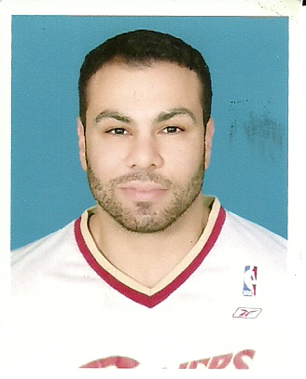

Waleed Elabed waleedelabed@live.com
Jabr Bin Mohammed Street, Doha, Qatar 974.512.7298

English Teacher

- Canadian Citizen
- Demonstrates patience and understanding while teaching
- Discipline and conscientious work ethic proved to be key assets
- Well versed in Microsoft Office including Excel, PowerPoint, Word
- Very successful with teaching methods applied
- Sports background allow for easy coaching and high level of confidence and self worth

Professional Experience

Primary School Teacher 2009 - 2010
Al Mahd International School Doha, Qatar
- Taught across primary key stages
- Teacher of grade 1 with pastoral care (home room teacher)
- Teacher of British curriculum English
- Teacher of British curriculum Math
- Teacher of Drama/PE

IELTS Course Teacher 2009 – 2010
Edu-Tech Doha, Qatar
- Introduced high school students to key concepts and strategies for IELTS English exam
- Examined and conveyed understanding in reading, speaking, writing and listening modules
- Overcame countless challenges with language and discipline with excellent results

Waleed Elabed waleedelabed@live.com 974.512.7298 -2-

Baseball Coach 2005 - 2008
University of British Columbia Summer camps Vancouver, BC
- Instructed children from 6-16 through fundamentals and techniques
- Took the children through countless drills and video analysis
- Instilled the importance of healthy and active lifestyle
- Supervised children in away fixtures

Manager/Sales Coordinator 2005 - 2008
Target Fitness and Health Services Vancouver, BC
- Screened and developed relationships with personal training companies to ensure harmony with top level trainers and physiotherapists
- Conducted face to face and telephone focus groups to determine interest in facility and room for potential improvement
- Oriented new employees and monitored their progress
- Maintained excellent client relationships, securing trust and confidence while providing honest and capable service
- Sold membership packages and constantly up sold packages to include physiotherapy and personal training to constantly meet 40 000 dollar monthly quota
- Overcame countless objections while tactfully and sincerely selling our service as top facility in the city

Semi – Professional Baseball Player 2003 - 2005

EDUCATION

Associate Arts Degree 1999 – 2001
Glendale Community College

Bachelor of Arts 2001 – 2003
University of British Columbia Vancouver, BC

References Available Upon Request

