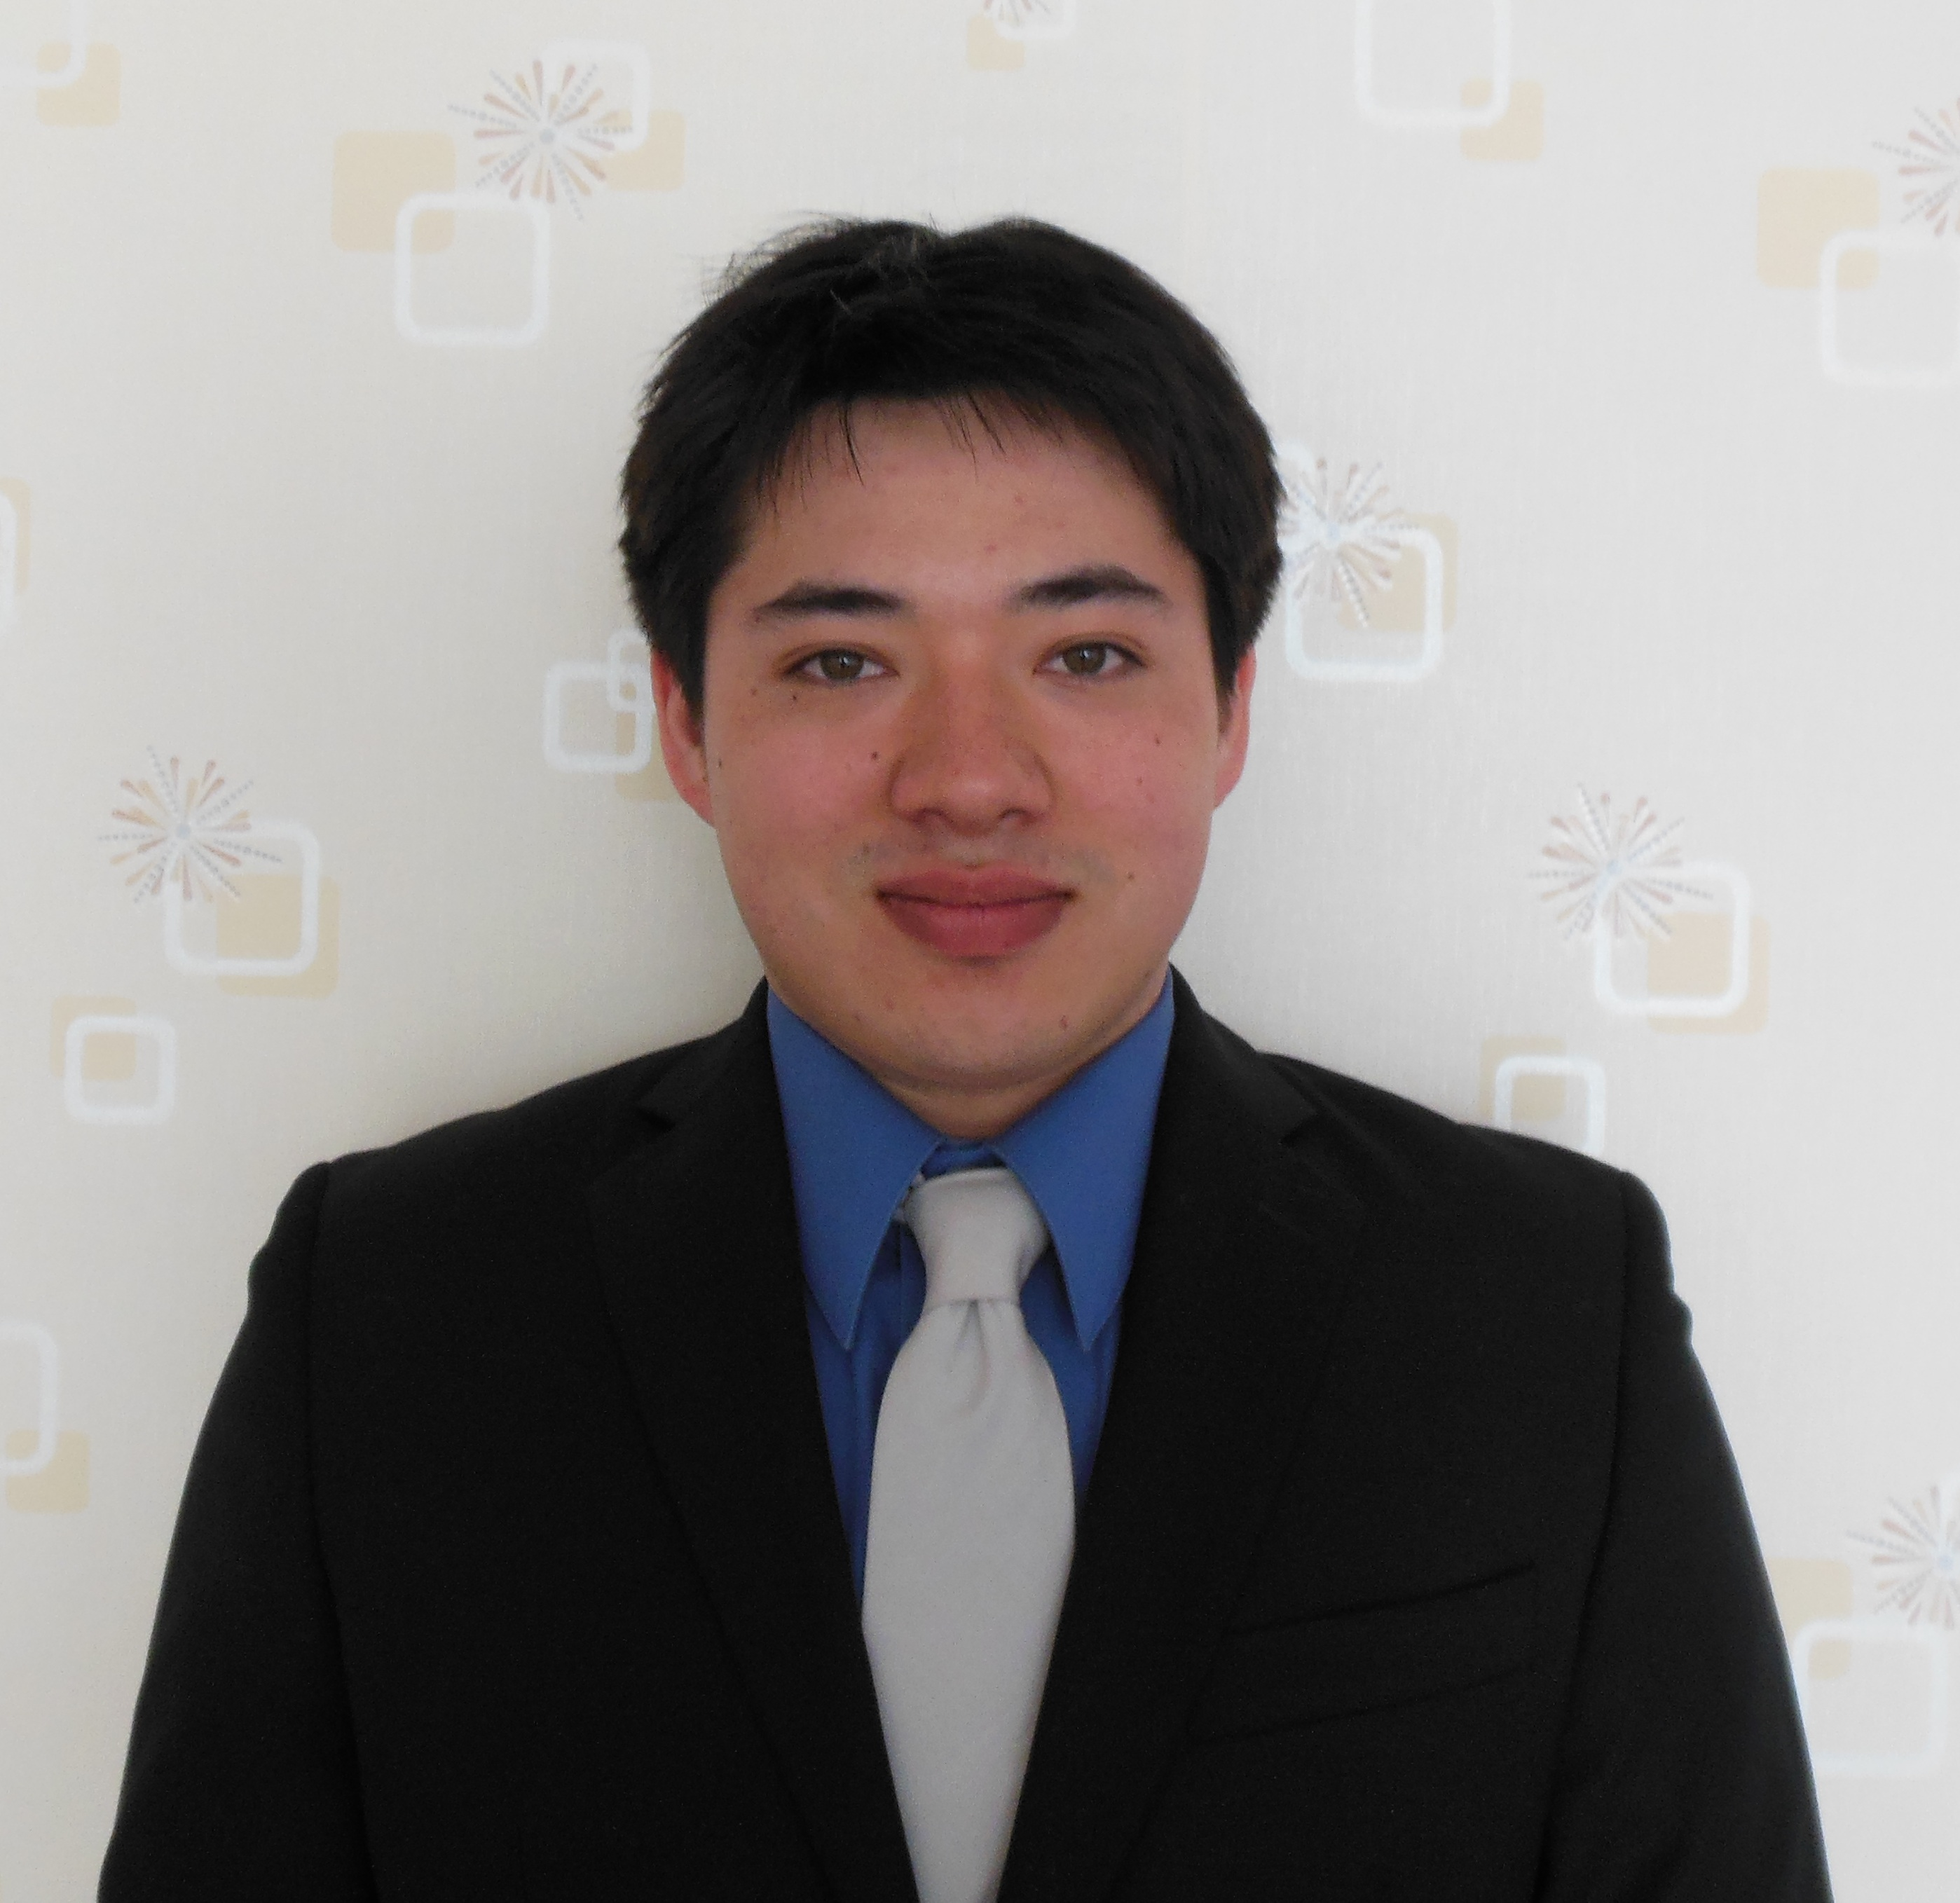

WAYNE EDWARD KEPNER_____________________________________________

4220. West 2nd Street Cellular: (323) 470-5861
Los Angeles, CA 90004 E-mail: wkepner@gmail.com

EDUCATION
University of California, Los Angeles Sept. 2006 – June 2012
Bachelor of Arts, Major in History & Minor in Cognitive Science
- Cumulative GPA: 3.5
- Coursework in Economics, Financial/Managerial Accounting, Computer Programming, Psychology and History: Asia, Africa, Europe, US.
- Graduated Los Angeles Center for Enriched Studies, California as a Valedictorian with a 4.25 cumulative GPA
- SAT I: 1430 (680 Math, 750 Verbal)

PROFESSIONAL EXPERIENCE
RedLight Fusion, Inc. Los Angeles, CA
IT Personnel, Field Technician Nov. 2004 – Jun. 2006
- Provided comprehensive technical support for individuals and small businesses; worked both on-site and through remote terminal.
- Responsibilities included: Virus / Spyware / Pop-up Removal, Data Backup and Recovery, Hardware and Software installation, Windows upgrades and updates, Custom-built computers, Wireless Network Installations, Web Design, Advice and Troubleshooting.

Charles & Co. Los Angeles, CA
Textile Importing, Junior Accountant June 2005 – June 2007
June 2010 - Present
- Advised Intuit QuickBooks operations resulting in the restructuring of firm-wide accounting practices to properly account for assets, liabilities and equity as well as income, expenses and free cash flow.
- Staffed and managed a payroll of 15 employees, obtaining an understanding of financial and managerial accounting along with the fundamentals of operating Intuit QuickBooks.

SKILLS / PROFICIENCIES
- Operating systems: Windows 95, 2000, NT, XP, and Vista; familiarity with Linux and Apple.
- Applications: Microsoft Office, Adobe, Symantec, Kaspersky.

*References available upon request

