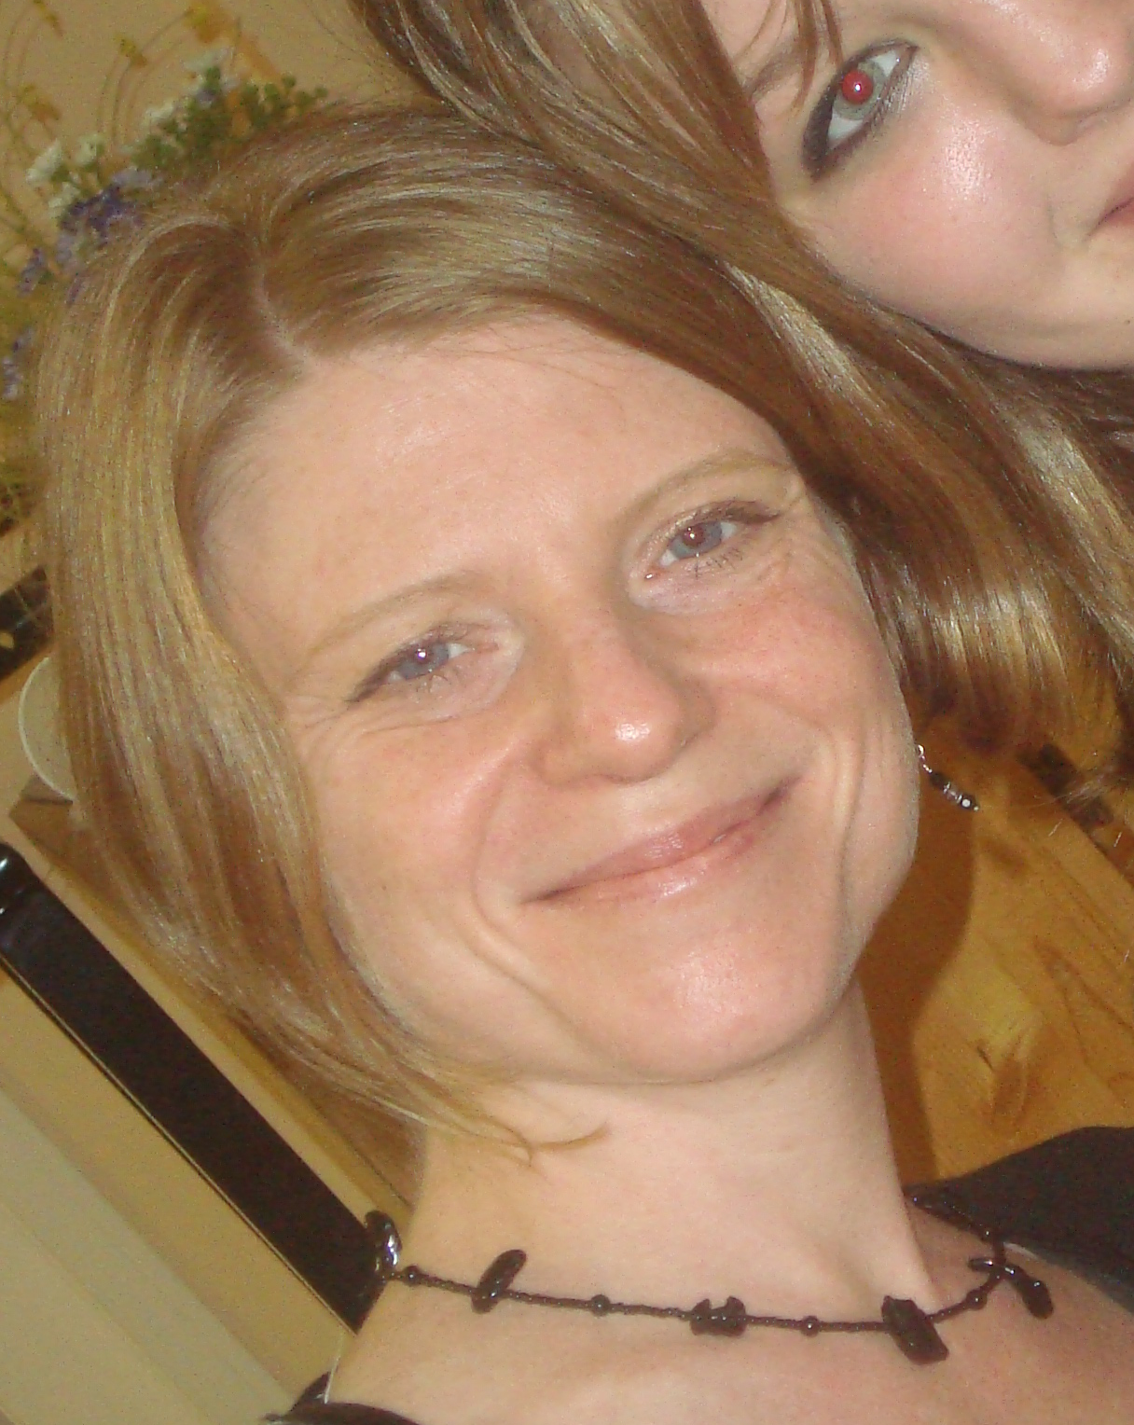

Wendy Taylor
1601 Third Ave, Apt 14C New York, NY 10128

Objective: To have the privilege of teaching ESL in Korea

Education: Bachelor of Arts degree in Speech/Theatre from Wagner College,
Staten Island, NY

Certified Yoga Teacher, trained at The Mindful Body, San Francisco, CA

Teaching Related Experience

Yoga: The Mindful Body, Jewish Community Center, Drew High School, Lowell High School: San Francisco, CA

Pre-school: Bella Mente Early Learning Center: Seattle, WA

Current Work Experience:

Yoga: 8 Limbs Yoga, All Star Fitness, Golds Gym, Northwest Community Yoga: Seattle, WA 9/08----Present
Childcare: Caring for the child of Amber Tande, age 1. Duties include feeding, reading, changing diapers, keeping child safe and happy: Seattle, WA 9/08---Present

Miscellaneous: Experience babysitting for children aged 6 months - 12 years since 1995
Worked as a professional actress in various plays and films in New York City and San Francisco, including two national tours doing children’s theatre.
Traveled to Europe, Israel and lived in India for 3 months.

Language Skills: Basic Hebrew

Hobbies and Interests: Film, being with children, yoga, meditation, hiking, music

References: Hillary Bergmann, manager of The Mindful Body : 415-608-1910 xxx

Amber Tande, current employer, owner of Raincity Yoga and Sutra Restaurant : 206-335-2324

