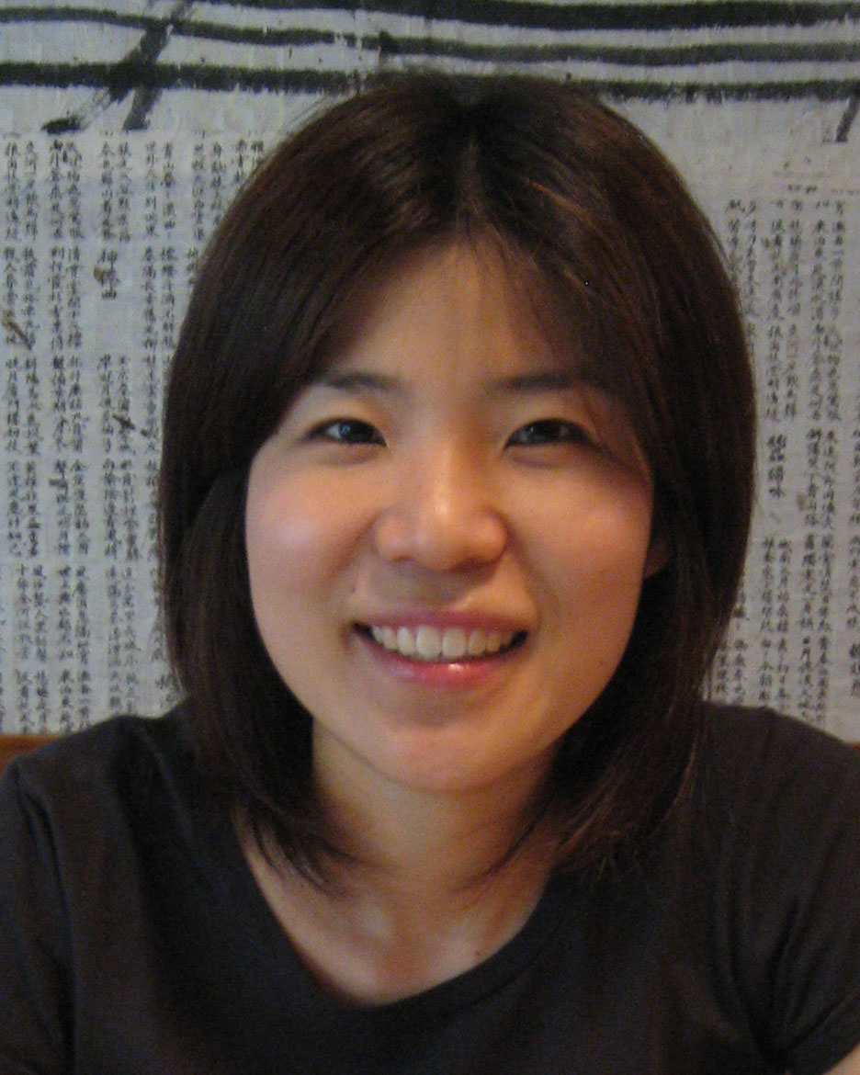

Park, Young Eun (박영은)
Current Address:
Mok-2-dong 231-239 302-Ho
Yangcheon-gu, Seoul, Korea
010-4948-1563
Yepark8081@hotmail.com

OBJECTIVE | To obtain ESL Teaching position.
EDUCATION | BACHELOR OF HUMANITIES, English Literature - February 2004  The University Suwon, Korea
RELATED SKILLS | - Five years of teaching experience.  - Experience with all skill levels.  - Taught children age 5 to Adults.  - Able to work independently and quickly.  - Experience with lesson planning.  - Experience consulting with parents on the phone.
WORK EXPERIENCE | - Evan English School – Mokdong, Seoul  August 2007 - August 2008  - Korea Herald School – Bupyeong, Incheon  July 2006 – June 2007  - Child U – Bupyeong, Incheon  March 2005 – August 2005  - Chungchul Junior Language Institute – Inha Campus, Incheon  September 2004 – March 2004  - Global Language Institute – Juan, Incehon  December 2003 – May 2004

