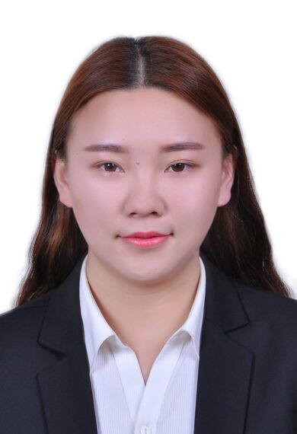
Personal Information: 个人信息
Passport size photo: 请付证件彩照

Chinese Name(中文姓名） : 张米歌
English Name（英文名）: Zio
Gender性别: Female
Ethnic 民族： 汉族
语言能力 Language ability: 英语CET-4
Date of Birth生日: 1994.1.12
Tall身高: 164cm
Highest Degree最终学历: Bachelor
Passport no护照号码:
China ID card no身份证号码: 61232519940112032X
Mobile phone 手机号码： 18591600189
Landline:座机号码：

Personal Character个性描述:
走过很多地方，同很多陌生人聊过，我的视野开拓，性格乐观包容，喜欢拥抱这个大世界，遇见不同的人。不同的文化碰撞使我感受到这个世界的奇妙。拥有这些生活和旅行的经历，我完全可以适应环境，独自生活，并且我擅长很好的与各种生活背景下的人相处。希望可以有一个机会向大家展示我的温暖，分享我的故事和见解。
Having travelled to so many places and talked to so many strangers, my mind and view have become wide open and my characters easygoing and tolerant. I love going outside to touch the huge world and to meet people with different personalities. Those conflicts between different cultures make me feel this world amazing and people living in different conditions makes me realize how mystical this world is. With all these life experiences and travelling experiences, I can totally handle any unexpected situations by myself and live on my own. What’s more, I can get along with different people with different life backgrounds. I hope I can show people how warm I am and share them with my stories, my views and opinions.

Other information对中文教师工作的看法:
在我看来，中文不仅是一门语言，更是连通世界的工具。看见越来越多的外国人开始学习中文，这让我非常自豪，同时也激励我想成为传播中华文明中的一员。我可以让更多的人了解中文以及我对中文的热爱。虽然可以预想到作为一名新的中文老师会面临很多困难，但我已经准备好用我特别的经历去正视、克服这些障碍。最终，我会交到难忘的朋友，收获一项我这辈子都会珍惜的生命体验。
At my point of view, Chinese is more than a language but a tool to bridge the whole world. Seeing more and more foreigners from all over the world learning Chinese makes me feel so proud and also inspires me to be one member of those who are broadcasting it. That I could let more people know Chinese and love Chinese is such a wonderful and exciting thing for me. I could imagine there could be a lot of difficulties in front of me as a brand new Chinese teacher, however I am totally prepared with my previous experiences, to embrace, to overcome and to conquer those obstacles. Finally, to gain one experience that I will cherish in the rest of my life, to make friends that I will memorize for a whole life.

Education教育经历:
University : Northwest University​​
年份： From 2011 To 2014
Major专业: Auditing
Degree学历:
GPA（平均成绩点数）:

University : Ankang University​​
年份： From 2014 To now
Major专业: Auditing
Degree学历: Bachelor
GPA（平均成绩点数）: 2.84

Skills and Qualification: 个人技能和所获证书（英文等级资格证等）：
English Level： CET-4
Mandarin Proficiency Test： Level 1,Grade A二级甲等
Familiar with MS software application.
WORK EXPERIENCE: 工作经历
Employer#1 第一份工作 | Volunteer in hostel
Date of Employment 任职期 | From Jun.2014 to Sep.2014  From Jul.2015 to Sep.2015
Work place任职地点： | City

Employer#2 第二份工作 | Reception desk in hostel
Date of Employment 任职期 | From Dec.2015 to May 2016
Work place 任职地点： | City

ACTIVITIES AND INTERESTS个人兴趣及爱好：
Writing ,Singing, Running

Plz check my photos on the next page
다음 페이지에서 사진을 확인해주세요 :)
