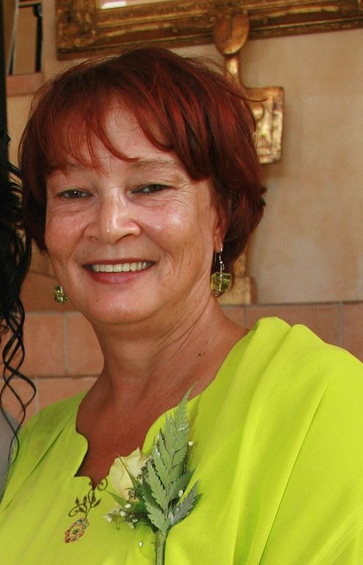

CURRICULUM VITAE OF E.A. LEANDER

PERSONAL INFORMATION
Names : Elizabeth Alice
Surname : Leander
Postal Address : 16 Heemro Place
: Heath Park
: Port Elizabeth
: 6059
Date of Birth : 25 August 1957
Identity Number : 5708250113084
Age : 52
Gender : Female
License : Code 08
Criminal Record : None
Nationality : South African
SACE reg. number : 28342
Languages : English and Afrikaans : (read, write and speak)
: Xhosa (rudimentary)
:00966 (0) 530021179
Contact Numbers : 0027(0) 41 481 9090
: abigail.leander@gmail.com
SECONDARY EDUCATION

High School Attended : St. James High School
Highest Grade Passed : Grade 12
Subjects : English First Language HG
: Afrikaans Second Language HG
: Biology HG
: Mathematics HG
: Accounting HG, Geography HG.
TERTIARY EDUCATION

Institution : University of Western Cape
Courses : BA.STD. (1976-1981)

Institution : University of Port Elizabeth
Course : F.D.E. (English) Cum Laude
1996-1997
Institution : Rhodes University
Courses : BA HON. (English Language & : Applied Linguistics) - 2001-2002.
: M.A. (English & Applied Ling.)
: 2003-2006.

ADDITIONAL COURSES : Computer literacy course
(Bethelsdorp Tech. - 1993)
: Xhosa Conversational course
(ALD 1997, 1999)
: Curriculum Studies
(6 month course)
: (National Private Colleges -1998)

EMPLOYMENT HISTORY
Institution : King Khalid University
Period : September 2009- July 2010
Job description : Lecturer: English Language
Skills: Grammar 4,Vocabulary 4
Listening & Speaking4, Reading3.

Institution : Mary Waters S.School.
Period : September 1999 - December 2008
Job Description : Teaching English Home & First
Additional Language
(Grades 8-12). H.O.D. Languages.

Institution : Booysen Park Secondary School
Period : January 1986 -1999.
Job Description : Teaching English 2nd Language,
(Stds. 8-10), H.O.D. (English)

Institution : Arcadia S. Sec. School.
Period : January 1982- 1984
Job Description : Teaching English Second language : (Stds. 7-8)

REFERENCES

Dr. Hizbullah Al-Sindy
(Dean of English
King Khalid University
Abha.
Tel: 00966(0)50306970.

Mr. E. Bosman.
(Principal)
Booysen Park S.School.
Port Elizabeth.
Tel: 0027 (0)41-4831984.

Mrs H. Alfers
Rhodes University (Extended Studies Unit)
Grahamstown.
Tel:0027 (0) 46 – 6038863.

~~~~~~~~~~~~~~~~~~~~~~~~~~~~~~~~~~~~~~~~~

PROFILE: Elizabeth Alice Leander

CAREER-RELATED EXPERIENCES:

I have been teaching English as a subject for 28 years to learners from grade 8 to 12, both as additional and as home language. Since 1999, I have been involved in O.B.E, filling the position of co-ordinator as well as Head of Department of English. In these positions, I usually I worked in teams of 8 to 15 teachers. As Head of Department, I have been part of the Senior Management team which oversees school- and teacher management and development. I have also been involved in day-to-day teaching, assessment and co- curricular activities.

My dissertation for the M.A. degree explicated the contextual factors that influence learners’ reading abilities at primary and high school (specifically at government schools). Consequently, I initiated a Remedial Reading programme for grade 8 learners who were academically hampered by their reading deficiencies.

Given my experience in the field of teaching English, I am confident that I have the necessary skills to fill a position at your school. In the aspects where I do not meet your requirements, I can assure you that I will acquaint and educate myself in due course.

Yours truly,
E.A. Leander.

