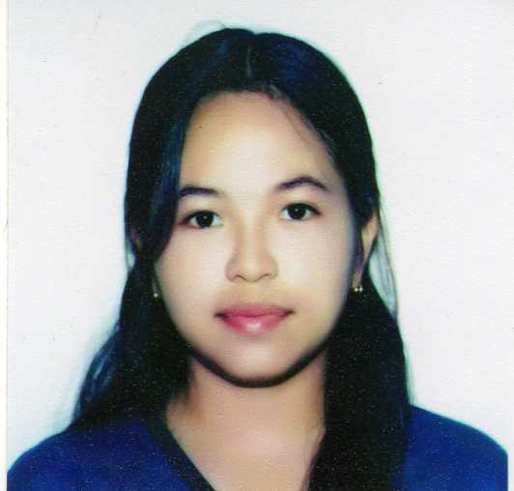
ALELYN APETA GREGANDA
 경기도 수원시 장안구, 마릇들길 127 713호 (정자동 29-1 신미주Apt)-Korea 440-831
 +821041591207
 yangalelyna@yahoo.com

 PROFESSIONAL OBJECTIVES
To work in the best working environment abroad, where I could enhance my work experiences towards career development and financially improve my family’s welfare.

 WORKING EXPERIENCES
July 1, 2008 – Oct 30,2009 PROCTER & GAMBLE PHILIPPINES INC.
(ADVAN INTEGRATED SERVICES INC.)
#10 Main Avenue,Light Industrry & Science Park, Cabuyao, Laguna Philippines
Engineering Office Assistant
 Filing and organizing forms and creates documentation report for easy access forms and documented papers necessary for the operations.
 Answers business related calls and informs the concerned personnel.
 Assists purchasing officer in following up and checking vendor’s and suppliers.
 Performs other related functions as maybe assigned from time to time.

March, 2003 – August 15, 2005 PROCTER & GAMBLE PHILIPPINES INC.
(PEERLESS INTEGRATED SERVICES INC.)
#10 Main Avenue,Light Industrry & Science Park, Cabuyao, Laguna Philippines
Module Encoder
 Do payroll and timekeeping of all project personnel (80-100 pp’s / shift).
 Assure enough supplies and materials needed for the incoming production shift.
 Filing and organizing forms and creates documentation report for easy access forms and documented papers necessary for the operations.
 Inputs leaves and absences of the project personnel and informs the immediate supervisors for review and immediate action plans.
 Answers business related calls and informs the concerned personnel.
 Performs other related functions as maybe assigned from time to time.

September, 2001 – December , 2001 NEC- COMPUTER STORAGE PHILIPPINES INC.
Technopark, Binan, Laguna Philippines
Test Line Operator
 Assigned in card removal and unloading station.

May, 2001 – July , 2001 NEC- COMPUTER STORAGE PHILIPPINES INC.
Technopark, Binan, Laguna Philippines
Test Line Operator
 Assigned in tester station such as Final, SRST and Function Testers.

 RELEVANT SKILLS
 With effective communication skills.
 Proficient in MS Word, Excel, Power Point and other windows application.
 Know how to operate simple office equipments i.e. copier machine, fax machine, plotter and printing machine, scanner and computer.
 Managing Office Support Admn.

 EDUCATION
2009 MFI Technological Institute
Brgy. Uno, Crossing Calamba City
AUTOCAD – 2 months with complete certification

2001 TERTIARY COLEGIO DE SAN PEDRO
Pacita Complex, San Pedro Laguna Philippines
Computer Technician - Graduate

1999 SECONDARY BINAN NATIONAL HIGH SCHOOL
Sto. Domingo, Binan Laguna Philippines
High School

1995 PRIMARY MALABAN ELEMENTARY SCHOOL
Malaban, Binan Laguna Philippines
Elementary

 PERSONAL INFORMATION
Nickname : Lyn
Birthplace : Binan, Laguna Phils.
Birthdate : March 23, 1982
Weight : 44.7
Height : 5’
Religion : Roman Catholic

 REFERENCES
 Available upon request…

