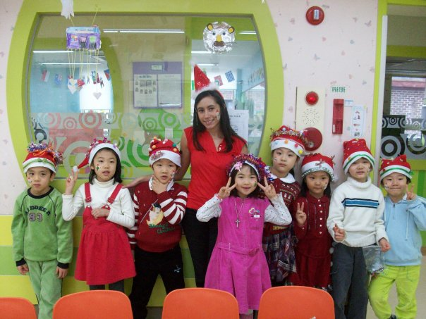
Amanda rodriguez
mailto:Amanda25Rodriguez@gmail.com 30 Montrose Avenue, Brooklyn, NY 11206
PHONE (718) 388-8530

objective
To obtain a teaching position where I may utilize my positive attitude, abilities as a diligent worker, and academic knowledge for the training and care of children.

Experience

2011- 2012 The Fort Greene/Clinton Hill Cooperative Preschool New York, NY
http://www.thecoopschool.com/
Assistant Teacher
- Provided a proper learning environment through various types of learning activities for children such as play, music, games and outdoor activities to encourage the development of motor, verbal and social skills.
- Applied basic care needs, including supplying proper nutrition, performed cleaning duties and coordinated naptime.
- Monitored the progress of the children and discussed their educational development with parents.

2009- 2010 YBM Sisa/ Jamsil ECC Seoul, S. Korea
ESL Teacher
- Enabled children to effectively communicate in English through lessons of English grammar, writing, reading, speaking, and listening skills.
- In addition to English, taught an array of subjects to kindergarten students including math, science and art.
- Administered tests, assigned homework, and managed behavior of students.
- Prepared and implemented ESL teaching lesson plans.
- Assessed students English abilities and completed monthly evaluations.
- Attended teacher workshops and seminars to further develop my teaching skills.
Education
SUNY Fashion Institute of Technology BS- 2007 in Advertising and Marketing Communications

Qualifications
- Through extensive travel and growing up in a diverse city, I have the ability to develop rapport with people of all cultures and ages.
- With past experience in event planning, I am able to multitask many different projects and prioritize against tight deadlines, without losing attention to detail.

References

Katie Baek
Academic Supervisor
YBM Sisa/Songpa ECC
Office: 82-2-402-0509
kyungna_baek@hotmail.com

Hyun Jaewon
English Teacher
YBM Sisa/Jamsil ECC
Direct line: 010-9226-9823
kyungna_baek@hotmail.com

Meredith Gray
Director
The Fort Greene/Clinton Hill Cooperative Preschool
87 Irving Place, Brooklyn NY 11238
Office: 347-721-3408
meredith@thecoopschool.com

