Anthony Michael Gaskell

E-mail: tonygaskell@hotmail.com

Currently residing in England, UK
Full documents ready for Korea, and residence permit for China
Call between 7-9pm only as I need to be by phone

Dear Sir or Madam,

Please allow me to introduce myself: I am Anthony Gaskell, a British Citizen and Teacher, currently residing in England. I am seeking employment anywhere in the world and open to many other locations.
I have completed all contracts whether large or small, to enable me to see many different schools and teaching practices.

I would now like to settle down in 1 school. I have taught Communication, Debate, Business English and English Speech to students whose ages range mostly from 5 to 50 years of age. I have also taught kindergarten children. I truly enjoy teaching. It is a highly rewarding experience.

I find that teaching is a career I should have chosen many years ago. There is truly no reward as great as the look in a student’s eyes when he realises a truth and applies it in his life. “The greatest gift of Man is knowledge.” is a motto I have come to live by.

I have attached copies of all credentials which you may request and stand ready to hear from you at your convenience. I welcome an interview either by phone or in person and am prepared to teach with your school on mutual agreement as to conditions and terms. I am available immediately. My credentials are in summary:

• I am a citizen of the United Kingdom
• I possess:
• Bachelor of Science Degree (Honours) in Chemistry and Medical Laboratory Sciences
2 Honorary Masters / PhD in Chemistry and Science
• Experience in ESL, having taught for more than 2years
• Valid Passport of the United Kingdom (expires 2016)
- TEFL, TOEFL Certification
- Business English Certification
- Grammar Certification

I look forward to hearing from you at your convenience,

With warmest regards,

Anthony M. Gaskell
NOTE: Currently all papers ready for Korea
Work permit until March 2009 for China
Green Card Holder


Resume of Anthony Gaskell

E-mail: tonygaskell@hotmail.com

Name: Anthony Michael Gaskell Citizenship: U.K.
Height: 5’7” D.O.B. 7/15/65
Weight: 175lb Health: Good
Eyes: Blue Hair: Blonde

Experience:

1/2007 – Present: School camps in Singapore, Thailand, Hong Kong, Korea and China. I taught in various schools for fixed periods, to expand my knowledge of teaching in different cultures. Each was under the local regulations and laws.

1/2006 – 12/2006: Sunson Middle School, Zheijiang Province. I was employed as the only native English speaker teaching oral Business English to several hundred students. . My duties included but were not limited to designing new curriculum, marketing, and instruction of English to paying students. I left, completing my obligation. I am held in high regard here.

1/2005 – 12/2005: English Language Center, Ulsan, Korea. I was employed as an English Teacher where my duties include but were not limited to designing new curriculum, marketing, and instruction of English to paying students. I left, completing my obligation. I am held in high regard here.
Supervisor: Albert Kim.

3/2004 – 1/2005 Allied Chemical Corporation, UK. I was employed a communications instructor where my duties included but were not limited to teaching communications and speech skills to chemists and engineers within the firm. I improved their skills so as to improve the bottom line of the company. I left on good terms. I am held in high regard here.
Supervisor: Mr. Kennedy, Chief Operating Officer.

1/1991 – 3/2004: Geneva Steel Company, UK. I was employed as a Research Chemist where my duties included but were not limited to primary research and applications testing of new polymer blends. I left when the company was acquired by a larger firm. I am still held in high regard there.
Supervisor: Mr. Charles Windsor III.

Education & Awards:

1983: Graduate, Rainhill High School, Rainhill, England, U.K. where subjects were general academics with preparation toward university studies. Award: Diploma.

1986: Graduate, Leicester Polytechnic University, Leicester, England. U.K. where subjects were general education and specialized studies toward that of a research chemist. Award; BSc Chemistry (Honours)

2005: Chartered Scientist Award, Royal Society of Chemistry, London, England. I was awarded this certification in light of my contributions to the field of Chemistry and service to the industry.

Hobbies and Interests: Computers, Travel.

*References both personal and private available on request *

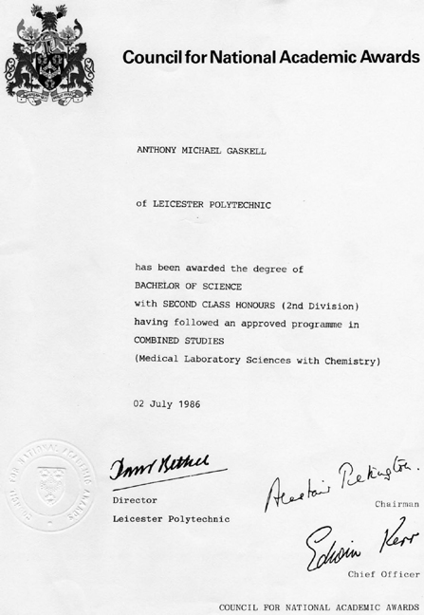
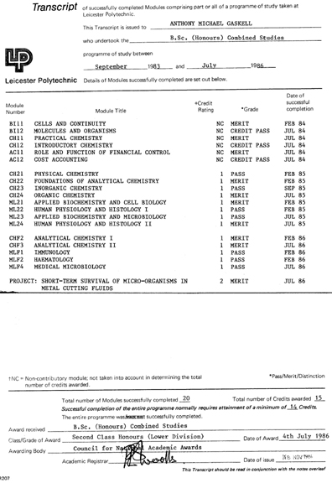

Transcripts

Diploma

END OF DOCUMENT

