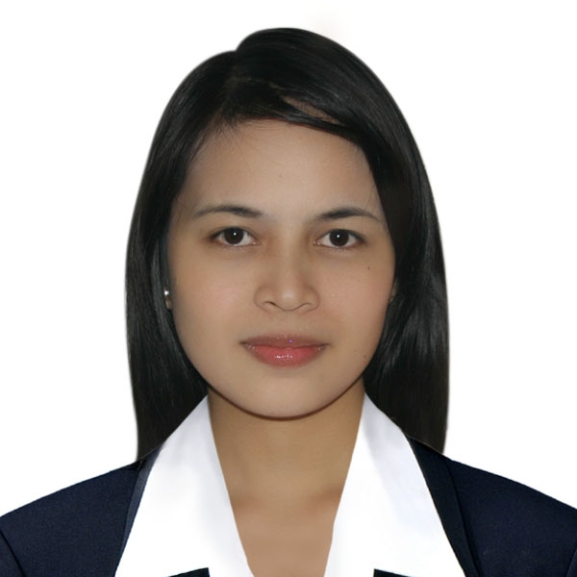
APRIL ROSE D. YANGSON
#280 MOLINO 3, BACOOR CAVITE
PHILIPPINES
09267517095
e-mail: aprilrose_cute10@yahoo.com
……………………………………………………………………………

OBJECTIVE: I want to obtain a position of an English Tutor in a school where I am able to utilize my expertise, knowledge and experience in teaching children as well as adults about English. I view teaching as an interactive and dynamic process.

OTHER PERSONAL DATA:
BIRTHDAY : April 10, 1987
BIRTHPLACE : Pintuyan Southern Leyte
SEX : Female
CIVIL STATUS : Single
CITIZENSHIP : Filipino
HEIGHT : 5’2’’
WEIGHT 45 kls.
BLOOD TYPE : O+

WORKING EXPERIENCE:

Online English Tutor
September 1, 2010 up to present
OMC Korea
#380 Molino 3, Bacoor, Cavite

*Korean-English Tutor
March 23, 2010-September 15, 2010
Moohan Academy
Pilar Village, Las Pinas City

*Korean-English Tutor
December 22-February 12, 2010
E4U (Education 4 U)Academy
English Center
Zapote Road, Las Piñas City

*Korean English Tutor
July 13-August 20, 2009
NICE Academy
Pilar Village, Las Piñas City

*Dental Nurse
April 2008-July 2009
Porley-Legaspi Dental Clinic
16 Dahlia St. De Castro Subd.
Sta. Lucia, Pasig City
Porley-Legaspi Dental Clinic
Lot 9 Blk9 Incinitas St. Covina
Subd. Brgy. Buhay na Tubig
Imus, Cavite

EDUCATIONAL BACKGROUND:

LEVEL NAME OF SCHOOL DEGREE/COURSE INCLUSIVE DATES

Elem. Pintuyan Central School 1994-2000

Secondary Pintuyan National High School 2000-2004

College University of Perpetual Help Bachelor of Science 2004-2008
Molino in Nursing

SKILLS/HOBBIES:
>Computer Literate
>Cooking
>Drawing
>Writing Poems

SEMINARS/ TRAININGS ATTENDED:

Enlgish Language Training
July 27, 2009-August 10, 2009
NICE Academy
Pilar Village, Las Piñas City

Total Quality Management: Not a Destination,
But a journey towards Improvement

Personality Development: A process of Self Becoming

Integrated Management of Childhood Illness

REFERENCES:

NAME ADDRESS CONTACT NO.

*Floramor D. Castañares B5 L22 Cardinal Vill.1 0920225388
Acting Accounting Head Dasmariñas,Cavite
Dasmariñas Water District

*Ederlina P. Legaspi Lot 9 Blk9 Incinitas St. Covina 00639228015553
Dentist Subd. Brgy. Buhay na Tubig
Porley-Legaspi Dental Clinic Imus, Cavite

*Ronald Ondiano Silver St., Pilar Village 09282335292
Academy Supervisor Las Pinas, City
Moohan Academy

