CURRICULUM VITAE

NAME: Conor Keelaghan | 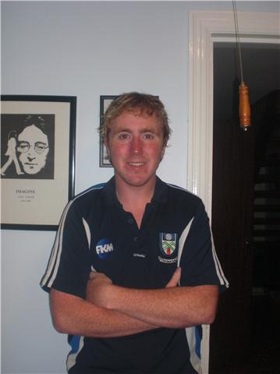

ADDRESS: Clones Rd.,  Monaghan,  Co. Monaghan,  Ireland. | PHONE NO.: (00353) 47 81169  (00353) 86 3139890  E-MAIL ADDRESS:  conorkeelaghan@hotmail.co.uk

EDUCATION:
- Weekend TEFL course (20 hrs.) Aug - 2009
- St. Mary’s B.S. Monaghan Town, Co. Monaghan 1991- 1999
- St. Macartan’s College, Monaghan, Co. Monaghan 1999- 2005
- University of Liverpool, Liverpool, U.K. 2005- 2008

EXAMINATION RESULTS

Junior Certificate Leaving Certificate
HONOUR LEVEL |  | HONOURS LEVEL
Irish C | Geography A | Irish C1 | Business A2
Maths C | History B | Biology A1
English B | German. B | English D1 | ORDINARY LEVEL
Science A | Business B | Geography A2 | Maths A1
French B | C.S.P.E. B | History. B1

EMPLOYMENT:

Employer | From | To | Job Title | Description of Main Duties
Argos  Monaghan Retail Park,  Monaghan,  Co. Monaghan, | November 2008 | Present | Sales Assistant | - Check outs  - Stock room  - Customer services
Ananas Spa,  71 Hill Street, Southampton, NY 11968, USA. | June 2008 | September 2008 | Spa Receptionist | - Confirming and taking bookings  - Customer relations  - Computer work
Dunnes Stores department store, Monaghan,  Co. Monaghan | September 2005 | June 2008 | Sales Assistant /Check Outs | - Handling money  - Greeting customers  - dealing with enquires  - Putting out stock
Dunnes Stores department store,  Drogheda,  Co. Louth | June 2005 | September 2005 | Personnel Department / Sales Assistant | - Reference checking  - Arranging interviews  - Helping with open days
Plant Motors filling station, Clones road, Monaghan  047 71360 | September 2002 | January 2005 | Sales Assistant | - Serving customers  - Putting out stock  - Preparing food

REFEREE:
Name | Address and Phone Number | Relationship
Mr. Thomas O’ Donaghue,  Lifestyle Foods | Dublin Rd.  Carrickmacross | Employer

VOLUNTARY WORK

- I have completed many runs (10 K, half marathon, full marathon) in aid of many charities such as the I.S.P.C.A, St. Vincent de Paul and Trocaire.
- I am involved with the Foroige youth organisation in Monaghan town. This work involved taking groups of children on day trips to the zoo, organising entertainment and games for the children.
- In secondary school, I worked with a club for local foster children with (NYP) Neighbourhood Youth Project centre in Monaghan.

OTHER ACHIEVEMENTS
- I have certified skills in typing and I have also have passed my ECDL examinations. .
- I have received my bronze Gaisce / president award.
- I have been involved with charity fund raisers including The Lions Club, Famine Aid, Cancer Research, the Special Olympics, Rehab Foundation.
- I spent last summer working and travelling in America on a J1 visa.

HOBBIES AND INTERESTS
- I like to keep fit by going to the college gym and swimming pool.
- I enjoy living in Monaghan with my friends as there is so much to do like going to see shows, the cinema, bars and clubs.
- I love to travel and experience new cultures.
- I am also an avid runner and hope to train for the Seoul marathon next year during my time in South Korea.

